**JIRA Project Management Document**

**Project Title:**

Arms Application for SIMATS Engineering

**Subtitle:**

Efficient Task Tracking and Workflow Management

**Submitted by:**

Pola Nandivardhan  
Department of AI & Data Science  
SIMATS Engineering

**Submitted to:**

Dr. Prakash Mathialagan

**Project Overview**

This project aims to design and develop an arms management application for SIMATS Engineering. The development involves 15 key tasks, a defined workflow, and a strict timeline managed using the JIRA Project Management template.

**1. Project Setup**

* **JIRA Template Used:** Project Management
* **Project Type:** Team-managed
* **Workflow Stages:**
  + To Do
  + In Progress
  + Under Review
  + Testing
  + A screenshot of a computer

    Description automatically generatedA screenshot of a computer

    Description automatically generatedDone

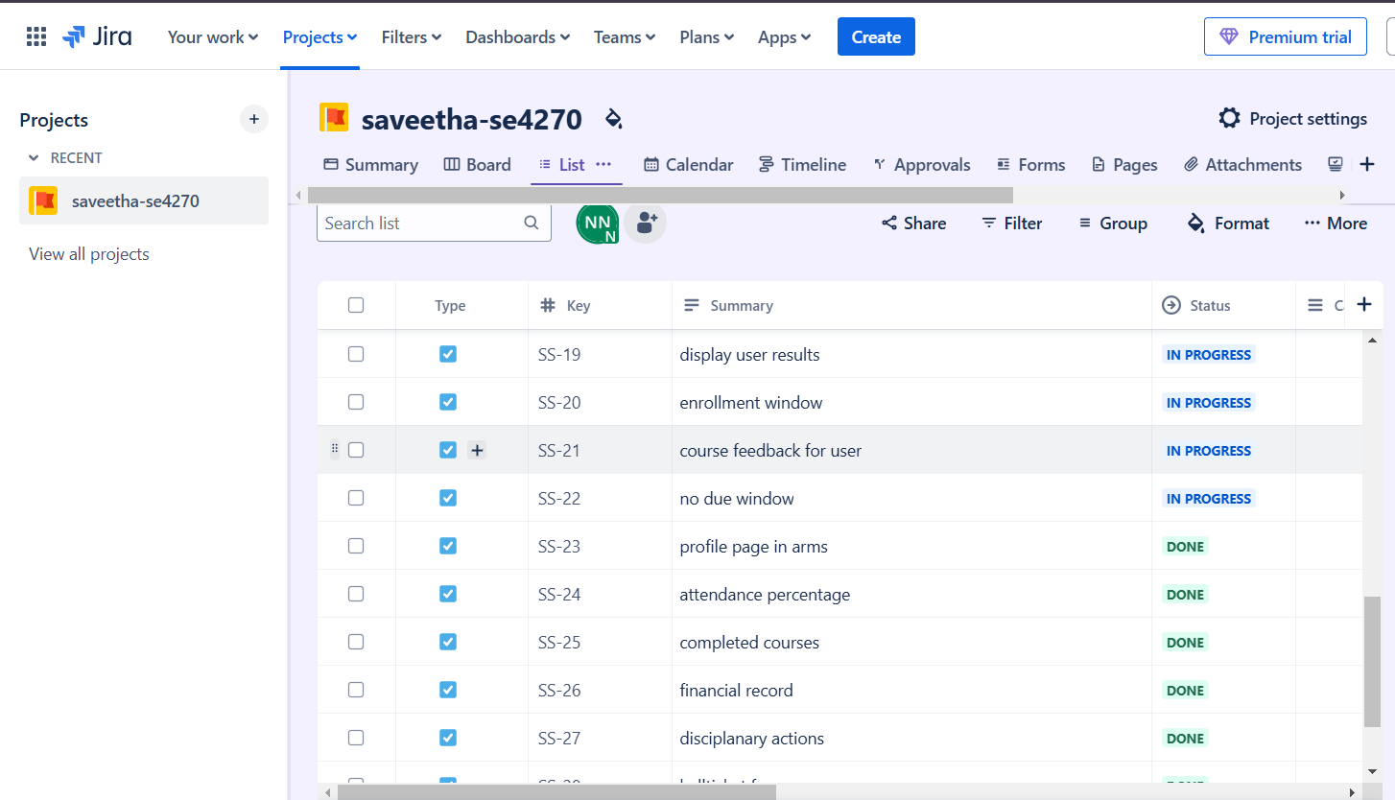

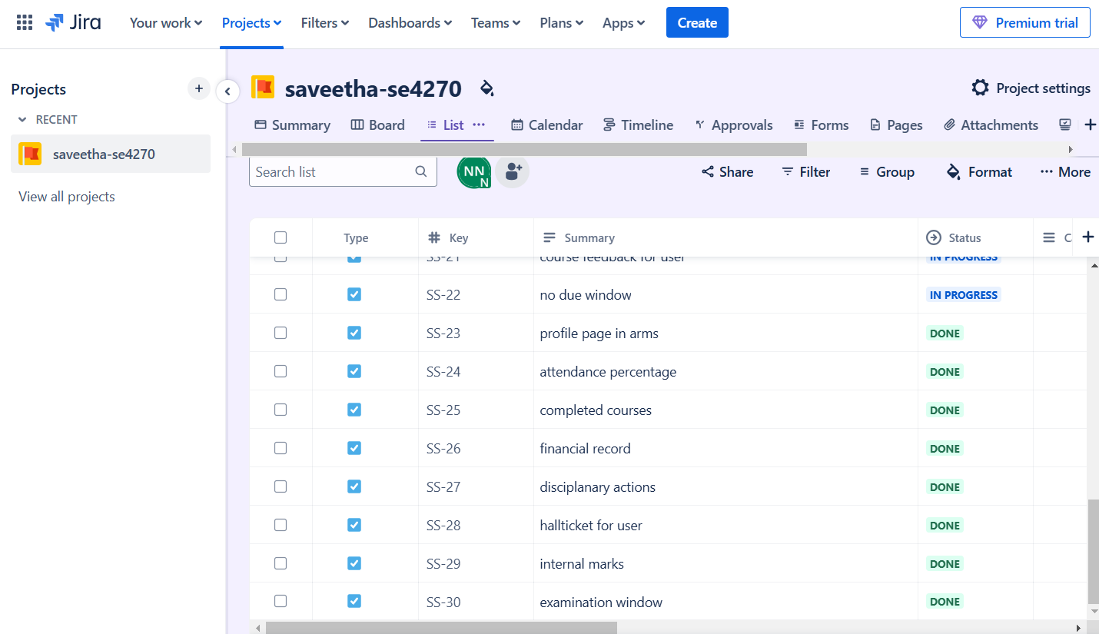

**2. Task Management in JIRA**

**List of Tasks Created in JIRA:**

1. Create profile page in ARMS
2. Validate user details
3. Display user details
4. Display user attendance percentage
5. Display user registered courses
6. Display user results
7. Display user completed courses
8. Create enrollment window
9. Create financial record
10. Display course feedback for user
11. Display disciplanary actions window
12. Display hallticket for user
13. Display internal marks for user
14. Create an examination window
15. Create no due window

**3. Timeline Setup**

* **Roadmap Created:**
  + Week 1: Requirement gathering, UI/UX design.

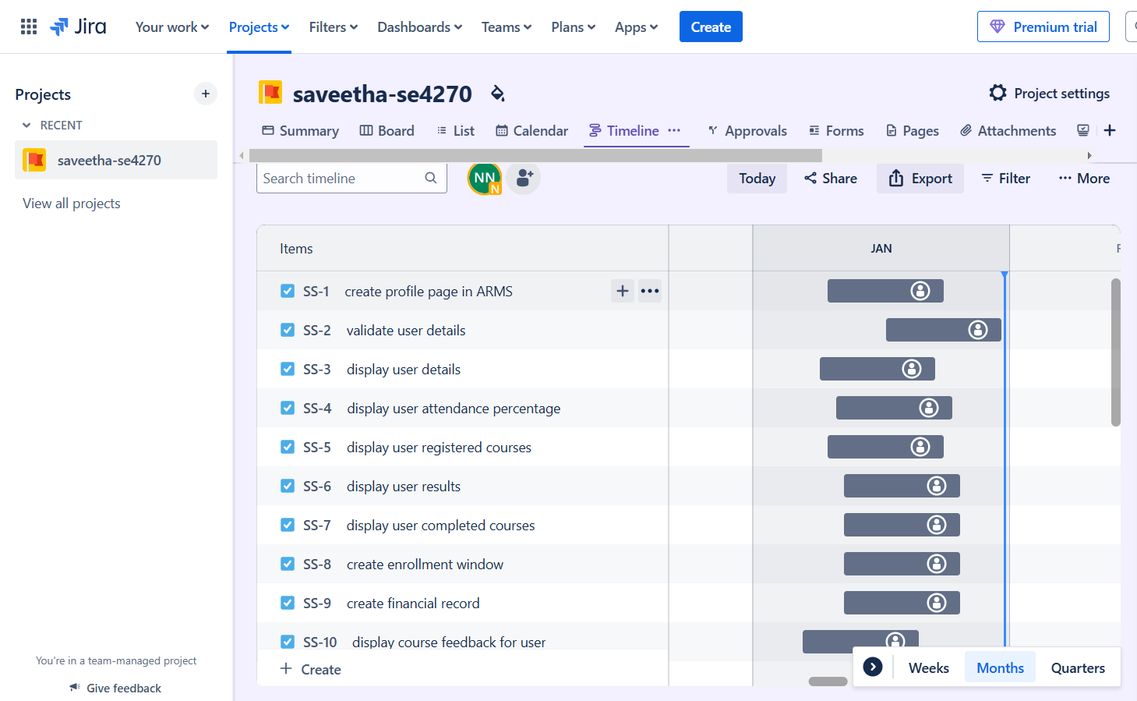

* + Week 2: Backend development, database schema creation.

* + Week 3: Frontend implementation, module integration.

* + Week 4: Testing and deployment.

**4. Sprint Activities**

**Before the Sprint**

* **Kick-off Meeting:**
  + Defined project goals.
  + Discussed deliverables and team responsibilities.
* **Planning Meeting:**
  + Tasks prioritized in JIRA backlog.
  + Timeline assigned to each task.

**During the Sprint**

* **Daily Stand-up Meetings:**
  + Progress updates shared using JIRA’s Kanban board.
* **Mid-Sprint Review:**
  + Checked incomplete tasks and reprioritized if needed.

**After the Sprint**

* **Sprint Review Meeting:**
  + Demoed completed features using JIRA task details.
* **Sprint Retrospective:**
  + Reviewed progress and discussed areas of improvement.

**5. Progress Tracking in JIRA**

* **Kanban Board:** Used to move tasks between workflow stages.
* **Reports Used:**
  + Burndown Chart: Monitored task completion.
  + Task Distribution: Visualized workload across team members.
* **Dependencies Managed:** Linked tasks to avoid delays.

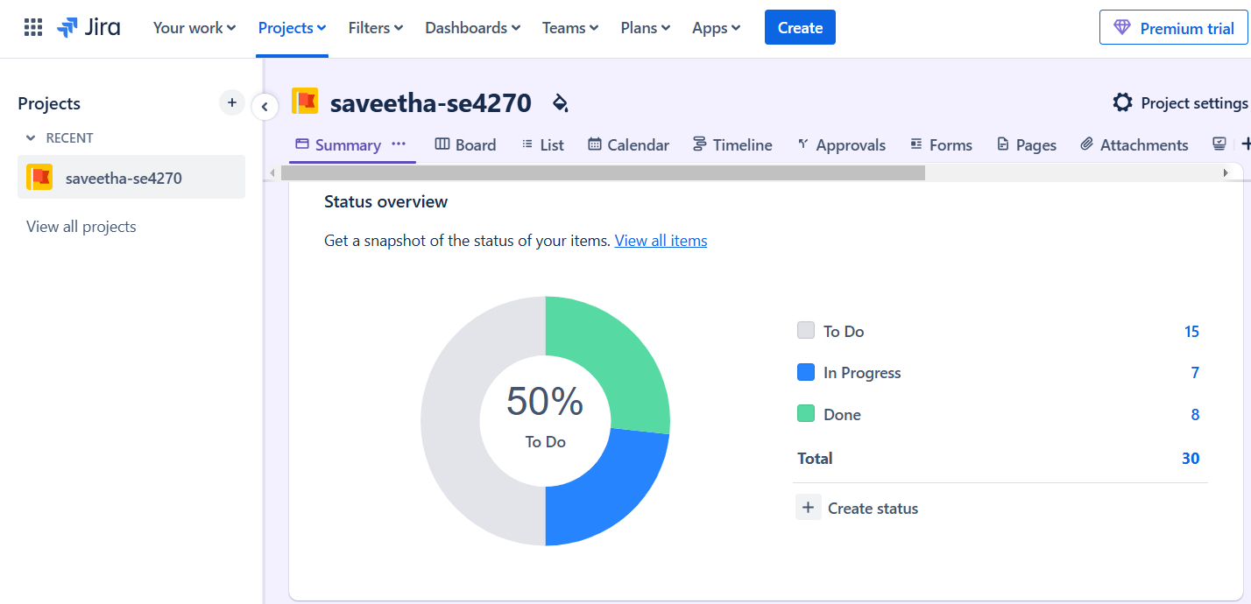

**6. Tools Used Alongside JIRA**

* **Confluence:** For centralized project documentation.
* **Slack:** For team communication and daily stand-ups.
* **GitHub:** Code repository for version control.

**Summary**

The project, **Development of Arms Application for SIMATS Engineering**, was effectively managed using JIRA's Project Management template. The primary objective was to streamline task tracking, improve team collaboration, and ensure timely delivery of the application.

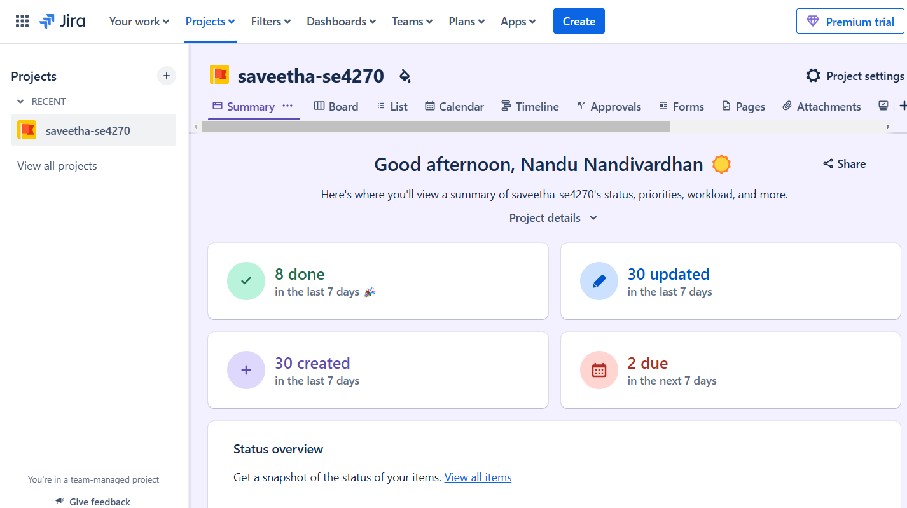

A total of **30 tasks** were created in JIRA, categorized into the following statuses:

* **Done:** 8 tasks successfully completed.
* **In Progress:** 7 tasks currently under development.
* **To Do:** 15 tasks awaiting initiation.

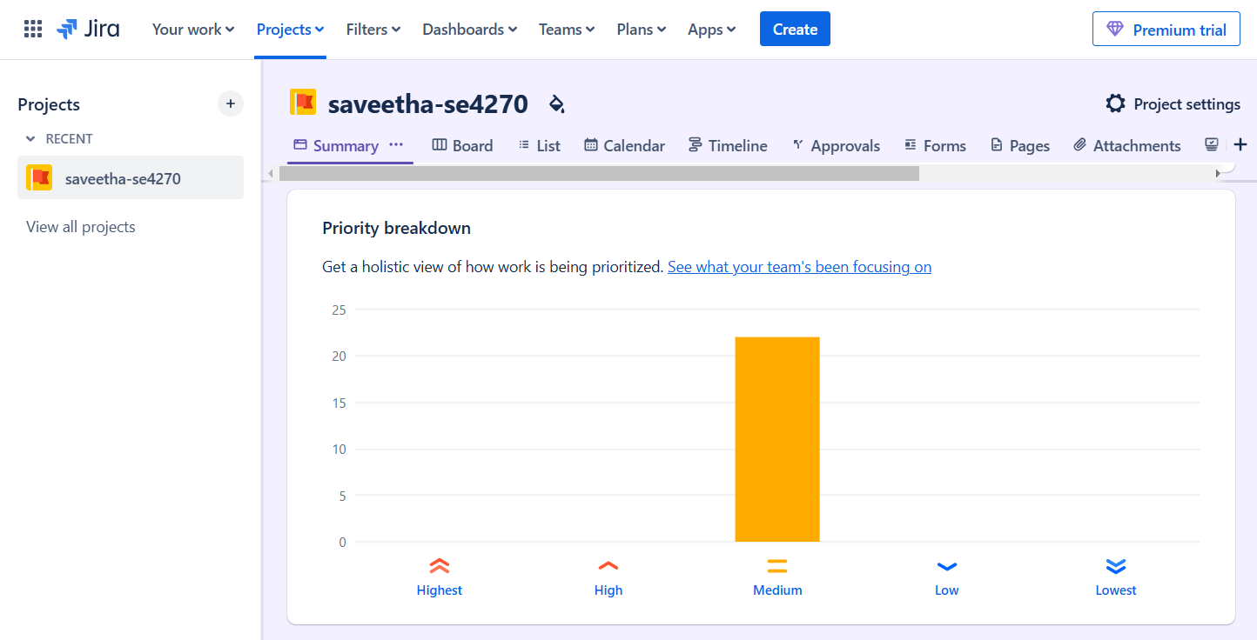

Key features of JIRA, such as the **Kanban Board**, **Timeline (Roadmap)**, and **Reports** (e.g., Burndown Chart and Task Distribution), were utilized to monitor and manage the workflow efficiently. Regular meetings were conducted to ensure alignment across the team, including **kick-off meetings, daily stand-ups, sprint reviews**, and **retrospectives**.

The project leveraged JIRA's robust task tracking and dependency management tools, allowing the team to maintain productivity and focus while meeting project deadlines.

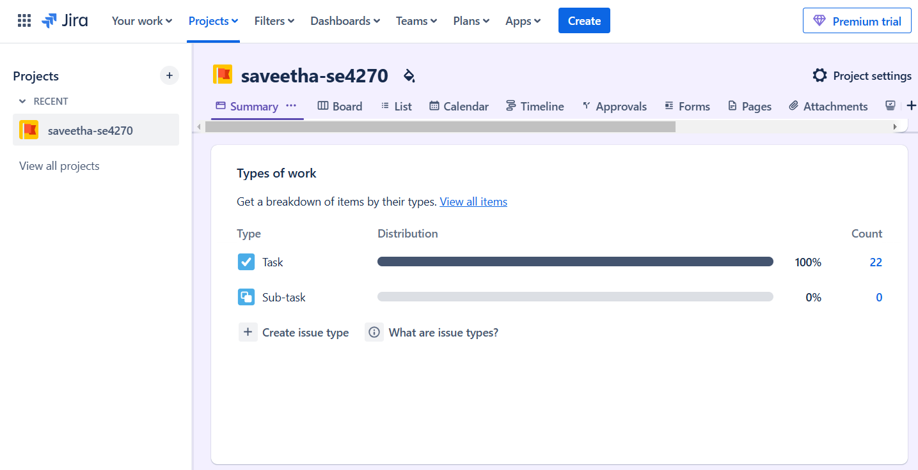

**Conclusion**

The project, Development of Arms Application for SIMATS Engineering, was effectively managed using JIRA, with 8 tasks completed, 7 in progress, and 15 pending. JIRA’s tools enabled efficient tracking, collaboration, and timely progress through well-structured workflows and regular team meetings.