2.ATM Management System - Mini Project

1. Introduction
This project is a simple ATM Management System implemented in Java. It demonstrates basic banking operations such as deposit, withdrawal, balance inquiry, and interest calculation using object-oriented programming concepts.

2. Objectives
- To understand Java OOP concepts like classes, objects, inheritance, and interfaces.
- To simulate real-world ATM operations.
- To implement user interaction using Scanner.

3. Technologies Used
- Java
- JDK
- Command Line Interface

4. System Description
The system allows users to log in using an account number. After successful login, users can perform operations such as deposit, withdraw, check balance, add interest, and view account details.

5. Code Implementation
import java.util.Scanner;
interface BankOperations {
void deposit(double amount);

void withdraw(double amount);

void displayBalance();

void addInterest();
}
class Account {
private int accNo;
private String name;
private double balance;

Account(int accNo, String name, double balance) {
this.accNo = accNo;
this.name = name;
this.balance = balance;
}

public int getAccNo() {
return accNo;
}

public String getName() {
return name;
}

public double getBalance() {
return balance;
}

public void setBalance(double balance) {
this.balance = balance;
}
}

class SavingsAccount extends Account implements BankOperations {
SavingsAccount(int accNo, String name, double balance) {
super(accNo, name, balance);
}

public void deposit(double amount) {
if (amount > 0) {
setBalance(getBalance() + amount);
System.out.println("Deposited: " + amount);
} else {
System.out.println("Invalid amount");
}
}

public void withdraw(double amount) {
if (amount <= 0) {
System.out.println("Invalid amount");
} else if (amount > getBalance()) {
System.out.println("Insufficient balance");
} else {
setBalance(getBalance() - amount);
System.out.println("Withdrawn: " + amount);
}
}

public void displayBalance() {
System.out.println("Balance: " + getBalance());
}

public void addInterest() {
double interest = getBalance() * 0.05;
setBalance(getBalance() + interest);
System.out.println("Interest added: " + interest);
}

public void displayDetails() {
System.out.println("Acc No: " + getAccNo());
System.out.println("Name: " + getName());
System.out.println("Balance: " + getBalance());
}
}

public class ATMManagementSystem {
public static void main(String[] args) {
Scanner sc = new Scanner(System.in);
SavingsAccount[] accounts = new SavingsAccount[3];
accounts[0] = new SavingsAccount(101, "Hema", 9000);
accounts[1] = new SavingsAccount(102, "varshitha", 2000);
accounts[2] = new SavingsAccount(103, "Sharanya", 3000);
System.out.print("Enter Account Number: ");
int accNo = sc.nextInt();
SavingsAccount current = null;
for (int i = 0; i < accounts.length; i++) {
if (accounts[i].getAccNo() == accNo) {
current = accounts[i];
break;
}
}
if (current == null) {
System.out.println("Account not found");
return;
}
int choice;
do {
System.out.println("\n1.Deposit");
System.out.println("\n2.Withdraw");
System.out.println("\n3.Balance");
System.out.println("\n4.Interest");
System.out.println("\n5.Details");
System.out.println("\n6.Exit");
choice = sc.nextInt();
switch (choice) {
case 1:
System.out.print("Enter amount: ");
current.deposit(sc.nextDouble());
break;
case 2:
System.out.print("Enter amount: ");
current.withdraw(sc.nextDouble());
break;
case 3:
current.displayBalance();
break;
case 4:
current.addInterest();
break;
case 5:
current.displayDetails();
break;
case 6:
System.out.println("Thank you!");
break;
default:
System.out.println("Invalid choice");
}
} while (choice != 6);
}
}
OUTPUT:
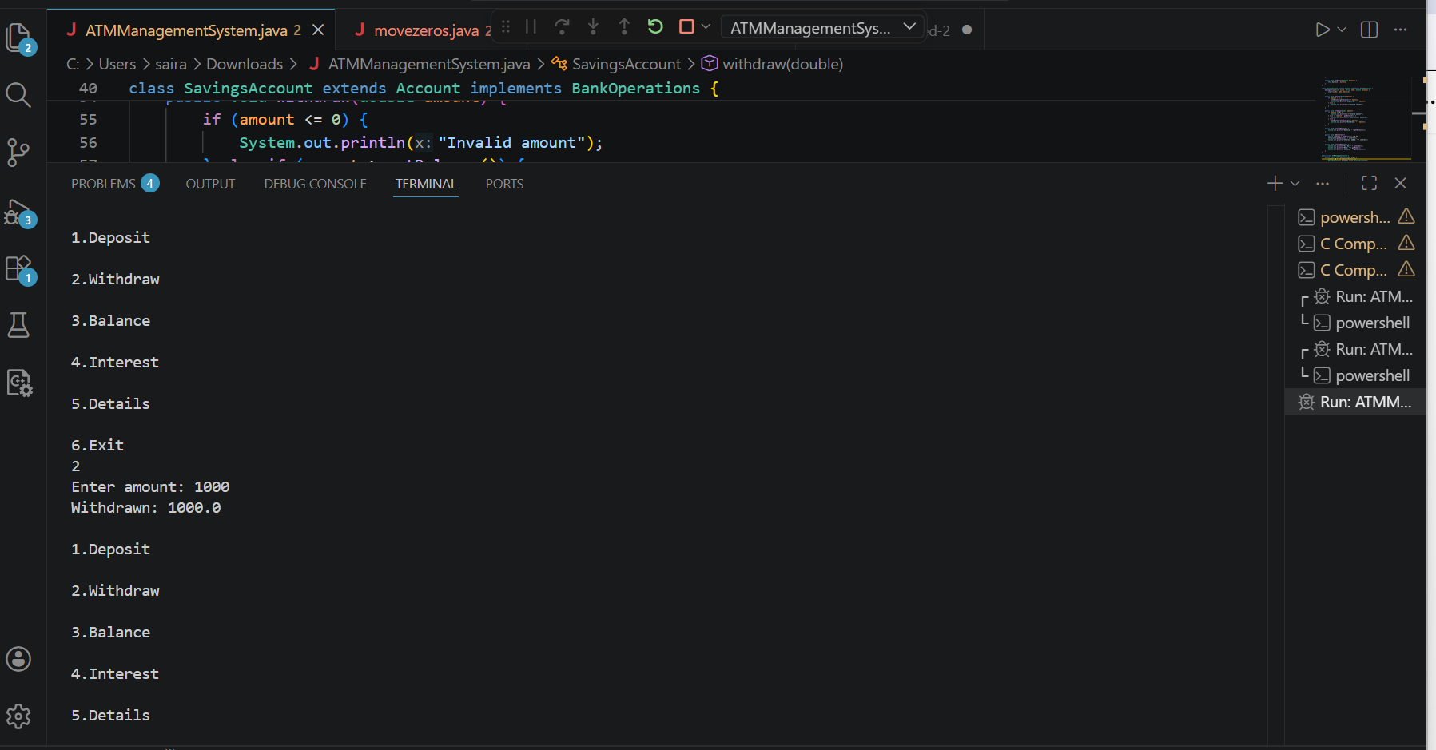
6. Features
- Deposit money
- Withdraw money
- Check account balance
- Add interest
- View account details

7. Conclusion
This project helps in understanding basic banking operations and enhances knowledge of Java programming and object-oriented design.

