PYTHON PROGRAMMING ACTIVITY-BASED LEARNING 10 CASES STUDIES WITH SOLUTIONS

Name: A.Naga Nandini
Roll Number: 26000854
Branch: Computer Science & Engineering(AI & ML)
Section: CSM1
Course: Python Programming
Institution: Dr RVR NRI Institution of Technology

Contents
Case 2 : Progressive Electricity Bill
Case 3: Hospital Billing And Patient classification
Case 4: Employee Payroll And Deduction Analysis
Case 5: Telecommunication Cost Optimization
Case 8: Manufacturing Cost and Profitability Analysis
Case 9: Travel Budget Analysis
Case 12: Attendance Recovery
Case 14: Warehouse Inventory
Case 15: Smart Parking Fee
Case 16: Multi-Day Water Tank Simultation

Case study 1 : Prograssive Electricity Bill

Problem Statement
To write a Python program to calculate the electricity bill based on the number of units consumed by a user using different tariff rates.
Objectives
- To dynamically calculate electricity bill amounts based on tiered unit consumption slabs.
- To apply fixed fixed meter charges and surcharge penalties accurately.
- To implement input validation ensuring unit consumption and inputs are valid numbers.
- To output an itemized summary statement for the customer.

Assumptions
- Slab Rates (Domestic Consumption):
- First 100 units: ₹3.00 per unit
- Next 100 units (101 - 200 units): ₹4.50 per unit
- Next 100 units (201 - 300 units): ₹6.00 per unit
- Above 300 units: ₹8.00 per unit
- Fixed Charges: A constant meter charge of ₹50.00 is added to every bill.
- Late Fee: If payment is late, a 5% surcharge is applied to the total energy charge.
Algorithm
Start the program.
Read the electricity units consumed (u) from the user.
If u <= 100, calculate the bill as u × 1.5.
If u <= 200, calculate the bill as 150 + (u - 100) × 2.5.
Otherwise, calculate the bill as 400 + (u - 200) × 4.
Display the electricity bill.
Stop the program.

Flowchart:
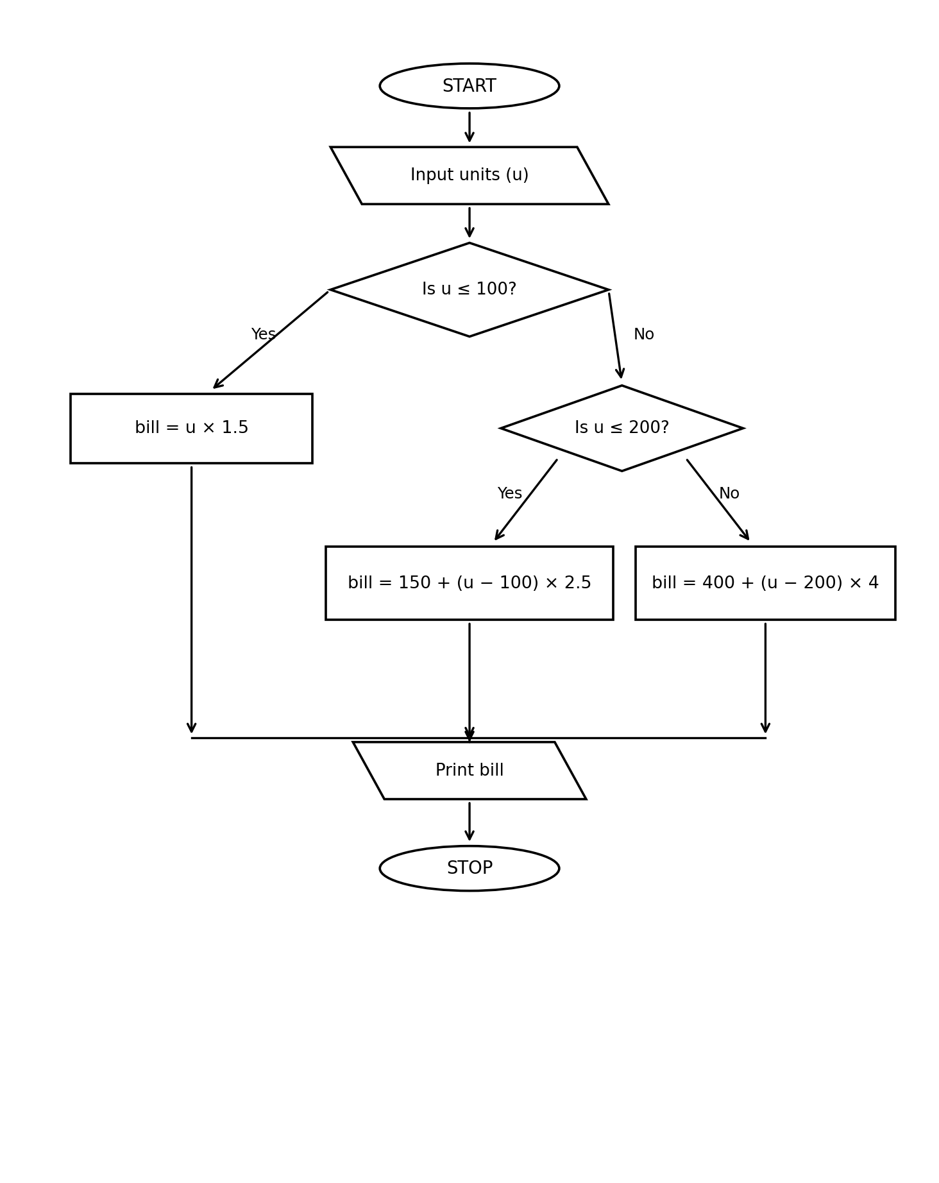

Pseudocode
BEGIN
INPUT u

IF u <= 100 THEN
bill = u * 1.5
ELSE IF u <= 200 THEN
bill = 150 + (u - 100) * 2.5
ELSE
bill = 400 + (u - 200) * 4
END IF

PRINT bill
END

Python source code
u = int(input("Enter units: "))

if u <= 100:
bill = u * 1.5
elif u <= 200:
bill = 150 + (u - 100) * 2.5
else:
bill = 400 + (u - 200) * 4

print("Electricity Bill =", bill)

Test Cases
Test case Input units Expected bill
1 . 50 ₹75.0
2 . 100 ₹150.0
3 . 150 ₹275.0
4 . 200 ₹400.0
5 . 250 ₹600.0
6 . 300 ₹800.0
9. Output
Sample Output
Enter units: 50
Electricity Bill = 75.0

Conclusion
The Python program successfully calculates the electricity bill based on the units consumed. It uses if-elif-else conditional statements to apply different tariff rates for different unit ranges. Thus, the program demonstrates the use of conditional statements in solving a real-world billing problem.

2.Hospital Billing

Problem Statement
To develop a Python program to calculate a patient's hospital bill based on consultation, diagnostic, and treatment charges. Apply a 10% discount to the total bill and classify the patient based on the final bill amount.
Objectives
To calculate the total hospital bill.
To apply a 10% discount to the total amount.
To calculate the final bill after discount.
To classify patients into Basic, Standard, and Advanced categories.
To use arithmetic operators and conditional statements in Python

Assumptions
Consultation, diagnostic, and treatment charges are entered by the user.
All charges are non-negative integers.
The discount rate is fixed at 10%.
The final bill is calculated after deducting the discount.
If the final bill is less than or equal to ₹1,000, the patient is classified as Basic.
If the final bill is greater than ₹1,000 and less than or equal to ₹5,000, the patient is classified as Standard.
If the final bill is greater than ₹5,000, the patient is classified as Advanced.

Algorithm
Start the program.
Input consultation charge c.
Input diagnostic charge d.
Input treatment charge t.
Calculate total bill: total = c + d + t
Calculate discount: discount = total × 10 / 100.
Calculate final bill: bill = total - discount.
Display total bill, discount, and final bill.
If bill <= 1000, display Basic Patient.
Else if bill <= 5000, display Standard Patient.
Otherwise, display Advanced Patient.
Stop the program.

Flowchart
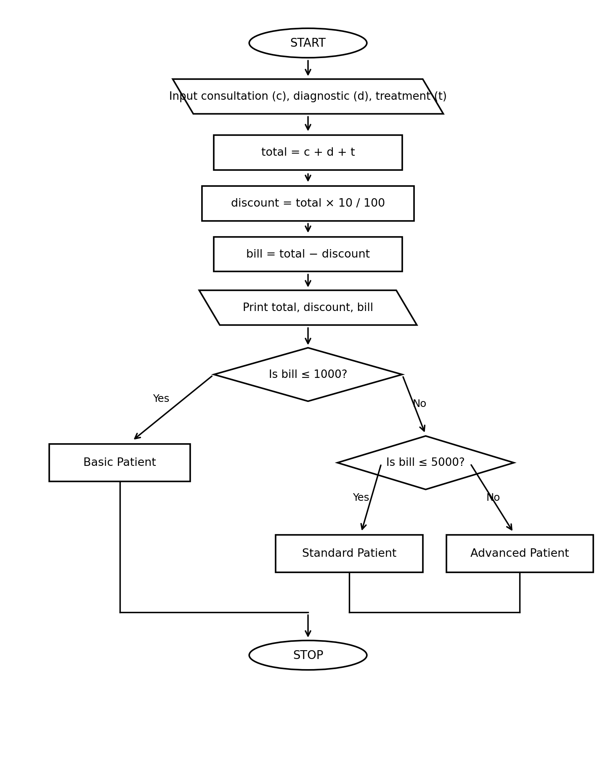

Pseudocode

BEGIN
INPUT c, d, t

total = c + d + t
discount = total * 10 / 100
bill = total - discount

PRINT total
PRINT discount
PRINT bill

IF bill <= 1000 THEN
PRINT "Basic Patient"
ELSE IF bill <= 5000 THEN
PRINT "Standard Patient"
ELSE
PRINT "Advanced Patient"
END IF
END

Python sourcr code

c = int(input("Consultation charge: "))
d = int(input("Diagnostic charge: "))
t = int(input("Treatment charge: "))

total = c + d + t
discount = total * 10 / 100
bill = total - discount

print("Total Bill =", total)
print("Discount =", discount)
print("Final Bill =", bill)

if bill <= 1000:
print("Basic Patient")
elif bill <= 5000:
print("Standard Patient")
else:
print("Advanced Patient")

Testcases

FLOWCHART DIAGRAMS
Case Study 1: Progressive Electricity Bill
bill = u × 1.5 | Is u ≤ 200?

Case Study 2: Hospital Billing
Yes: Standard Patient | No: Advanced Patient

