CUSTOMER BEHAVIOR ANALYSIS REPORT

Name: Nandu vadlamudi

Executive Summary:
This report analyzes customer purchasing behavior using transaction data to identify key patterns, trends, and insights. The analysis focuses on customer demographics, product preferences, and revenue trends. Based on the findings, actionable recommendations are provided to improve customer engagement, increase revenue, and support data-driven decision-making.
Introduction:
This project focuses on analyzing customer purchasing behavior using a dataset containing transaction details. The objective is to identify patterns, trends, and insights that can help businesses make better decisions and improve overall performance.

Dataset Information:
The dataset was obtained from Kaggle and includes the following
- Customer ID
- Purchase Date
- Product Category
- Product Price
- Quantity
- Total Purchase Amount
- Payment Method
- Customer Age
- Returns
This dataset helps in understanding customer preferences and buying patterns.

Data Cleaning and Preparation:
The dataset was prepared for analysis using the following steps
- removed missing values
  - Converted “Purchase Date” into datetime format
  - Created new columns such as Month and Age Group
  - Verified data consistency and structure

Data Analysis and Visualizations

Product Category Distribution
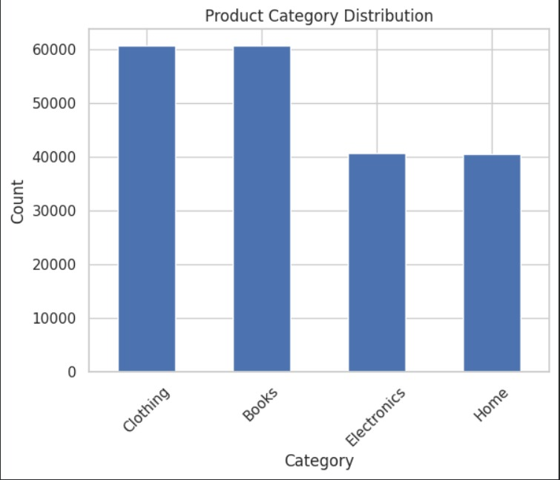
This chart shows the distribution of purchases across different product categories.

Revenue by Product Category :

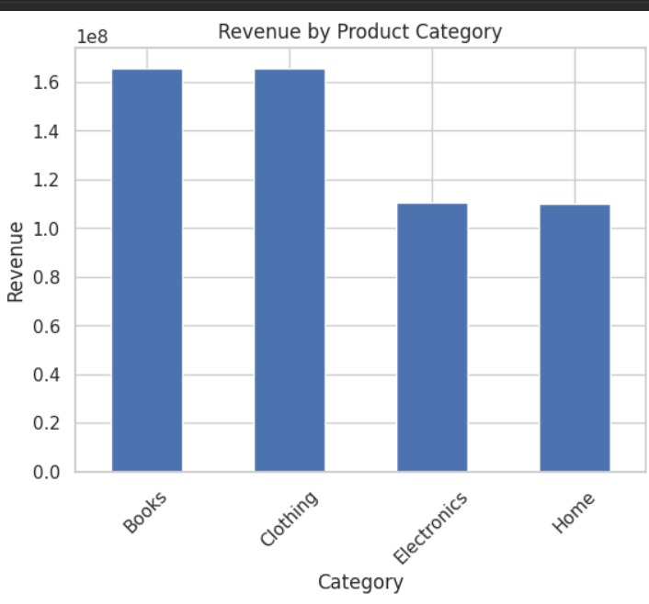
This visualization highlights which categories generate the highest revenue.

Monthly Revenue Trend

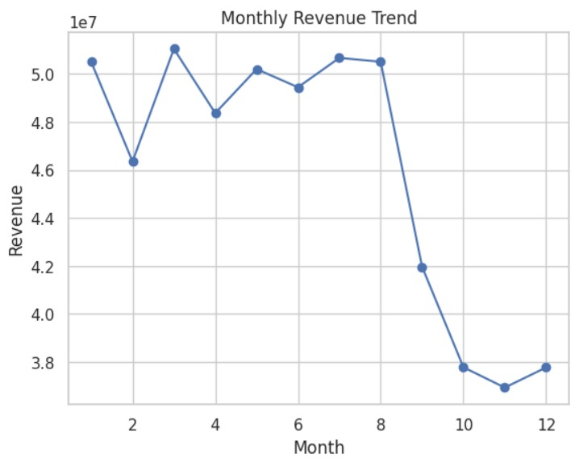
This line graph shows how revenue changes over time.

Customer Age Distribution

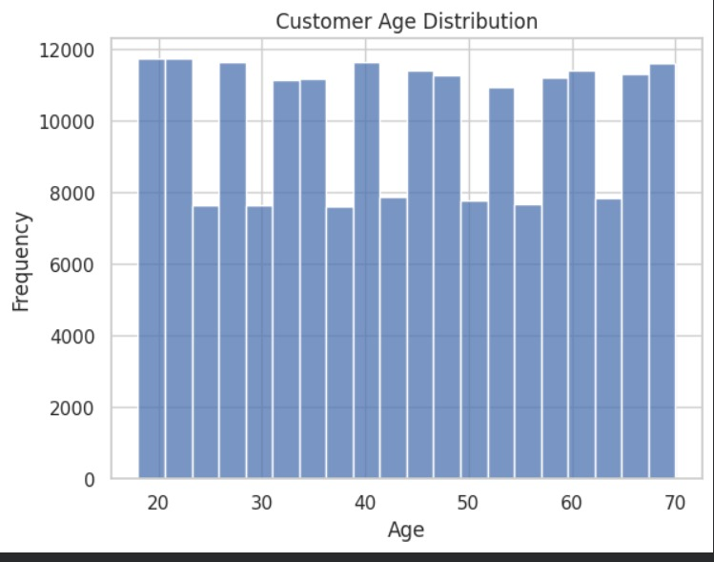
This chart shows the distribution of customers based on age.

Payment Method Analysis
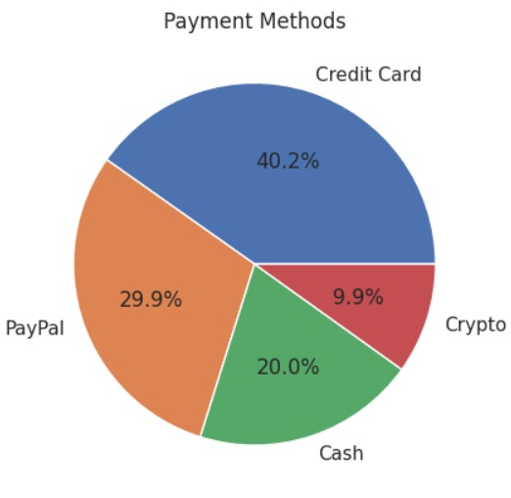
This pie chart represents customer payment preference.

Key Insights:

  - High revenue is generated from top-performing product categories
  - Customers aged 25–45 are the most active buyers
  - Sales vary across months, indicating seasonal trends
  - Digital payment methods are most preferred
  - A small group of customers contributes significantly to total revenue
  - Product returns are relatively low, indicating customer satisfaction

Recommendations:
  - Focus on high-performing categories to increase revenue
  - Target key customer age groups with personalized offers
  - Improve sales in low-performing months through promotions
  - Provide incentives for preferred payment methods
  - Retain high-value customers through loyalty programs
  - Maintain product quality to minimize returns

Conclusion:
The analysis provides valuable insights into customer purchasing behavior. These findings can help businesses optimize their strategies, improve customer
satisfaction,
and increase overall profitability.
Tools Used:

- (Pandas, NumPy)
- Matplotlib, Seaborn
- Google Colab

GITHUB LINK :
https://github.com/nanduvadlamudi/customer-behavior-analysis.git

