SECURE DIGITAL DOCUMENT
MANAGEMENT SYSTEM
For Legal and Investigation Documents

Problem Statement
Law-enforcement agencies, courts, legal departments and investigative organizations handle large volumes of sensitive documents such as FIRs, investigation records, witness statements, charge sheets, court filings, evidence records, forensic reports, legal notices and judgments. Paper-based systems and fragmented digital storage make documents difficult to locate, increase unauthorized-access and tampering risks, complicate version control and delay collaboration and legal processes.
The objective is to develop a secure, centralized and intelligent DMS that digitizes and organizes documents, enforces confidentiality, prevents unauthorized modification, maintains a complete audit trail, enables fast search and retrieval, supports authorized collaboration and preserves evidentiary integrity.

1. NOVELTY & INNOVATION
The innovation is not simply digitizing paper files. The proposed system treats each legal document as a controlled digital asset with identity, version history, integrity proof, access policy and an auditable lifecycle.
1.1 Novelty Comparison
Existing approach | What it provides | Gap | Proposed differentiation
Paper / physical files | Physical storage and manual retrieval | Slow retrieval, loss/damage risk, difficult sharing and tracking | Case-centric digital lifecycle with searchable metadata and controlled access
Generic cloud drive | File upload, folders and sharing | Not designed around legal evidence, chain-of-custody or investigation workflows | Evidence-aware DMS with integrity verification, versioning and audit trail
Conventional database | Structured metadata and records | Database entry alone does not provide an independent integrity anchor for the file | Database + encrypted object storage + cryptographic hash anchoring
Digital signature only | Signer authentication and integrity of signed content | Signing is only one stage of the document lifecycle | Signatures combined with RBAC, version control, audit logging and blockchain anchoring
Traditional DMS | Document organization, search and workflow | May not provide permissioned blockchain integrity or evidence-oriented verification | Blockchain-backed integrity + AI-assisted retrieval + legal case workflow
Proposed system | Secure end-to-end lifecycle | — | Encrypted storage + SHA-256 + permissioned blockchain + RBAC + signatures + AI search + audit

1.2 Key Innovation Points
- Secure case-wise document management instead of separate folders and files.
- SHA-256 hash is generated for every uploaded document and every new version.
- Permissioned blockchain stores the document hash and provenance information so that later changes can be detected.
- Actual confidential documents remain in encrypted storage instead of storing complete files on the blockchain.
- Role-based access controls what each investigator, legal officer, forensic officer, auditor or administrator can see and do.
- Every important action such as upload, view, download, share, version creation and verification is recorded in an audit trail.
- OCR can convert scanned documents into searchable text and extract useful fields such as case number, date and names.
- Digital signatures can be used for approved documents and official workflows.

2. TECHNICAL APPROACH & COMPLEXITY
2.1 Reference Architecture

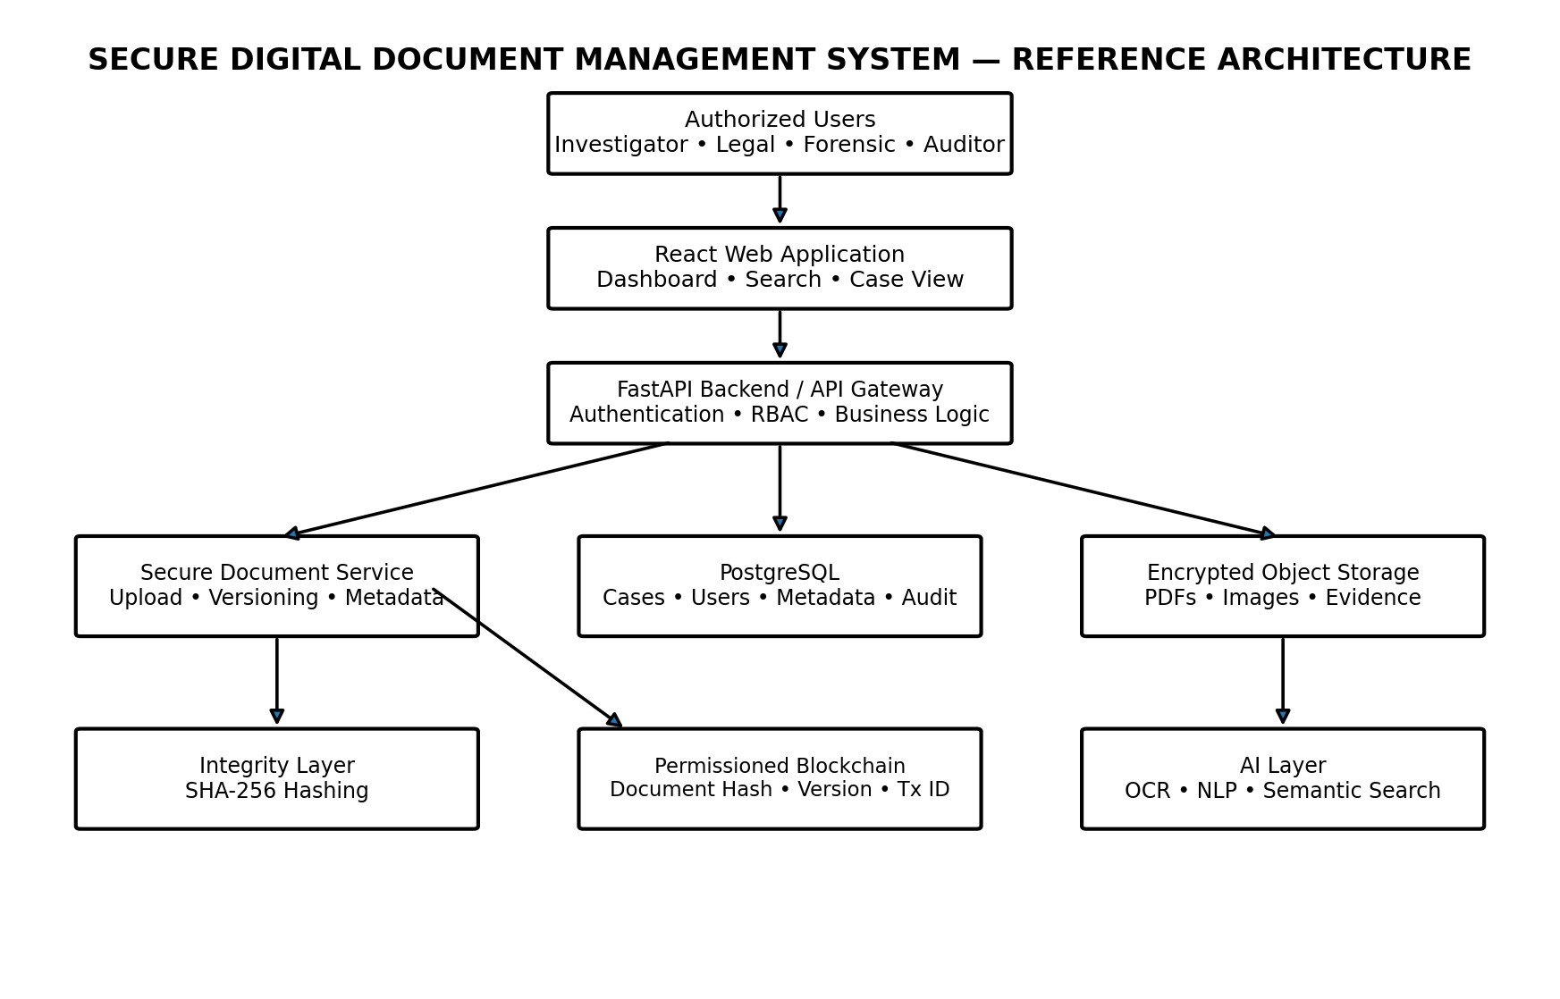

2.2 Technology Stack
Layer | Technology | Purpose | Why it is suitable
Frontend | React.js | Case dashboard, document viewer, search, audit and verification UI | Component-based UI supports modular dashboards and interactive workflows.
Backend/API | Python + FastAPI | Authentication, document APIs, workflow orchestration and validation | Fast development of typed REST APIs and file-upload endpoints.
Structured DB | PostgreSQL | Users, roles, cases, metadata, versions, audit references | Reliable relational storage for transactional and structured information.
File storage | Encrypted object/file storage | Stores PDFs, images and evidence files | Keeps large confidential payloads off-chain and supports scalable storage.
Blockchain | Hyperledger Fabric | Integrity metadata, document hash, version and transaction reference | Permissioned network model is appropriate where participating organizations are known.
Cryptography | SHA-256 + encryption | Document fingerprints and confidentiality | SHA-256 is an approved SHA-2 hash option; encryption protects stored/transmitted data.
Authentication | JWT + RBAC + optional MFA | Identity and authorization | Supports role and permission enforcement for sensitive resources.
Digital signatures | PKI / approved signature scheme | Signer authentication and document integrity | Provides verification that information was signed by the claimed signatory and not modified after signing.
OCR/NLP | Tesseract / Python NLP stack | Text extraction, classification and entity/keyword extraction | Converts scanned documents into searchable text and metadata.
Deployment | Docker + Nginx + controlled infrastructure | Reproducible deployment and secure routing | Supports isolated services and later on-premise/private-cloud deployment.

2.3 Secure Document Lifecycle
React file upload component
↓
FastAPI upload endpoint
↓
File validation
↓
Generate Document ID
↓
SHA-256
↓
Encryption
↓
Storage
↓
PostgreSQL metadata
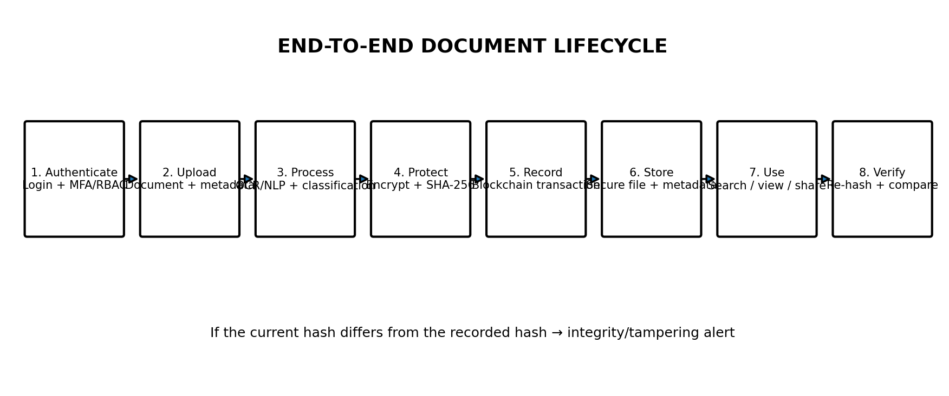

2.4 Blockchain Design
The blockchain is used as an integrity and provenance layer rather than as a bulk file-storage system. For each document version, the application can create a record containing the document ID, case ID, SHA-256 hash, version number, timestamp, authorized actor and blockchain transaction reference.
Document PDF / Image
↓
Normalize / Validate
↓
SHA-256(document bytes)
↓
Encrypt + store file securely
↓
Write integrity metadata to permissioned ledger
↓
Return Document ID + Version + Verification status
Hyperledger Fabric supports permissioned participation through channels and private-data mechanisms; its chaincode model allows organizations to define and invoke smart-contract logic for ledger transactions. This makes Fabric a strong candidate for a multi-organization legal-document prototype.
Hyperledger Fabric network
↓
Organizations/users
↓
Fabric identities
↓
Channel
↓
Chaincode
↓
Transaction
↓
Store:
Document ID
Hash
Version
Timestamp
Actor
2.5 Access Control Model
Role | Typical permissions
Administrator | Manage users, roles, policies, system configuration and security events
Investigator | Upload, view, search, create versions and share documents for assigned cases
Legal Officer | View and upload authorized legal documents; verify signatures/integrity
Forensic Officer | Upload and access authorized forensic/evidence records
Auditor | Read audit records and compliance information; no document modification
Viewer / Court User | Read-only access to explicitly authorized case/document scopes

Authorization is a security policy decision: authentication establishes who the user is, while authorization determines what that user may access or modify. OWASP describes access control as policy-driven mediation of access to resources and recommends explicit role/privilege definitions.
2.6 Integrity, Signatures and Auditability
- SHA-256: generate a deterministic digest for each document version and compare it during later verification.
- Digital signatures: associate a signed document or approval with an authorized signatory.
- Audit logging: record security-relevant actions such as login, upload, access, sharing, versioning, signing and verification.
- Audit protection: sensitive values should not be unnecessarily placed in logs; access to audit data should itself be controlled.
- Chain-of-custody: preserve a traceable sequence of document versions and integrity records.
Current document
↓
SHA-256
↓
Current hash
↓
Retrieve original hash
↓
Compare
↓
MATCH → Verified ✅
MISMATCH → Alert ⚠️
2.7 Digital Signatures
Digital signatures can be added to documents that require official approval. The signature can later be verified to check whether the signed content has been changed and whether it was signed by the expected authorized user.
2.8 OCR and Intelligent Search
Uploaded PDF/image
↓
Check if scanned
↓
Tesseract OCR
↓
Extract text
↓
Python processing
↓
Extract:
Case number
Names
Dates
Keywords
↓
Store/index extracted information
↓
Search
2.9 Version Control
Document table
+
Version table
↓
Version number
↓
New upload/change
↓
Create Version 2
↓
Calculate new hash
↓
Store new version
↓
Keep Version 1
2.10 Audit Trail
We need:
audit_logs table
containing things like:
user_id
action
document_id
timestamp
result
Then whenever something important happens:
Upload
View
Download
Share
Version creation
Signing
Verification
Permission change
we create an audit record. Your report identifies these as important audit events

2.11 Backend and Database
FastAPI provides the REST API between the frontend and backend services. PostgreSQL stores users, cases, permissions, document metadata, versions and audit information. Secure storage is used for the actual documents.
2.12 Frontend
A React-based web application can provide login, case dashboard, document upload, search, document preview, version history, verification and audit views.

3. FEASIBILITY & VIABILITY
3.1 Technical Feasibility
- The proposed components are mature software technologies with documented APIs and development tooling.
- A hackathon prototype can use synthetic/sample legal documents and a local or private development network.
- The blockchain can initially record only integrity metadata; this keeps the prototype practical and avoids storing large files on-chain.
- AI/OCR can be introduced as an asynchronous processing step so that core document management remains functional even if AI processing fails.
- The system can be containerized for reproducible deployment.
3.2 Operational Feasibility
The workflow is designed around familiar actions: login → select case → upload/search → verify authorization → view/share → verify integrity → record activity. This minimizes disruption to existing document-handling practices.
3.3 Economic Feasibility
- Prototype can be built largely with open-source software.
- Development can start on local machines before moving to controlled cloud or on-premise infrastructure.
- Modular deployment allows AI, blockchain and advanced search features to be scaled independently.
- Storage and compute requirements can be matched to document volume and organizational demand.
3.4 Legal & Ethical Feasibility
- Only lawfully obtained and authorized documents should be processed.
- Access must follow least-privilege and organization-defined authorization policies.
- AI-generated extraction or search results are assistive and should not be treated as independent legal conclusions.
- Retention, archival and deletion rules must be defined by the responsible organization and applicable law.
- The prototype should avoid real confidential case data unless an authorized environment and data-governance process exist.
3.5 Risks and Mitigation
Risk | Impact | Mitigation
Unauthorized access | High | RBAC, MFA, short-lived tokens, least privilege and access logging
Document tampering | High | SHA-256 verification + blockchain anchoring + version control
Blockchain outage | Medium | Queue integrity transactions and reconcile when the permissioned network returns
Large file / storage growth | Medium | Object storage, retention policy, compression where appropriate and lifecycle management
OCR/NLP errors | Medium | Keep original document, show extracted fields as assistive, allow human validation
Key compromise | High | Centralized key-management policy, rotation, separation of duties and secure backups
Sensitive data leakage in logs | High | Log metadata rather than document content; sanitize sensitive fields
Prototype integration complexity | Medium | Implement MVP in phases: DMS → hash verification → blockchain → AI search

3.2 Prototype Scope for Demonstration
Module | Demonstration
Secure upload | Upload a sample legal document and generate its hash
Login and RBAC | Show different access for different users
Document storage | Store and retrieve the uploaded document
Blockchain record | Show hash and transaction information
OCR | Extract text from a scanned document
Search | Search documents using case number, type or extracted text
Version control | Upload a modified document as a new version
Digital signature | Sign and verify a sample document
Integrity verification | Modify a copy and show hash mismatch
Audit trail | Display user actions with timestamps

4. IMPACT, SCALE & SUSTAINABILITY
4.1 Benefits to End Users
- Faster retrieval of case documents through metadata, full-text and semantic search.
- Lower risk of unauthorized access through role and policy enforcement.
- Tamper-evident document verification through cryptographic hashes and blockchain records.
- Clear version history so users can identify the origin and progression of a document.
- Improved collaboration between authorized investigators, legal staff, forensic teams and auditors.
- Reduced physical paperwork and dependence on manual file movement.
4.2 Benefits to Sponsoring Organizations
- Centralized case-document visibility and governance.
- Better auditability and accountability.
- Reduced time spent locating, comparing and validating documents.
- Scalable architecture for additional departments, document types and users.
- Improved preparedness for compliance and internal review.

4.3 Scale of Impact
Scale | Potential impact
Individual Case level | Secure management and verification of all documents for one investigation/legal matter.
Department level | Shared platform for investigators, legal staff, forensic teams and auditors.
Regional level | Controlled exchange and verification across authorized offices.
National level | Potential interoperability across participating institutions using permissioned networks and policy-controlled sharing.

4.4 Sustainability
- Social: supports more accountable and efficient handling of sensitive legal information.
- Economic: open-source components and modular deployment can reduce initial software licensing costs.
- Environmental: digitization reduces dependence on paper files and physical storage.
- Technical: APIs and modular services allow future replacement or upgrading of individual components without redesigning the entire system.

5. PROTOTYPE & DEMONSTRATION READINESS
The proposed minimum viable prototype should demonstrate a complete, measurable workflow rather than only a UI mock-up.
5.1 MVP Modules
Module | MVP capability | Demonstration evidence
Authentication | Login + role-based dashboard | Different roles see different actions
Case management | Create/select case and assign users | Case-specific document access
Document upload | Upload PDF/image with metadata | Document receives unique ID/version
Hashing | Generate SHA-256 on upload | Displayed hash / verification record
Blockchain | Write integrity metadata | Transaction/ledger reference shown
Versioning | Create a new version without overwriting history | Version timeline
Search | Metadata + extracted text search | Query returns relevant documents
Audit | Record document/security events | Audit timeline
Integrity verification | Recompute and compare hash | Verified / mismatch result
Digital signature | Sign/verify an approved document | Signature status and signatory

5.2 Recommended Live Demo Scenario
- Login as an Investigator.
- Open Case C-102.
- Upload a sample FIR PDF.
- System extracts metadata and generates SHA-256.
- System stores the encrypted document and records the integrity metadata on the permissioned blockchain.
- Show the document version and audit entry.
- Search for a keyword/entity extracted from the document.
- Download or open the document and run integrity verification.
- Create Version 2 and show that the original version remains available.
- Simulate a modified copy and demonstrate a hash mismatch/tampering alert.
- Switch to an Auditor account and show read-only audit access.
- Optionally demonstrate digital signature verification.

\
5.3 Suggested Measurable Prototype Metrics
Metric | How to measure
Upload success rate | Successful uploads / total test uploads
Integrity verification accuracy | Correctly detected unchanged vs modified test files
Search response time | Median response time for a fixed test corpus
Unauthorized access prevention | Blocked attempts across role/permission test cases
Audit completeness | Percentage of defined security/document actions producing audit entries
Version traceability | Percentage of test versions linked to actor, timestamp and hash

6. IMPLEMENTATION ROADMAP
Phase | Deliverables
Phase 1 — Core DMS | React UI, FastAPI, PostgreSQL, case management, upload and secure file storage
Phase 2 — Security | JWT/RBAC, encryption, audit trail, validation and access-policy enforcement
Phase 3 — Integrity | SHA-256 hashing, versioning and blockchain transaction workflow
Phase 4 — Intelligence | OCR, text extraction, metadata extraction and search
Phase 5 — Trust | Digital signature workflow and stronger verification UX
Phase 6 — Scale | Docker deployment, monitoring, backups and multi-organization design

7. END-TO-END EXECUTION FLOW
Stage 1 – Secure Upload
The authorized user logs in and uploads a legal or investigation document. The system validates the file and assigns a unique document ID.
Stage 2 – Hash Generation
A SHA-256 hash is generated immediately. This hash acts as the digital fingerprint of the document.
Stage 3 – Secure Storage
The original document is encrypted and stored. Basic case and document information is stored in PostgreSQL.
Stage 4 – Blockchain Record
The document hash, version and required metadata are recorded on the permissioned blockchain.
Stage 5 – OCR and Search
If the document is scanned, OCR extracts the text. The extracted content and metadata are indexed for search.
Stage 6 – Access and Sharing
Only users with the required role and case permission can view or share the document.
Stage 7 – Version and Signature
Changes create a new version. Authorized users can digitally sign documents when required.
Stage 8 – Verification and Audit
The system recalculates the document hash and compares it with the stored blockchain record. All important actions remain in the audit trail.

Aspect | Existing System / Research | Our Proposed System | Our Innovation / Differentiation
Primary Focus | Existing systems mainly focus on digital document or evidence management. | Focuses on secure management of legal and investigation documents. | Integrates security, integrity, search, versioning and traceability into one case-centric workflow.
Case Management | Cases and evidence can be organized and managed. | Every document is linked to a specific case. | Maintains a complete document lifecycle within each case.
Document Storage | Documents are generally stored in centralized or cloud-based systems. | Actual documents are stored in encrypted off-chain storage. | Separates confidential document storage from blockchain-based integrity verification.
Access Control | Existing systems provide authorization and access control. | Uses JWT authentication with Role-Based Access Control (RBAC). | Provides role-based access according to the responsibilities of investigators, legal officers, forensic officers, auditors and viewers.
Document Integrity | Blockchain-based evidence systems use hashes to verify integrity. | Uses SHA-256 for every document version. | Provides version-specific integrity verification instead of maintaining only a single document fingerprint.
Blockchain | Existing research uses blockchain for evidence integrity and chain of custody. | Uses Hyperledger Fabric permissioned blockchain to store document integrity metadata. | Uses blockchain as an integrity and provenance layer while keeping actual documents off-chain.
Tamper Detection | Hash and blockchain mechanisms can identify unauthorized modifications. | Current document hash is compared with the blockchain-recorded hash. | Provides a clear Verified / Integrity Mismatch status for documents.
OCR | Traditional document systems mainly store and retrieve documents. | Uses OCR to extract text from scanned legal documents. | Makes scanned legal documents machine-readable and searchable.
Metadata Extraction | Metadata may need to be entered manually. | Extracts information such as case number, names, dates and keywords. | Reduces manual data entry through automatic metadata extraction.
Search | Existing systems provide document or evidence search. | Searches case metadata and OCR-extracted document content. | Provides unified search across structured metadata and document text.
Version Control | Some systems maintain document updates or history. | Every modification creates a new version without deleting previous versions. | Each version receives its own hash and integrity record, providing traceable document evolution.
Digital Signature | Digital signatures are used in some legal and blockchain-based systems. | Authorized users can digitally sign approved documents. | Integrates signing with versioning, integrity verification and auditing.
Audit Trail | Existing systems provide activity tracking or blockchain records. | Records uploads, views, downloads, sharing, version creation, signing and verification. | Combines user activity, document history and integrity events into a unified audit trail.
Chain of Custody | Existing digital-evidence systems support chain-of-custody concepts. | Tracks document versions, users, timestamps, hashes and transactions. | Provides a verifiable digital history of the document throughout its lifecycle.
Overall Approach | Existing solutions generally focus on individual areas such as DMS, evidence management or blockchain-based integrity. | Combines DMS, security, OCR, blockchain, version control and auditing. | Provides an integrated, case-centric legal document lifecycle combining confidentiality, integrity, searchability and accountability.

