**1 - Configure the file explorer for your system to be able to view file name extensions and hidden files/folders.**

Windows 7:

Open Windows File explorer. Go to the Organize tab -> Folders and Search Options

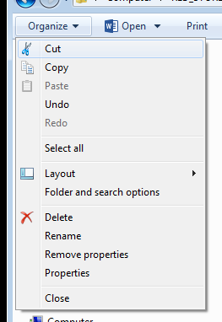

On the View tab, select Show hidden files, folders, and drives

Un-check Hide extensions for known file types

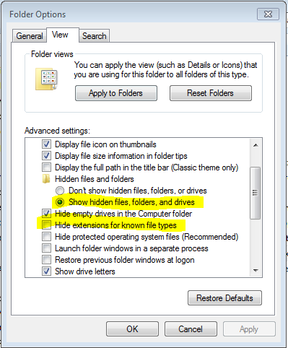

**2 – Download and install Git.**

Go to <https://git-scm.com/> and download the version appropriate for your operating system.



While you are there you can take a look at the Documentation if you want to.

**2.1 Install Git on your system. For now the default install setting should work.**

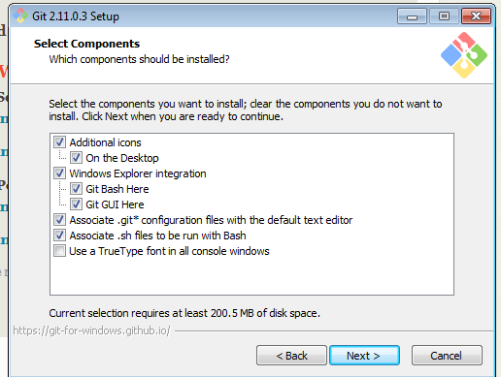 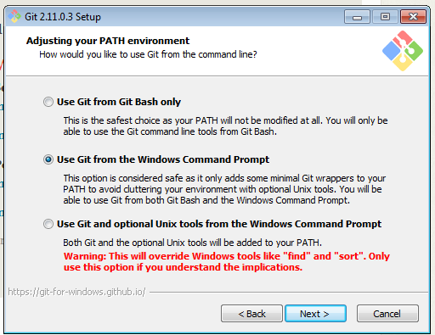

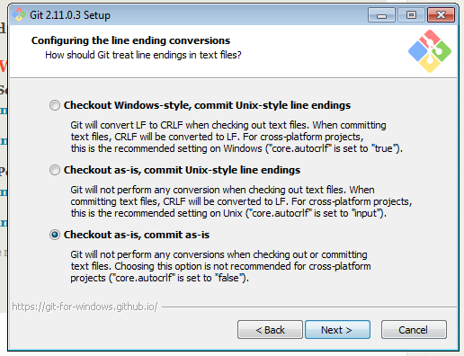 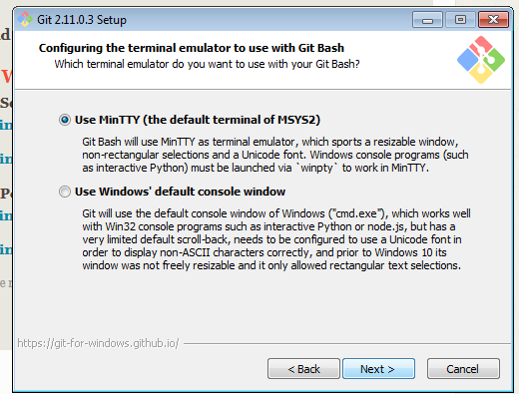

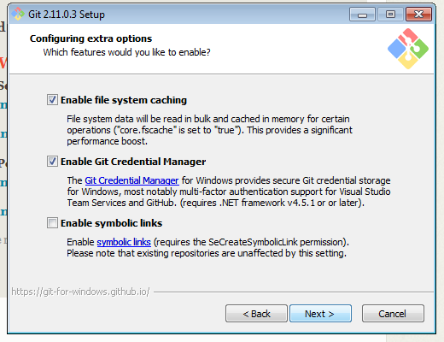 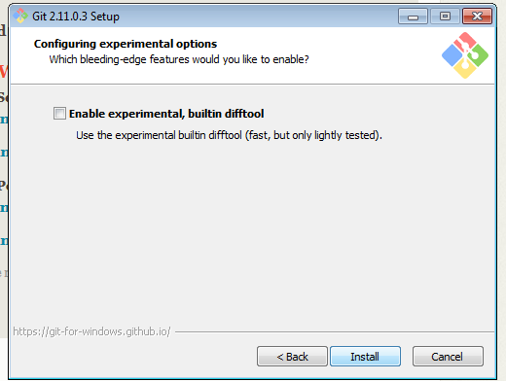

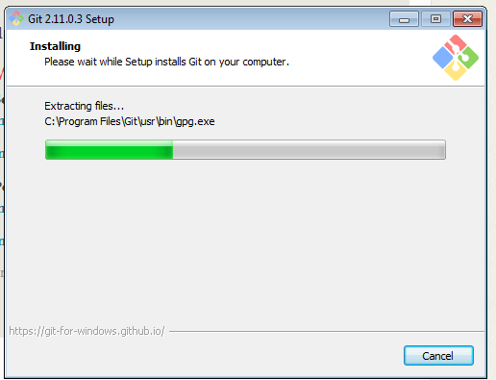 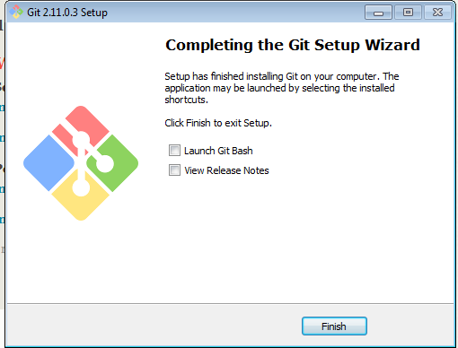

Check that it is installed and working:

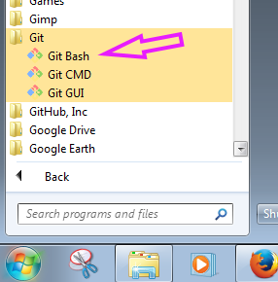

For now you will be using GitBash.

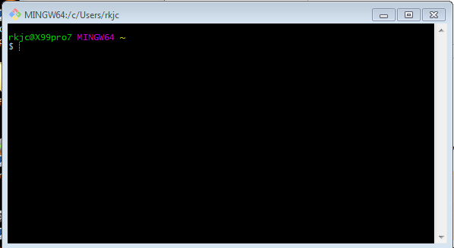

If you are on Mac or Linux after installing Git you will open a command line window and type in:

Git --version

If Git is installed and working you will get a response that looks similar to this:



**3. Build a practice Repository**

Make an empty folder in your file system somewhere that you can easily find it. It is highly recommended that until you get more familiar with the process that you make it in your root drive and that none of the file or folder names in the path contain spaces.

Generally if you start a folder name with an underscore it will be sorted to near the top of the list.

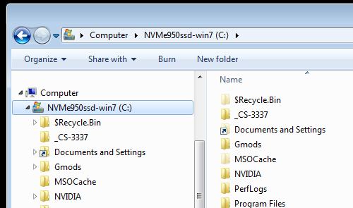

In this example my C: drive is named “NVMe950ssd-win7” and I have named the folder that I am going to use as my practice git repository “_CS-3337”

Open git bash and navigate into this folder with the command:

cd /c/_CS-3337

To set this folder up as a git repository you will need to “initialize” it.

git init

The contents of the _CS-3337 folder should no look like this:

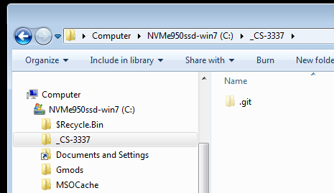

And Git Bash:

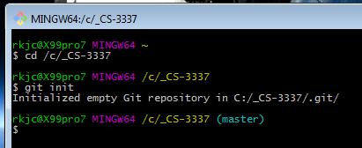

**4 – Additional reference material**

Here is a list of the git commands that will be covered during the Introduction to git lecture.

init

status

log

add

commit

checkout

branch

merge

