**Food Recipe Mobile Application Using Flutter**

Mobile Application Development Project Report

by

**Naneeta Talreja**

Sukkur IBA University  
Computer Science Department

(2022)

**Contents**

**1.0** **Introduction:** 3

**2.0 Aims and Objectives:** 3

**3.0 Problem Statement:** 3

**4.0 Proposed Methodology:** 3

**5.0 Major Outcomes:** 4

**6.0 Conclusion:** 5

# **Introduction:**

Food comes in a wide variety, so many different categories, classes and species are present in market. Its wide variety is the only reason that we enjoy different cuisines and food every day. Just a single ingredient changes the taste completely. The food industry is developing every day. Each and every day is giving birth to different items that bring a different taste to every recipe. Every culture has a different list of delicious recipes and different cooking method. A Punjabi culture has different variety of chatpata and spicy recipes. Chinese and Italian have their own different variety of food recipes and Indian culture is full of delicious recipes. However, these foods a person can only enjoy while visiting particular places.

However, there are many platforms like web applications where one can find different food recipes of particular culture like Indian, Italian, Chinese etc. but there is not any platform where one can easily get recipes of different cultures on a single page. This mobile application is developed using an API provided on a website where different culture’s recipes and list of ingredients and link of recipe video is also provided. This application will provide ease to users while looking for their favorite recipes and they can enjoy their favorite recipes at home just on a single click

# **2.0 Aims and Objectives:**

Following were the objectives of the proposed project:

1. To develop a platform independent mobile application for food recipes.

2. To reduce the time and efforts needed for searching for desired recipes by providing different culture recipes on single platform.

3. To eliminate the need of 3rd perform for enjoying different cuisine.

4. No need to visit places and restaurants to enjoy different culture’s recipes.

# **3.0 Problem Statement:**

There have been many different web applications where one can easily look for their favorite recipes but there is not a single platform like mobile application where one can easily look for different culture recipes on a single click.

# **4.0 Proposed Methodology:**

For the implementation of this project, at very first I made computer ready for flutter application. Then I developed the user interface using some of the material files in dart. Then next part was understanding API to use it in project. The API has about 2.3 million English recipes and 500+ top web recipe sources and also tells the number of calories that comes with each recipe. For every recipe its web url and total number of ingredients, quantity and its recipe are provided in the API and many more information. Next task was to connect the API with my application and it was possible through app key provided on the API website. Now the search component provided on the top of website look for related recipes using text provided in the text field.

# **5.0 Major Outcomes:**

After the completion of this project, we have a platform independent mobile application that uses search recipe API to look for your favorite recipe. It will provide ease to users in finding their desired recipe from different cultures and can enjoy tasty foods at home.

The user interface of the application is like this:

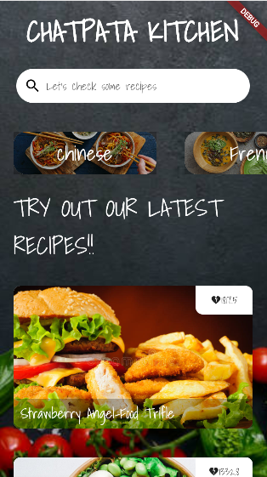

Method 1: It shows category wise list, like Chinese, Indian in horizontal scroll view etc

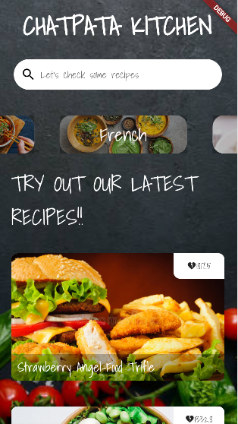

Method 2: You can look for your desired recipe using search component.

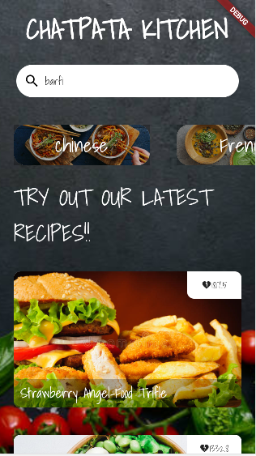

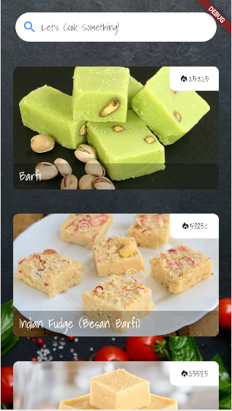

# **6.0 Conclusion:**

This project mainly looks for the related recipes based on the input text in search bar. The API has about 2.3 million recipes from different culture and have different king of methodology. This application will not only provide ease in looking for your favorite recipe but also reduces time efforts that are needed when looking for your recipes on any other platform.