

Proposal on a modern daily use item Renting Mobile Application

Naneeta Talreja, Sunaina Kukreja, Danish Hafeez



January 23, 2022

Department of computer science

Sukkur IBA University

Contents

**Abstract 2**

**1.0 Introduction 2**

**2.0 Literature Review 3**

**3.0 Problem Definition: 4**

**4.0 Project Aims and Objectives 4**

**5.0 Proposed Methodology: 4**

**6.0 Proposed Application architecture 5**

**6.1 Presentation tier: 5**

**6.2 Business tier: 5**

**6.3 Data tier: 5**

**7.0 Expected Research Outcomes 6**

**8.0 Research significance: 6**

**9.0 Timeline 6**

**References: 7**

**A Daily use item Renting Mobile Application**

# Abstract

Mobile applications are making it easier for individuals to get variety of services at their hand on just a single click. However, a mobile application which enables individuals to give and take daily use items for rent is a great contribution to the community. It will provide a way to people to save money from buying daily use items which will be of not much use to them in near future, with this owner will get money for giving items on rent. Previously, some mobile applications have been developed to bring both lessee and lessor on single platform and all those applications are developed for single purpose like for renting cars and houses. To the best of our knowledge not such mobile application has been deployed in Pakistan where daily use items could be rent out. The objective of our application is to help the people of Sukkur IBA University with financial instability as some will earn money by lending their idle items and others will save money by getting those things on rent that are needed for short span of time. The application will help people to monitor purchasing to make a compatible environment for both the lessor and lessee.

***Keywords****: Daily use item Renting Mobile Application, money-saving, earning-money, ecommerce*

# 1.0 Introduction

In this modern era of technology, almost everything is getting online, and every company is moving its business from offline to online because of its portability and effectiveness. The trend of getting business online is more and more in fashion these days as it has increased the progress and efficiency of overall process. Web based application were introduced to facilitate people in daily life routine and run businesses. Mobile applications are evolution to the world, as it has changed the way we work, it brought online services closer to the people so they can get their need fulfilled with a fingertip. A mobile application is a convenient feature for mobile and tablet users to get facilitated through content and services offered by the application. The services mobile application provide are in wide range and easily available to public. It charges some fee from users for its services, or it integrate advertisement to the application to earn money. Some applications do not charge a single penny from users. A large variety of different applications are available on play store where any mobile user can find and use any application and get their work done in minutes. With this increase in the use of internet, concept of buying and selling online got popular.

At first, social media was used to provide online shopping services to customer, but slowly and gradually all shopping brand moved to their own websites and today almost every brand has its own website and from grocery to readymade food, everything could be bought online. From the online buying and selling system, the idea of online renting came. Sometimes, a situation occurs where we need something expensive but only for short period of time, in this case lending that item can save money instead of buying it for actual price, and on the other side one can make its idle items an asset that brings money. Previously, many renting applications have been developed like [2], [4] in many countries that bring lessee and lessor on single platform and renting items has been easy but very few applications are developed yet that facilitate people to take daily use items on rent. Therefore, this project aims to develop a mobile application which users can use to look for things that they want to use for short period of time by paying some rent specified by owner. This application will work in Sukkur IBA University [6], so there will be no security issues or chance of any scam because users just have to login to this app using their credentials given by the University. This application will save money of students, staff, and faculty, and will solve the problem of many as student has to manage a lot of things along their expenditures.

# 2.0 Literature Review

In this part, we are intended to review the work which has been done to carry out similar projects in the field. We studied the existing applications such as:

1. **Rentable.PK**: Rental.pk is Pakistani website which offer individuals the chance to lease the material they don’t use, substantiating itself to be useless making it paying assets and customers can buy things that are needed just for short period of time. This website allows users to take any of the item on rent but the company don’t take of the responsibility for fraudulent deal. [1]
2. **Turo**: It is an American carsharing platform based in San Francisco, United states. This application allows car owners to rent-out their cars and needy one uses it by paying money specified by owner. This application was created to facilitates tourists and also allows users to track their cars so that they have complete knowledge of their asset. [2]
3. **Rentmycar**: Rentmycar.pk is a website which allows users to hire a car on rent from owners in the same manner one can rent out one’s car and can earn money. It has been operated in Karachi and Islamabad.[3]
4. **Style Lend**: This application is based in New York where owners can rent out their fashion related stuffs, like clothes, jewelry and person who want to use it just for one event can own it for few days by paying some charges specified by owner.[4]
5. **Fat Llama**: An application where you can rent out any daily use item. From fashion stuff to sports equipment, everything can be listed there. This application is based in UK and New York. This application takes the responsibility of fraudulent deal by providing insurance policy. [5]

All the mentioned mobile applications are rental apps which are facilitating both the Lessor and Lessee. One saves money by using a thing on rent instead of buying it for the actual price and on the other side one converts its idle and unused things such as car, clothes, sport equipment into an asset and earns money by renting them out. For the security purpose all these applications ask user to submit its identification documents and account details which are verified. Apps like Turo [2] and rentmycar [3] allow to lend and borrow cars only and permits the owner to track the vehicle and know the location of its car. Moreover, all these applications like Style Lend [4] have online transaction functionality as soon as a person lend something the specified amount by owner will be deducted from the account of customer. For protecting the stuff from getting damage some apps like Fat Llama [5] is providing the insurance policy too.

The proposed project is not so different from above mentioned mobile applications. People will easily lend and rent using this mobile application as, our application aims to bring lessee and lessor on single platform and make the renting and lending process easier.

|  |  |  |  |  |  |
| --- | --- | --- | --- | --- | --- |
| Features | Rentable [1] | Turo [2] | Rentmycar [3] | Insurance [4] | Tracking [5] |
| Search by category | Yes | Yes | Yes | No | No |
| Lend | Yes | Yes | Yes | Yes | Yes |
| Rent | Yes | Yes | Yes | Yes | Yes |
| Insurance | Yes | Yes | Yes | No | No |
| Tracking | Yes | Yes | Yes | Yes | No |

Table features comparison of existing rental applications

# 3.0 Problem Definition:

In the literature, we studied some of the websites and mobile applications which allow users to put their idle things on rent like car, house, and other daily use stuffs and on the other hand one can lend things at lower price, that are seldom needed. There are many applications which provide a platform to users to give and take items on rent online in different regions of world. In Pakistan rentable [1], is a website used for renting daily use items. However, to the best of our knowledge there is no such mobile application working in any region of Pakistan to facilitate people regarding renting there unused and idle items. Therefore, the application for renting daily use items is proposed in this paper.

# 4.0 Project Aims and Objectives

This paper has the following objectives to cover in the research:

Objectives:

1. To investigate the existing rental applications.
2. To reduce the expense by leasing instead of buying.
3. To earn money by sharing things.

Aims:

1. To make lending and renting process easier.
2. To connect lessee with lessor.

5.0 Proposed Methodology

For the proposed Project, the project management methodology that we would like to prefer is Agile Methodology, as it is a process in which implementation is carried out in phases, as shown in Figure 1 which are iterative and incremental. In agile methodology, a strong communication and coordination is needed between team and project stakeholders because after every iteration, customer is asked for feedback and team make changes accordingly with this every iteration has a testing phase in which all new added features are tested then team moves to next iteration. Agile methodology focuses more on development than documentation and is mainly used for smaller projects, this is the reason for preferring agile methodology for proposed project.

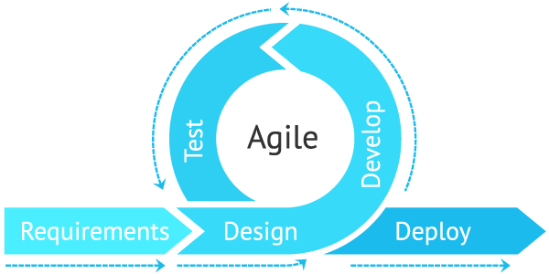

Figure 1:Methodology flow chart

# 6.0 Proposed Application architecture

Proposed mobile application will be comprised of 3 tiers as shown in Figure 2:

## 6.1 Presentation tier:

Presentation tier is the interface which is used to collect the required information from user, show the details to user and pass it to the next tier which is business tier. The proposed mobile application will be developed using react native because it allows us to develop native applications and the programming languages that will be used are JavaScript, with this it allows us to create some of the modules in other languages like java, swift and C. Most importantly it is cross-programming mobile app development tool so it can convert source code into native elements in less time.

## 6.2 Business tier:

The business tier is where data is processed collected from presentation tier and that processing usually depend on the business logic, set of rules, and can depend on the already existing data in data tier. The programming languages that we will use for the data processing are java, JavaScript and swift.

## 6.3 Data tier:

The data tier, which is called back-end too is, where processed data is collected from business tier and stored and managed. That could be any relational database like MySQL and Oracle and MongoDB. To Manage the data of proposed application we will used Oracle, relational database because it provides efficient way to access structured data.

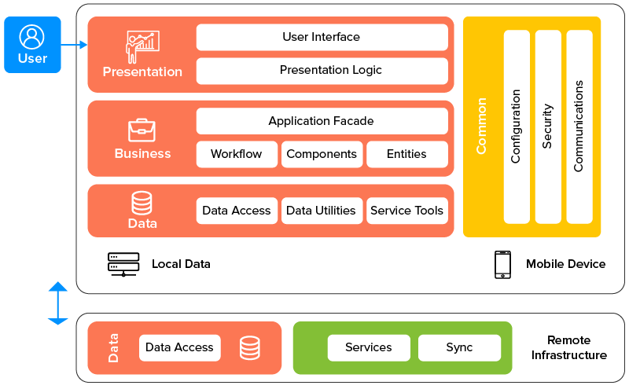

Figure Application Architecture

# 7.0 Expected Research Outcomes

After completing the project, we will have a fully functional mobile application for renting daily use item. This application will enable individuals to share their items like books, clothes, and other material and get paid by the one who needs that item. Similarly, the one who is taking for rent will save the money from buying new items.

# 8.0 Research significance

The proposed mobile application will give highlights of better the board, observing, and upkeep of the items and leasing process. It will facilitate the whole buying process and bring down the expense expected to utilize an item by leasing it.

# 9.0 Timeline

The proposed timeline for this project is shown below in Table 1.

|  |  |  |  |  |  |  |  |  |  |  |  |  |
| --- | --- | --- | --- | --- | --- | --- | --- | --- | --- | --- | --- | --- |
| Task | Dec | Jan | Feb | Mar | Apr | May | June | July | Aug | Sep | Oct | Nov |
| Literature review |  |  |  |  |  |  |  |  |  |  |  |  |
| Problem identification |  |  |  |  |  |  |  |  |  |  |  |  |
| System requirements |  |  |  |  |  |  |  |  |  |  |  |  |
| System design |  |  |  |  |  |  |  |  |  |  |  |  |
| System development |  |  |  |  |  |  |  |  |  |  |  |  |
| System Testing |  |  |  |  |  |  |  |  |  |  |  |  |

Table 2 Research timeline

# References:

1. <https://en.dailypakistan.com.pk/24-Apr-2020/introducing-rentable-pakistan-s-first-ever-online-renting-service>
2. <https://en.wikipedia.org/wiki/Turo_(company)>

1. <https://rentmycar.pk>

1. [https://rocketreach.co/style-lend-profile_b5ffe4](https://rocketreach.co/style-lend-profile_b5ffe42af6d2bac1)[2af6d2bac1](https://rocketreach.co/style-lend-profile_b5ffe42af6d2bac1)
2. <https://techround.co.uk/startups/startup-profile-fat-llama/#:~:text=Fat%20Llama%20is%20a%20peer,UK%20and%20in%20New%20York>.
3. https://www.iba-suk.edu.pk/
4. Michael H.Anderson “Rent-to-own agreements: Customer characteristics and contract outcomes” in ISSN: Volume 61, Issue 1 EDM 2009
5. Nidhi Vishnoi Sharma, Varsha Khattri “Study of online shopping behavior and its impact on online deal websites” in ISSN 2229 – 3795 EDM 2016
6. Vidyashree DV, Neelam Bhandari, Richa Sharma, Pooja M Verma, Priya Chauhan “A Comparative study on consumer Preferences towards online retail marketer” in ISSN: 2394-5869 in EDM 2015
7. Swapnil V. Mishra & Dr. Shamkant N. Kotkar “A Study on Current Status of E-Commerce in India” in ISSN:232 7782 Volume 3,Issue 2 EDM 2015 Web
8. <https://stackoverflow.com/search?q=android+development>
9. https://www.olx.in/posting/
10. <https://azure.microsoft.com/en-in/>
11. https://rentmycar.pk/ (website)
12. https://www.zipcar.com/ (website)
13. https://www.zoomcar.com/ (website)
14. https://www.getaround.com/ (website)
15. https://turo.com/ (website)
16. https://buildfire.com/mobile-app-development-tools/#app-dev-tools-open-source