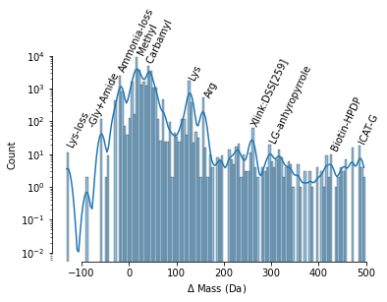

**Figure 2**: Histogram of observed mass changes due to PTMs observed across bacterial peptides. The data was gathered by finding the difference between the expected mass of a typical bacterial protein and its actual observed mass. The peaks in the histogram indicate the most common PTMs found across the data set and are annotated on the graph.