

Business Template

Healthcare clinic
Logo / Image

Contents
Business Description 3
1.1 the Benefits of implementing a database. Project Vision 3
2 Model description 3
2.1 Definitions & Acronyms 3
2.2 Logical Scheme 3
2.3 Objects 3

Business Description

the Benefits of implementing a database. Project Vision
The main purpose of my database is to organize the clinic's information in one place. It connects patients, doctors, appointments, medical records, and payments, so there is no need to store the same information multiple times.
The database will be used by receptionists, doctors, medical staff, and administrative employees. Receptionists can manage appointments, doctors can record visits and treatments, and administrative staff can handle schedules and payments. This will save time, reduce mistakes, and make daily work easier.
To keep the data correct, I used primary keys, foreign keys, and constraints. They help prevent duplicate records, missing information, and incorrect connections between tables.
I also added appointment_history and visit_history to keep track of changes. These tables store previous information, when it was changed, and which staff member made the change.
The database is flexible because new patients, appointments, treatments, and payments can be added without changing its structure. New features can also be added later if needed.
Finally, I used checks to make sure appointment end times are later than start times, payment amounts are positive, and diagnosis codes are unique. Some additional rules, like avoiding overlapping appointments, would require extra validation.

Model description

Definitions & Acronyms
The following definitions clarify recurring terms and business concepts used in the logical model:
- Patient: person registered for care.
- Staff: clinic employee, including doctors.
- Appointment: planned consultation.
- Visit: actual consultation, recorded separately because cancelled or missed appointments need not create visits.
- Diagnosis catalog: reusable diagnosis definition.
- Prescription: medication ordered during a visit, with dosage instructions.
- History entry: saved prior state or amendment for traceability.
- Invoice: bill for a visit.
- Payment: individual transaction against an invoice.

Logical Scheme

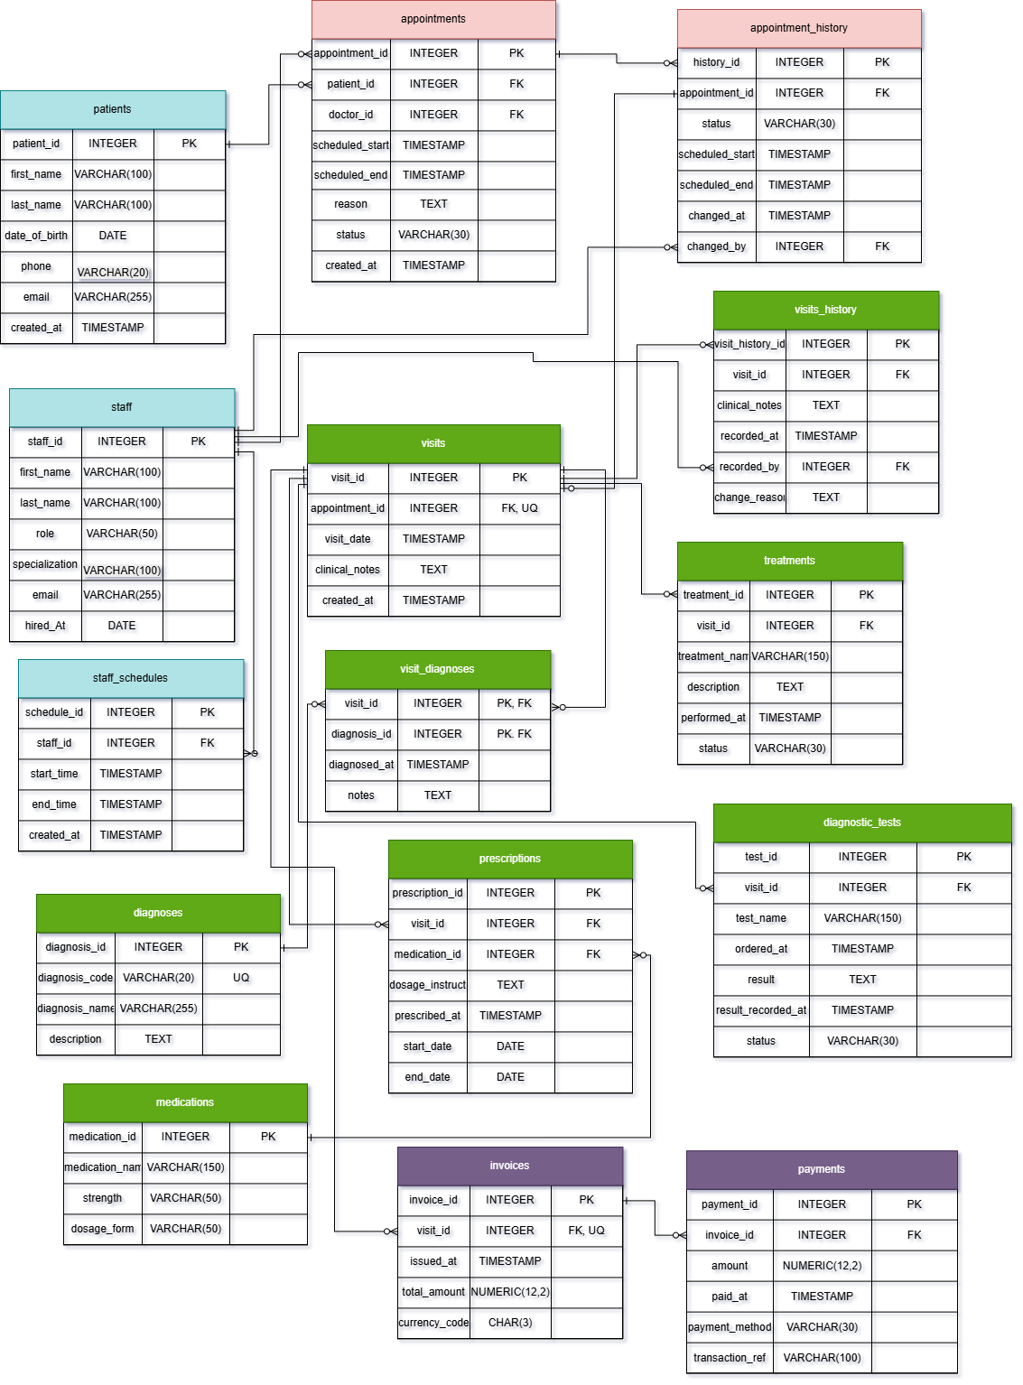
Relationships (parent PK → child FK; cardinality):
patients.patient_id → appointments.patient_id (1:0..N)
staff.staff_id → staff_schedules.staff_id (1:0..N)
staff.staff_id → appointments.doctor_id (1:0..N)
appointments.appointment_id → appointment_history.appointment_id (1:0..N)
staff.staff_id → appointment_history.changed_by (1:0..N)
appointments.appointment_id → visits.appointment_id (1:0..1)
visits.visit_id → visit_history.visit_id (1:0..N)
staff.staff_id → visit_history.recorded_by (1:0..N)
visits.visit_id → visit_diagnoses.visit_id (1:0..N)
diagnoses.diagnosis_id → visit_diagnoses.diagnosis_id (1:0..N)
visits.visit_id → treatments.visit_id (1:0..N)
visits.visit_id → prescriptions.visit_id (1:0..N)
medications.medication_id → prescriptions.medication_id (1:0..N)
visits.visit_id → diagnostic_tests.visit_id (1:0..N)
visits.visit_id → invoices.visit_id (1:0..1)
invoices.invoice_id → payments.invoice_id (1:0..N)

This ER diagram includes 15 tables, 16 FK relationships and the many-to-many association between visits and diagnoses through visit_diagnoses.
The most challenging decision was separating appointments from actual visits while considering historical changes. A cancelled appointment must not produce a medical visit. UNIQUE(visits.appointment_id) enforces at most one visit for an appointment and the history tables preserve revisions.
About anomalies
- Update anomaly: storing patient phone numbers in appointments would require repeated edits; patients holds the number once.
- Insertion anomaly: medication definitions can exist before any prescription because medications is independent.
- Partial dependency: diagnosis names are stored in diagnoses, not visit_diagnoses. PK/FK/UNIQUE/CHECK constraints reinforce these separations.
If you were to add new attributes or participants, would the model remain scalable and why?
Yes. New appointments, visits, treatments and payments are new rows rather than new columns. New catalogs, participants or processes can be added as related entities without major redesign of existing tables.
Which part of your model would most likely change if requirements expand?
Billing would likely expand first: invoice_items may be needed for individual services, prices and discounts. Multiple branches, insurance claims and role-based access control would also require additional entities.

Objects
Each of the 15 objects is documented below using the original template’s field-description and example-data tables. All examples are illustrative, not real medical records.
- Each table represents one concept or event: patient, staff member, schedule entry, appointment, appointment change, visit, visit revision, diagnosis, visit-diagnosis association, treatment, medication, prescription, test, invoice or payment.
- Separating these concepts avoids repeated groups and permits one-to-many relationships. For example, one visit can have many tests and prescriptions, and one invoice can have several payments.
- All tables are designed for 3NF: fields are atomic (1NF) and non-key fields depend on complete keys (2NF) and descriptive information about patients, staff, medications and diagnoses stays in its own table instead of depending transitively on other attributes (3NF).
- The composite key (visit_id, diagnosis_id) in visit_diagnoses uniquely identifies an association; diagnosed_at and notes describe that whole association. Diagnosis names depend on diagnosis_id and are therefore kept in diagnoses. Surrogate-key tables have no partial-key dependencies.
- Surrogate INTEGER primary keys give identities in 14 tables. visit_diagnoses instead uses a meaningful composite primary key to prevent duplicate visit-diagnosis pairs. Foreign keys connect each child record to its parent; UNIQUE on visits.appointment_id and invoices.visit_id limits those relationships to at most one child.

1. patients — A person registered for care. Separate demographic data prevents repeated names and contact information in appointments.
Normalization and keys: 3NF.
Single surrogate PK; all descriptive attributes depend on patient_id, without partial or transitive dependencies.
Fields depend on the table key, without partial or transitive dependencies.

Table Name | Field name | Field Description | Data Type
patients | patient_id | PK; PK | INTEGER
patients | first_name | NOT NULL; attribute | VARCHAR(100)
patients | last_name | NOT NULL; attribute | VARCHAR(100)
patients | date_of_birth | NOT NULL; attribute | DATE
patients | phone | optional; attribute | VARCHAR(20)
patients | email | optional; attribute | VARCHAR(255)
patients | created_at | NOT NULL, DEFAULT CURRENT_TIMESTAMP; attribute | TIMESTAMP

Example with data (2 rows):

patient_id | first_name | last_name | date_of_birth
101 | Anna | Smith | 1998-03-14
102 | David | Lee | 1985-08-21

2. staff — A clinic employee, including doctors and nurses. Centralizes roles and contact details reused by appointments, schedules and change histories.
Normalization and keys: 3NF.
Single surrogate PK; role and specialization describe the employee; doctor eligibility is checked separately.
Fields depend on the table key, without partial or transitive dependencies.

Table Name | Field name | Field Description | Data Type
staff | staff_id | PK; PK | INTEGER
staff | first_name | NOT NULL; attribute | VARCHAR(100)
staff | last_name | NOT NULL; attribute | VARCHAR(100)
staff | role | NOT NULL; attribute | VARCHAR(50)
staff | specialization | optional; attribute | VARCHAR(100)
staff | email | UNIQUE; attribute | VARCHAR(255)
staff | hired_at | NOT NULL; attribute | DATE
Example with data (2 rows):

staff_id | first_name | role | specialization
10 | Mariam | doctor | Cardiology
11 | Aram | nurse | General

3. staff_schedules — A defined staff working period. Allows multiple schedule entries per employee without repeating staff information.
Normalization and keys: 3NF.
Single surrogate PK; staff_id FK; time order enforced by CHECK(end_time > start_time).
Fields depend on the table key, without partial or transitive dependencies.

Table Name | Field name | Field Description | Data Type
staff_schedule | schedule_id | PK; PK | INTEGER
staff_schedule | staff_id | FK, NOT NULL; FK | INTEGER
staff_schedule | start_time | NOT NULL; attribute | TIMESTAMP
staff_schedule | end_time | NOT NULL; attribute | TIMESTAMP
staff_schedule | created_at | NOT NULL, DEFAULT CURRENT_TIMESTAMP; attribute | TIMESTAMP
Example with data (2 rows):

schedule_id | staff_id | start_time | end_time
1 | 10 | 2026-10-26 09:00 | 2026-10-26 17:00
2 | 11 | 2026-10-26 10:00 | 2026-10-26 18:00

4. appointments — A scheduled patient-doctor consultation. Separates future bookings from actual medical visits and stores the current booking state.
Normalization and keys: 3NF.
Surrogate PK; patient_id and doctor_id FKs; CHECK end > start and controlled status values.
Fields depend on the table key, without partial or transitive dependencies.

Table Name | Field name | Field Description | Data Type
appointments | appointment_id | PK; PK | INTEGER
appointments | patient_id | FK, NOT NULL; FK | INTEGER
appointments | doctor_id | FK, NOT NULL; FK | INTEGER
appointments | scheduled_start | NOT NULL; attribute | TIMESTAMP
appointments | scheduled_end | NOT NULL; attribute | TIMESTAMP
appointments | reason | optional; attribute | TEXT
appointments | status | NOT NULL, CHECK allowed values; attribute | VARCHAR(30)
appointments | created_at | NOT NULL, DEFAULT CURRENT_TIMESTAMP; attribute | TIMESTAMP
Example with data (2 rows):

appointment_id | patient_id | doctor_id | status
201 | 101 | 10 | completed
202 | 102 | 10 | scheduled

5. appointment_history — A recorded state or change of an appointment. Retains scheduling and status snapshots without overwriting history.
Normalization and keys: 3NF.
Surrogate PK; appointment_id and changed_by FKs; snapshots depend on history_id, not on appointment attributes.
Fields depend on the table key, without partial or transitive dependencies.

Table Name | Field name | Field Description | Data Type
Appointment_history | history_id | PK; PK | INTEGER
Appointment_history | appointment_id | FK, NOT NULL; FK | INTEGER
Appointment_history | status | NOT NULL, CHECK allowed values; attribute | VARCHAR(30)
Appointment_history | scheduled_start | NOT NULL; attribute | TIMESTAMP
Appointment_history | scheduled_end | NOT NULL; attribute | TIMESTAMP
Appointment_history | changed_at | NOT NULL, DEFAULT CURRENT_TIMESTAMP; attribute | TIMESTAMP
Appointment_history | changed_by | FK, NOT NULL; FK | INTEGER
Example with data (2 rows):

history_id | appointment_id | status | changed_by
1 | 201 | scheduled | 10
2 | 201 | completed | 10

6. visits — An actual patient consultation. Not every scheduled appointment becomes a visit; clinical records remain separate from booking.
Normalization and keys: 3NF.
Surrogate PK; appointment_id FK + UNIQUE enforces at most one visit per appointment.
Fields depend on the table key, without partial or transitive dependencies.

Table Name | Field name | Field Description | Data Type
visits | visit_id | PK; PK | INTEGER
visits | appointment_id | FK, UNIQUE, NOT NULL; FK | INTEGER
visits | visit_date | NOT NULL; attribute | TIMESTAMP
visits | clinical_notes | optional; attribute | TEXT
visits | created_at | NOT NULL, DEFAULT CURRENT_TIMESTAMP; attribute | TIMESTAMP
Example with data (2 rows):

visit_id | appointment_id | visit_date | clinical_notes
301 | 201 | 2026-10-25 10:00 | Routine consultation
302 | 203 | 2026-10-25 11:00 | Follow-up

7. visit_history — A historical clinical-note snapshot. Preserves earlier notes, who recorded them, and why they changed.
Normalization and keys: 3NF.
Surrogate PK; visit_id and recorded_by FKs; each historical snapshot depends on visit_history_id.
Fields depend on the table key, without partial or transitive dependencies.

Table Name | Field name | Field Description | Data Type
Visit_history | visit_history_id | PK; PK | INTEGER
Visit_history | visit_id | FK, NOT NULL; FK | INTEGER
Visit_history | clinical_notes | optional; attribute | TEXT
Visit_history | recorded_at | NOT NULL, DEFAULT CURRENT_TIMESTAMP; attribute | TIMESTAMP
Visit_history | recorded_by | FK, NOT NULL; FK | INTEGER
Visit_history | change_reason | NOT NULL; attribute | TEXT
Example with data (2 rows):

visit_history_id | visit_id | recorded_by | change_reason
1 | 301 | 10 | Initial clinical notes recorded
2 | 301 | 10 | Clarified clinical notes

8. diagnoses — A reusable clinical diagnosis definition. Avoids duplicating diagnosis names and descriptions for every visit.
Normalization and keys: 3NF.
Surrogate PK; diagnosis_code is a separate unique business identifier; no non-key dependencies.
Fields depend on the table key, without partial or transitive dependencies.

Table Name | Field name | Field Description | Data Type
diagnoses | diagnosis_id | PK; PK | INTEGER
diagnoses | diagnosis_code | UNIQUE, NOT NULL; attribute | VARCHAR(20)
diagnoses | diagnosis_name | NOT NULL; attribute | VARCHAR(255)
diagnoses | description | optional; attribute | TEXT
Example with data (2 rows):

diagnosis_id | diagnosis_code | diagnosis_name
1 | I10 | Hypertension
2 | J11 | Influenza

9. visit_diagnoses — The assignment of a diagnosis to a specific visit. Junction table resolves the M:N relationship between visits and diagnoses.
Normalization and keys: 3NF.
Composite PK (visit_id, diagnosis_id); diagnosed_at and notes describe the whole association, not diagnosis alone.
Fields depend on the table key, without partial or transitive dependencies.

Table Name | Field name | Field Description | Data Type
Visit_diagnoses | visit_id | PK, FK; PK | INTEGER
Visit_diagnoses | diagnosis_id | PK, FK; PK | INTEGER
Visit_diagnoses | diagnosed_at | NOT NULL, DEFAULT CURRENT_TIMESTAMP; attribute | TIMESTAMP
Visit_diagnoses | notes | optional; attribute | TEXT
Example with data (2 rows):

visit_id | diagnosis_id | diagnosed_at
301 | 1 | 2026-10-25 10:10
302 | 2 | 2026-10-25 11:10

10. treatments — A medical treatment planned or performed during a visit. One visit can have multiple treatments; no repeating treatment columns are needed.
Normalization and keys: 3NF.
Surrogate PK and visit_id FK; CHECK controlled status and require performed_at if completed.
Fields depend on the table key, without partial or transitive dependencies.

Table Name | Field name | Field Description | Data Type
treatments | treatment_id | PK; PK | INTEGER
treatments | visit_id | FK, NOT NULL; FK | INTEGER
treatments | treatment_name | NOT NULL; attribute | VARCHAR(150)
treatments | description | optional; attribute | TEXT
treatments | performed_at | nullable; attribute | TIMESTAMP
treatments | status | NOT NULL, CHECK allowed values; attribute | VARCHAR(30)
Example with data (2 rows):

treatment_id | visit_id | treatment_name | status
1 | 301 | Wound cleaning | completed
2 | 302 | Physiotherapy | planned

11. medications — A reusable medication catalog entry. Stores medication identity separately from prescription-specific dosage instructions.
Normalization and keys: 3NF. Surrogate PK; name, strength and form describe medication_id;
no partial/transitive dependencies.
Fields depend on the table key, without partial or transitive dependencies.

Table Name | Field name | Field Description | Data Type
medications | medication_id | PK; PK | INTEGER
medications | medication_name | NOT NULL; attribute | VARCHAR(150)
medications | strength | optional; attribute | VARCHAR(50)
medications | dosage_form | optional; attribute | VARCHAR(50)
Example with data (2 rows):

medication_id | medication_name | strength | dosage_form
1 | Paracetamol | 500 mg | tablet
2 | Ibuprofen | 200 mg | tablet

12. prescriptions — A medication prescribed during a visit. Stores the association and dosage instructions independently from the medication catalog.
Normalization and keys: 3NF.
Surrogate PK; visit_id and medication_id FKs; date range CHECK end_date >= start_date.
Fields depend on the table key, without partial or transitive dependencies.

Table Name | Field name | Field Description | Data Type
prescriptions | prescription_id | PK; PK | INTEGER
prescriptions | visit_id | FK, NOT NULL; FK | INTEGER
prescriptions | medication_id | FK, NOT NULL; FK | INTEGER
prescriptions | dosage_instructions | NOT NULL; attribute | TEXT
prescriptions | prescribed_at | NOT NULL, DEFAULT CURRENT_TIMESTAMP; attribute | TIMESTAMP
prescriptions | start_date | optional; attribute | DATE
prescriptions | end_date | optional; attribute | DATE
Example with data (2 rows):

prescription_id | visit_id | medication_id | dosage_instructions
1 | 301 | 1 | One tablet every 6 hours
2 | 302 | 2 | One tablet twice daily

13. diagnostic_tests — A test ordered as part of a visit and its latest result. Allows many tests per visit, with results populated after ordering.
Normalization and keys: 3NF.
Surrogate PK; visit_id FK; CHECK status values and result_recorded_at >= ordered_at.
Fields depend on the table key, without partial or transitive dependencies.

Table Name | Field name | Field Description | Data Type
diagnostic_tests | test_id | PK; PK | INTEGER
diagnostic_tests | visit_id | FK, NOT NULL; FK | INTEGER
diagnostic_tests | test_name | NOT NULL; attribute | VARCHAR(150)
diagnostic_tests | ordered_at | NOT NULL, DEFAULT CURRENT_TIMESTAMP; attribute | TIMESTAMP
diagnostic_tests | result | optional; attribute | TEXT
diagnostic_tests | result_recorded_at | optional; attribute | TIMESTAMP
diagnostic_tests | status | NOT NULL, CHECK allowed values; attribute | VARCHAR(30)
Example with data (2 rows):

test_id | visit_id | test_name | status
1 | 301 | Complete blood count | completed
2 | 302 | Chest X-ray | ordered

14. invoices — A bill for a medical visit. Keeps financial charges separate from clinical details and payment transactions.
Normalization and keys: 3NF. Surrogate PK; visit_id FK + UNIQUE enforces at most one invoice per visit; total_amount >= 0. Fields depend on the table key, without partial or transitive dependencies.

Table Name | Field name | Field Description | Data Type
invoices | invoice_id | PK; PK | INTEGER
invoices | visit_id | FK, UNIQUE, NOT NULL; FK | INTEGER
invoices | issued_at | NOT NULL, DEFAULT CURRENT_TIMESTAMP; attribute | TIMESTAMP
invoices | total_amount | NOT NULL, CHECK >= 0; attribute | NUMERIC(12,2)
invoices | currency_code | NOT NULL; attribute | CHAR(3)
Example with data (2 rows):

invoice_id | visit_id | total_amount | currency_code
401 | 301 | 15000.00 | AMD
402 | 302 | 25000.00 | AMD

15. payments — A single transaction toward an invoice. Supports installments and transaction traceability without repeating invoice information.
Normalization and keys: 3NF. Surrogate PK; invoice_id FK; amount > 0; optional UNIQUE transaction_reference. Fields depend on the table key, without partial or transitive dependencies.

Table Name | Field name | Field Description | Data Type
payments | payment_id | PK; PK | INTEGER
payments | invoice_id | FK, NOT NULL; FK | INTEGER
payments | amount | NOT NULL, CHECK > 0; attribute | NUMERIC(12,2)
payments | paid_at | NOT NULL, DEFAULT CURRENT_TIMESTAMP; attribute | TIMESTAMP
payments | payment_method | NOT NULL, CHECK allowed values; attribute | VARCHAR(30)
payments | transaction_reference | UNIQUE, optional; attribute | VARCHAR(100)
Example with data (2 rows):

payment_id | invoice_id | amount | payment_method
1 | 401 | 10000.00 | cash
2 | 401 | 5000.00 | card

