

2022/9/30

BGO

余庆祥

作业2--利用基本线段画森林

2220631136

2D游戏引擎应用与开发

刘生建

GC2014

1. **如何Phaser.js基本图元画线段？（10分）**

pen = this.add.graphics()

pen.lineStyle(2, 0xffffff, 1)

pen.beginPath()

pen.moveTo(50, 50)

pen.lineTo(100, 100)

pen.closePath()

pen.strokePath()



1. **利用递归画三叉树（30分）**

function get_angle(n) {

return n * Math.PI / 180

}

function drawTree(x_positon, y_positon, distance, init_angle, angle, deep) {

if(deep == 0) {

return

}

pen.lineTo(x_positon, y_positon)

distance *= 0.9

let x_positon_new = x_positon - Math.cos(get_angle(init_angle)) * distance

let y_positon_new = y_positon - Math.sin(get_angle(init_angle)) * distance

// pen.moveTo(x_positon, y_positon)

drawTree(x_positon_new, y_positon_new, distance, init_angle, angle, deep - 1)

pen.moveTo(x_positon, y_positon)

drawTree(x_positon_new, y_positon_new, distance, init_angle - angle, angle, deep - 1)

pen.moveTo(x_positon, y_positon)

drawTree(x_positon_new, y_positon_new, distance, init_angle + angle, angle, deep - 1)

}



1. **如何响应鼠标单击画多棵树（40分）**

function drawAll(x, y) {

pen.lineStyle(2, 0xffffff, 1)

pen.beginPath()

pen.moveTo(x, y)

drawTree(x, y, 70, Phaser.Math.RND.between(70, 110), 25, 8)

pen.closePath()

pen.strokePath()

}

this.input.on("pointerdown", (pointer) => {

drawAll(300, 400)

})

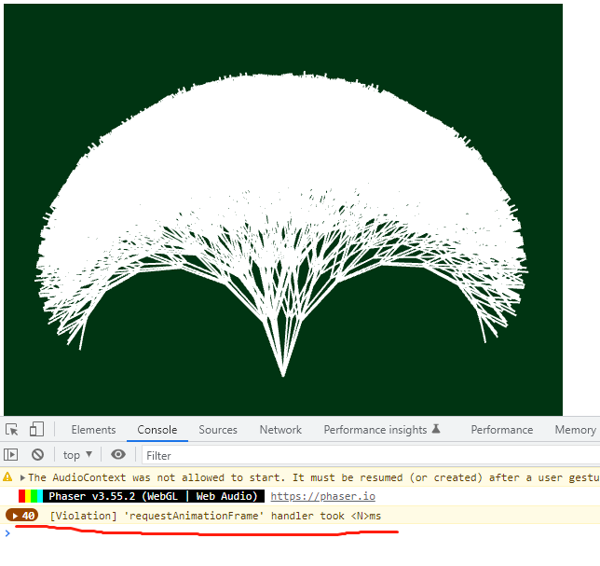

每次响应一次鼠标事件，都需要从头开始绘制，导致系统增加负担并增加绘制事件。

1. **如何利用纹理缩短绘制时间？（20分）**

//tip: graphics.generateTexture

function create ()

{

pen = this.add.graphics()

colors = [0xfe0000, 0xfda128, 0xfcff00, 0xade702, 0x00e1fd, 0x278dff, 0xb628fe, 0xfb28dc, 0x8424e1]

drawAll(300, 400)

pen.generateTexture('tree', 600, 600);

pen.destroy(true);

this.input.on("pointerdown", (pointer) => {

let tree = this.add.image(pointer.x, pointer.y, 'tree');

tree.setTint(Phaser.Math.RND.pick(colors));

tree.angle = Phaser.Math.RND.between(-20, 21);

})

}

