实验手册7：kafka集群搭建

实验环境
linux虚拟机
jdk1.8+
zookeeper3.x
kafka2.x

实验目的
1.kafka环境搭建
2.kafka生产者消费者模型展示

实验步骤

1.下载解压软件
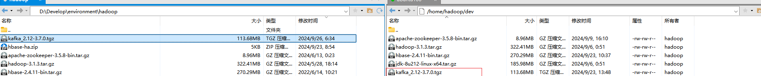

2.修改配置文件

2.1 添加环境变量.bashrc
# 进入环境变量文件
vim ~/.bashrc
# 添加如下设置
export KAFKA_HOME="/usr/local/develop/kafka_2.12-3.7.0"
export PATH=${KAFKA_HOME}/bin:$PATH
# 加载环境变量
source ~/.bashrc

2.2修改kafka配置信息 server.properties
#broker的全局唯一编号，不能重复，只能是数字。每个节点唯一，不能重复
broker.id=1
#修改为当前节点的ip
listeners = PLAINTEXT://hadoop100:9092
#运行日志存放的路径，不需提前创建，kafka会自动创建
log.dirs=/usr/local/develop/kafka_2.12-3.7.0/logs
#连接zookeeper集群地址
zookeeper.connect=hadoop100:2181,hadoop101:2181,hadoop102:2181

2.3分发到其他主机节点

修改其他主机节点的配置【id和节点名称】
#broker的全局唯一编号，不能重复，只能是数字。每个节点唯一，不能重复
broker.id=1
#修改为当前节点的ip
listeners = PLAINTEXT://hadoop100:9092

3.启动服务

在三个节点执行
/usr/local/develop/kafka_2.12-3.7.0/bin/kafka-server-start.sh /usr/local/develop/kafka_2.12-3.7.0/config/server.properties &

查看任务进程
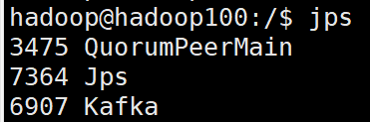

4.生产者消费者模型演示

4.1创建主题
/usr/local/develop/kafka_2.12-3.7.0/bin/kafka-topics.sh --create --topic Mytopic_test --partitions 1 --replication-factor 1 --bootstrap-server hadoop100:9092,hadoop101:9092,hadoop102:9092

4.2启动消费者 【新开一个窗口：程序运行之后在控制台显示消费的数据】
kafka-console-consumer.sh 控制台的消费者服务
/usr/local/develop/kafka_2.12-3.7.0/bin/kafka-console-consumer.sh --topic test --from-beginning --bootstrap-server hadoop100:9092,hadoop101:9092,hadoop102:9092

4.3启动生产者
kafka-console-producer.sh 控制台的生产者服务
/usr/local/develop/kafka_2.12-3.7.0/bin/kafka-console-producer.sh --topic test --bootstrap-server hadoop100:9092,hadoop101:9092,hadoop102:9092
生产者每发送一个数据，对应消费者可以接收对应数据
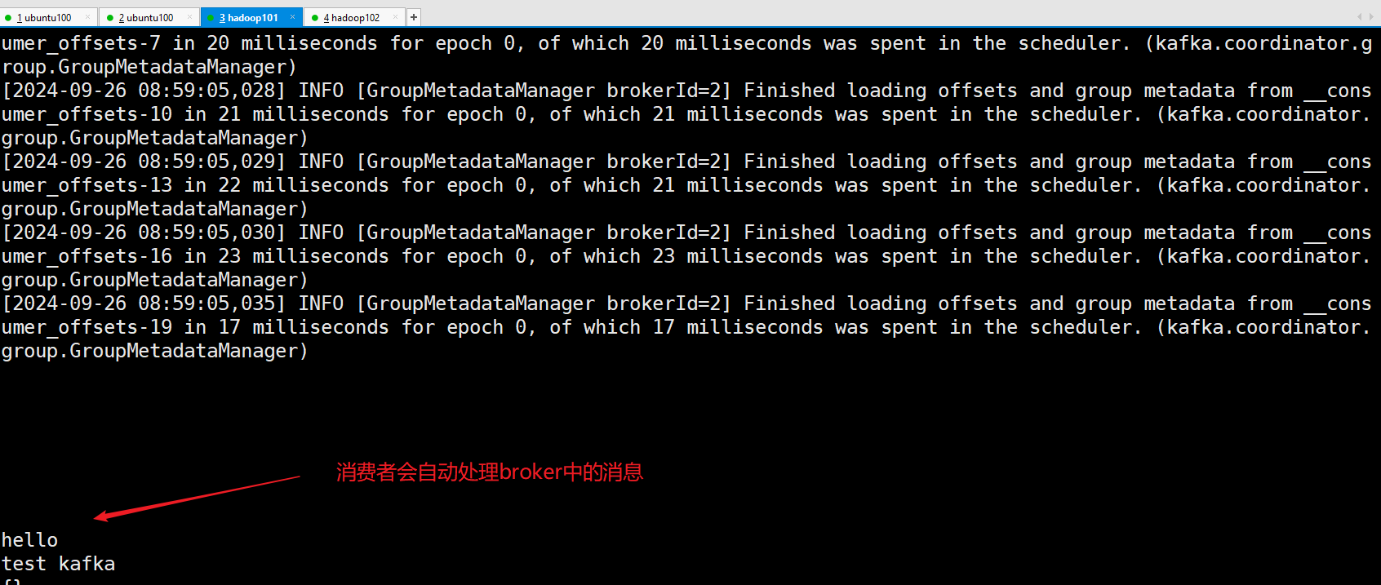

5.测试kafka常用指令
#创建topic，1分区，1副本，topic名字 Mytopic_test
[root@hadoop102 ~]# kafka-topics.sh --create --topic Mytopic_test --partitions 1 --replication-factor 1 --bootstrap-server hadoop100:9092,hadoop101:9092,hadoop102:9092
WARNING: Due to limitations in metric names, topics with a period ('.') or underscore ('_') could collide. To avoid issues it is best to use either, but not both.
Created topic mytopic_test.
#查看topic列表
[root@hadoop102 ~]# kafka-topics.sh --bootstrap-server hadoop100:9092,hadoop101:9092,hadoop102:9092 --list
Mytopic_test
#更改topic分区为3
[root@hadoop102 ~]# kafka-topics.sh --alter --bootstrap-server hadoop100:9092,hadoop101:9092,hadoop102:9092 --topic Mytopic_test --partitions 3
#添加配置，当producer发送了100条消息后，就会强制将缓存中的消息刷新到磁盘上
[root@hadoop102 ~]# kafka-configs.sh --bootstrap-server hadoop100:9092,hadoop101:9092,hadoop102:9092 --entity-type topics --entity-name Mytopic_test --alter --add-config flush.messages=100
Completed updating config for topic Mytopic_test.
#查看Topic描述
[root@hadoop102 ~]# kafka-topics.sh --describe --bootstrap-server hadoop100:9092,hadoop101:9092,hadoop102:9092 --topic Mytopic_test
Topic: Mytopic_test TopicId: L1V4yI1UQy6_ZMkwgMHUmA PartitionCount: 3 ReplicationFactor: 1 Configs: flush.messages=100
Topic: Mytopic_test Partition: 0 Leader: 11 Replicas: 11 Isr: 11
Topic: Mytopic_test Partition: 1 Leader: 12 Replicas: 12 Isr: 12
Topic: Mytopic_test Partition: 2 Leader: 13 Replicas: 13 Isr: 13
#启动生产者
#在任意Kafka节点上启动Producer生产数据
[root@hadoop102 ~]# kafka-console-producer.sh --broker-list hadoop100:9092,hadoop101:9092,hadoop102:9092 --topic Mytopic_test
>abcd
#在任意kafka节点上启动消费者
[root@hadoop102 ~]# kafka-console-consumer.sh --bootstrap-server hadoop100:9092,hadoop101:9092,hadoop102:9092 --topic Mytopic_test
abcd
#消费多主题
#新建topic名为topic_test2
[root@hadoop102 ~]# kafka-topics.sh --create --topic topic_test2 --partitions 1 --replication-factor 1 --bootstrap-server hadoop100:9092,hadoop101:9092,hadoop102:9092
#同时消费Mytopic_test和topic_test2
[root@hadoop102 ~]# kafka-console-consumer.sh --bootstrap-server hadoop100:9092,hadoop101:9092,hadoop102:9092 --consumer-property group.id=grouptest --consumer-property consumer.id=old-consumer-cl --whiteli
st "Mytopic_test|topic_test2"
#创建消费组
[root@hadoop102 ~]# kafka-console-consumer.sh --bootstrap-server hadoop100:9092,hadoop101:9092,hadoop102:9092 --topic Mytopic_test --group mygroup_test
#查看消费组列表
[root@hadoop102 ~]# kafka-consumer-groups.sh --list --bootstrap-server hadoop100:9092,hadoop101:9092,hadoop102:9092
mygroup_test
grouptest
console-consumer-18469
#查看消费组详细信息，LOG-END-OFFSET下一条将要被加入到日志的消息的位移，CURRENT-OFFSET当前消费的位移，LAG 消息堆积量
[root@hadoop102 ~]# kafka-consumer-groups.sh --describe --bootstrap-server hadoop100:9092,hadoop101:9092,hadoop102:9092 --group mygroup_test
GROUP TOPIC PARTITION CURRENT-OFFSET LOG-END-OFFSET LAG CONSUMER-ID HOST CLIENT-ID
mygroup_test Mytopic_test 0 0 0 0 console-consumer-66df351d-4457-4278-9900-b3d0c95b4e69 /192.168.1.12 console-consumer
mygroup_test Mytopic_test 1 5 5 0 console-consumer-66df351d-4457-4278-9900-b3d0c95b4e69 /192.168.1.12 console-consumer
mygroup_test Mytopic_test 2 0 0 0 console-consumer-66df351d-4457-4278-9900-b3d0c95b4e69 /192.168.1.12 console-consumer
#移动消费组偏移到某个位置
#最早处
[root@hadoop102 ~]# kafka-consumer-groups.sh --bootstrap-server hadoop100:9092,hadoop101:9092,hadoop102:9092 --group mygroup_test --reset-offsets --all-topics --to-earliest --execute
#最新处
[root@hadoop102 ~]# kafka-consumer-groups.sh --bootstrap-server hadoop100:9092,hadoop101:9092,hadoop102:9092 --group mygroup_test --reset-offsets --all-topics --to-latest --execute
#某个位置
[root@hadoop102 ~]# kafka-consumer-groups.sh --bootstrap-server hadoop100:9092,hadoop101:9092,hadoop102:9092 --group mygroup_test --reset-offsets --all-topics --to-offset 2000 --execute
#删除topic
[root@hadoop102 ~]# kafka-topics.sh --delete --topic topic_test2 --bootstrap-server hadoop100:9092,hadoop101:9092,hadoop102:9092
#删除消费组
[root@hadoop102 ~]# kafka-consumer-groups.sh --bootstrap-server hadoop100:9092,hadoop101:9092,hadoop102:9092 --group mygroup_test --delete

