Website Proposal: Habitat for Humanity South Africa (HFHSA)

# Table of Contents

1. 1. Introduction
2. 2. History of HFHSA
3. 3. Mission, Vision and Values
4. 4. Target Audience
5. 5. Website Goals and Objectives
6. 6. Current Website Analysis
7. 7. Proposed Website Features
8. 8. Design and User Experience
9. 9. Technical Requirements
10. 10. Timeline and Budget
11. 11. Wireframe Mockup
12. 12. References

# 1. Introduction

This proposal presents a plan to redesign and improve the website of Habitat for Humanity South Africa (HFHSA), an organisation committed to reducing poverty housing. The new website will highlight the organisation’s mission, encourage donations, attract volunteers, and share inspiring stories.

# 2. History of HFHSA

Habitat for Humanity South Africa was founded in 1996 as part of the global Habitat for Humanity movement, which began in 1976 in the United States. Since its founding, HFHSA has been active in building safe, affordable homes for disadvantaged families across South Africa. The organisation has expanded its focus beyond construction to include community leadership training, water and sanitation projects, and advocacy for long-lasting change.

# 3. Mission, Vision and Values

• Slogan: “Building homes, communities, and hope.”

• Mission: To bring people together to build homes, communities, and hope.

• Vision: A South Africa where everyone has a decent place to live.

• Values: Partnership, inclusivity, dignity, sustainability, and hope.

# 4. Target Audience

The main target groups are:  
1. Donors & Sponsors – individuals and corporates who provide financial support.  
2. Volunteers – local and international groups supporting projects.  
3. Families & Communities – beneficiaries in need of housing.  
4. Partners – government agencies, NGOs, and advocacy groups.

# 5. Website Goals and Objectives

The redesigned website will:

1. 1. Make donations and volunteering simple and accessible.
2. 2. Share success stories of families supported.
3. 3. Increase website traffic by 20% annually.
4. 4. Provide up-to-date project information.

Key Performance Indicators (KPIs):

* • Online donations
* • Volunteer sign-ups
* • Newsletter subscriptions
* • Website traffic growth

# 6. Current Website Analysis

Strengths: Recognised global brand, active social media presence, clear mission.

Weaknesses: Outdated design, poor mobile responsiveness, hidden donation button.

# 7. Proposed Website Features

• Homepage with slogan and 'Donate Now' button

• About Us page (history, mission, vision)

• Projects & Services section

• Volunteer sign-up form

• Donation page with secure payment system

• Success stories (Stories of Hope)

• Contact page with map, form, and social media links

# 8. Design and User Experience

• Colours: Earth tones (greens, browns, beige)

• Typography: Clean sans-serif fonts

• Layout: Mobile-friendly, modern, simple

• Tone: Warm and inspiring

• Accessibility: High-contrast design and image alt-tags

# 9. Technical Requirements

• Hosting: Shared hosting with SSL certificate

• Languages: HTML, CSS, JavaScript

• Database: MySQL for donor/volunteer data

• Security: SSL encryption, backups, and secure data handling

# 10. Timeline and Budget

Timeline (10 Weeks):

1. 1. Research & Planning – 2 weeks
2. 2. Design – 2 weeks
3. 3. Development – 4 weeks
4. 4. Testing – 1 week
5. 5. Launch – 1 week

Estimated Budget: R45,000 – R60,000

# 11. Wireframe

The homepage wireframe layout includes the following sections:

* Header: Logo + Navigation Menu
* Hero Section: Large Image + Slogan + 'Donate Now' Button
* About Section: Intro with link to About page
* Projects Section: Tiles/cards showing projects
* Volunteer Section: Call-to-action + form
* Stories of Hope: Success stories carousel
* Footer: Newsletter, contact info, social media.

SITE MAP

* 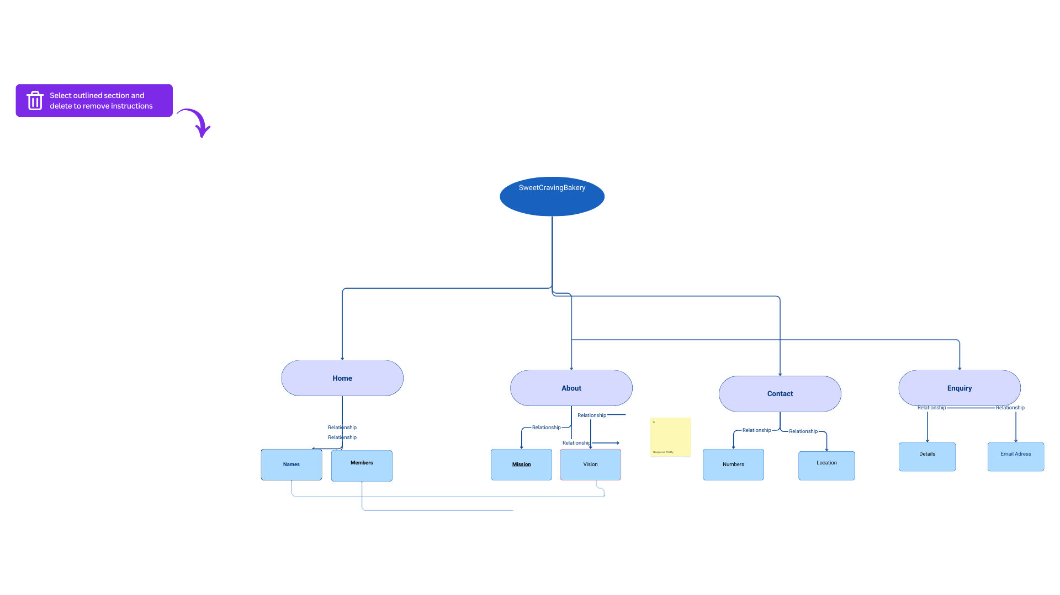

# 12. References

1. Habitat for Humanity South Africa – About Us: https://habitat.org.za/about-us

2. Habitat for Humanity International – Where We Build: South Africa: https://www.habitat.org/where-we-build/south-africa

3. Habitat for Humanity South Africa – Annual Reports: <https://habitat.org.za/annual-reports>