**DQ**-How can we, as Year-7 Indigo students, develop informational websites that draw attention & introduce Urban citizens/city dwellers to have an eco-friendly lifestyle and a sustainable future?

**EQ**-How can we create an educational and engaging website that points out current urban issues to support the improvement of eco-friendly cities and benefit the future generation?

Wire frame:

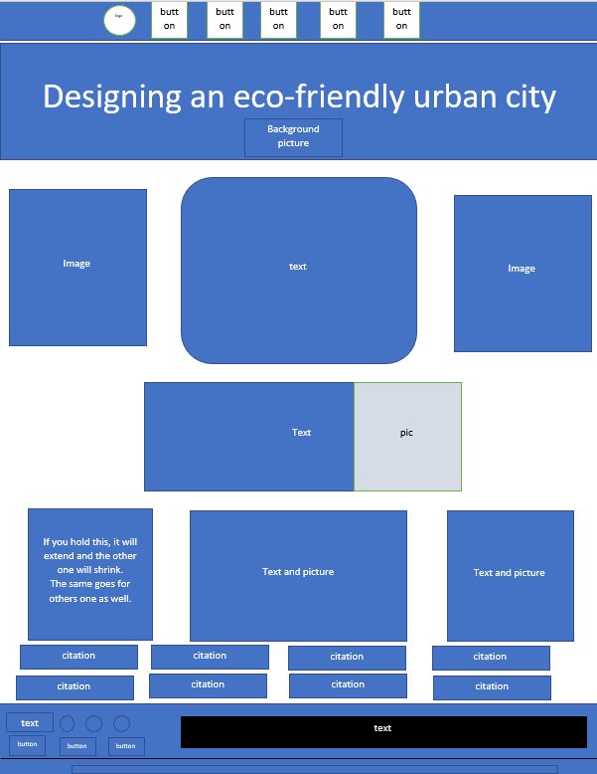

References:

NASA. (2023, July 13). NASA data reveals role of green spaces in cooling cities. NASA Science. https://science.nasa.gov/earth/climate-change/nasa-data-reveals-role-of-green-spaces-in-cooling-cities/   
  
Clean Air Fund. (n.d.). Cities. https://www.cleanairfund.org/theme/cities/   
  
Population Matters. (2024, August). Overpopulation: Causes, consequences and solutions. https://populationmatters.org/news/2024/08/overpopulation-causes-consequences-and-solutions/   
  
ACASH. (n.d.). Urban waste management challenges. https://www.acash.org.pk/urban-waste-management-challenges/   
  
Natural Resources Defense Council. (2023, March 9). Air pollution: Everything you need to know. https://www.nrdc.org/stories/air-pollution-everything-you-need-know   
  
Earth.Org. (2023, October 27). The environmental impact of e-waste. <https://earth.org/environmental-impact-of-e-waste/>

International Renewable Energy Agency (IRENA). (2021). Renewable energy and cities.

https://www.irena.org/publications/2021/Oct/Renewable-energy-and-cities

United Nations Environment Programme (UNEP). (2022). Greening the urban environment.

https://www.unep.org/resources/report/greening-urban-environment

World Health Organization (WHO). (2016). Urban green spaces and health.

https://www.euro.who.int/__data/assets/pdf_file/0005/321971/Urban-green-spaces-and-health-

review-evidence.pdf

United Nations Human Settlements Programme (UN-Habitat). (2020). The role of cities in

climate action. https://unhabitat.org/topic/climate-change

United Nations. (2023). Sustainable cities and communities – Goal 11.

https://sdgs.un.org/goals/goal11

Green Building Council. (2020). What is green building? https://www.worldgbc.org/what-green-

Building

United Nations Environment Programme (UNEP). (2021). Waste Management: Turning

waste into resources. Retrieved from https://www.unep.org

2. World Health Organization (WHO). (2020). Solid waste and health. Retrieved from

https://www.who.int

3. International Renewable Energy Agency (IRENA). (2022). Green Cities and Sustainable

Development. Retrieved from https://www.irena.org

4. National Geographic. (2021). What is an eco-city? Retrieved from

https://www.nationalgeographic.com

5. World Bank. (2020). What a Waste 2.0: A Global Snapshot of Solid Waste Management.

Retrieved from <https://datatopics.worldbank.org/what-a-waste/>

International Energy Agency.

The Future of Urban Transport. IEA, 2022,

https://www.iea.org/reports/the-future-of-urban-transport.

United Nations.

World Urbanization Prospects: The 2022 Revision. UN Department

of Economic and Social Affairs, 2022, https://population.un.org/wup/.

World Health Organization.

Air Pollution. WHO, 2021,

https://www.who.int/health-topics/air-pollution.

European Commission.

Urban Mobility. European Union, 2023,

https://transport.ec.europa.eu/transport-themes/urban-mobility_en