**What this project does??**

This project explains basic building blocks of debugging in Eclipse of Java program.

Here in this project you have to perform following tasks one by one. Please refer to the debugging notes which provides detailed explanation of each of these task.

* in detail the process of add breakpoint and start debugging
* debugging perspective's parts
* class loader breakpoint
* variable watch point with condition
* method breakpoint
* exception breakpoint
* drop to frame
* detailed formatter(Please refer to file ' NotesOnDetailedFormatterInEclipseDebugging.docx' for more notes on it)

**Please note that debugging can't be restricted to a single project. As we move ahead, you have to practice the debugging in each and every upcoming projects which clears each and every aspect of the debugging process for you. This project only explains basic building blocks of debugger in eclipse.**

**Steps to create project:-**

Go to File Menu->New-> Java Project->Give Project Name->Next->under details click 'Create New Source Folder'->Provide package Name->Click Finish

**Project Structure is as follows :-**

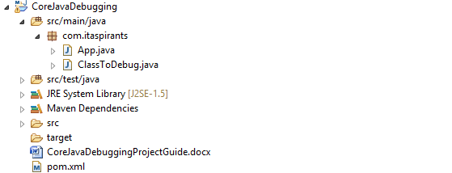

For all the operations mentioned below, we are going to use App.java file in our project except for adding ClassLoaderBreakpoint, for that case we are going to use ClassToDebugFile.

Now what you have to do is refer to the notes on debugging and carry out the debugging operations as mentioned in it one by one. Use class, method and variable for respective debugging as mentioned below:

1. For class loader breakpoint use following class in this project:

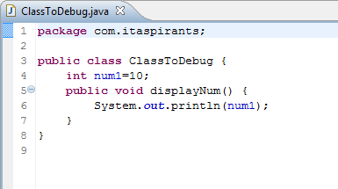

2. For variable watch point use:

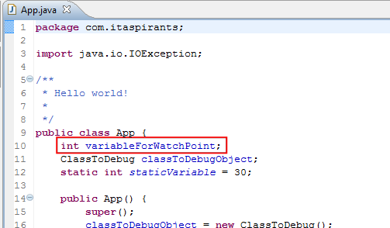

3. For method breakpoint use method:

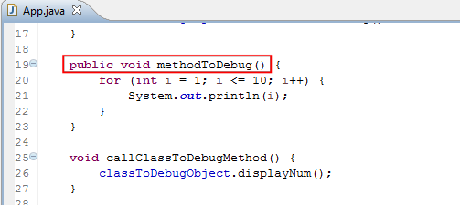

4. For Exception breakpoint use Exception class IOException as our code contains the same as follows:

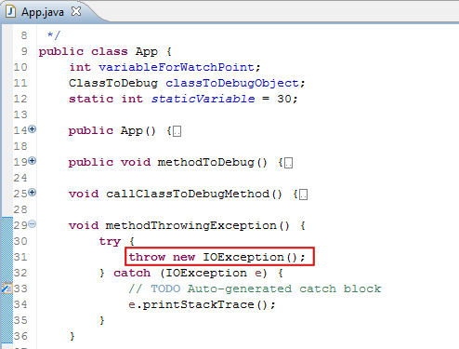

5. For detailed formatter you can use following highlighted object:

Please refer to file 'NotesOnDetailedFormatterInEclipseDebugging.docx' for more notes on it

