**Notes on Debug details formatter**

When you debug your application you probably use the Variables view. One of the disadvantages is that you cannot see the data inside complex objects (unless they implement toString() method). Eclipse allows you to write your own formatter for displaying the content you are interested in. You can do it in the Eclipse preferences under Java->Debug->Detail Formatters.

Let's consider the following class:

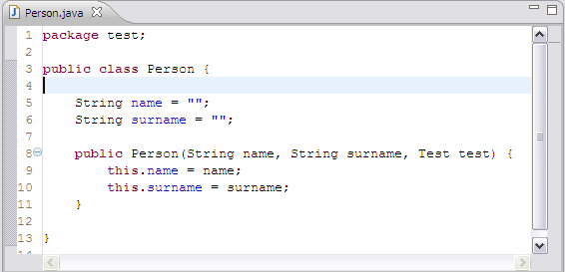

When you want to check the value of the an object of this class during the debugging session you have to expand the object and inspect the value of all it’s parts. (see the picture below).

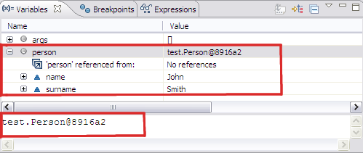

Let’s write our own formatter:

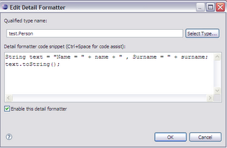

And now in the Variables view we can see that the person object is shown differently:

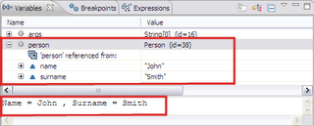

If you want to see the formatter in the labels for variables you have to select the following option in the Eclipse preferences:

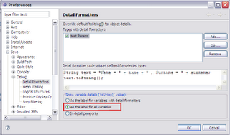

This allows you to see the result of your formatter in the value field of the Variables view:

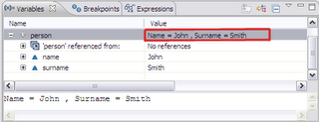

I find this option very useful also for the standard classes (e.g. ArrayList), then instead of:

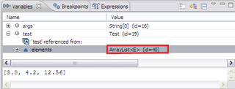

We can see:

