This is second project for introducing functionality of Java Logging Framework. There are total three projects about Java Logging in Core Java section. First one is 'CoreJavaLoggingWithSLF4JAndLog4j' and third one is ' CoreJavaLoggingWithXMLConfig'.

Before going further please go through and understand the first project of Java Logging in Core Java section viz. 'CoreJavaLoggingWithSLF4JAndLog4j' and the notes provided on Java logging.

This project is some different and advance than the previous one in following manner:

1.It is different in the sense that it uses Log4j alone instead of combination of SLF4J and log4j. Hence it is not possible for this project to change the logging framework from log4j to any other e.g. Logback which was possible in the previous project but on the other hand it can uses some log4j specific features which is not possible in combination with SLF4J.

2. This project is advance from the previous one as

i) it uses multiple appenders viz. console, file and database

ii) it uses file specific logger which is applicable for the given file only.

Here in this project guide we will focus only on the difference and the advance features used in this project than the previous one. For detail project structure, flow and functioning please refer to the previous project.

Project structure:

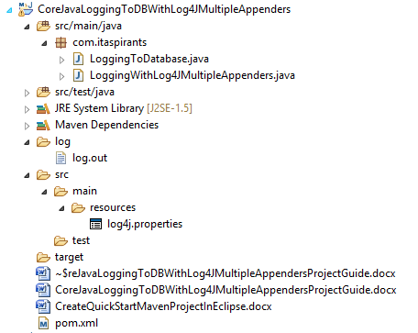

Configuration file for Log4j viz. log4j.properties:

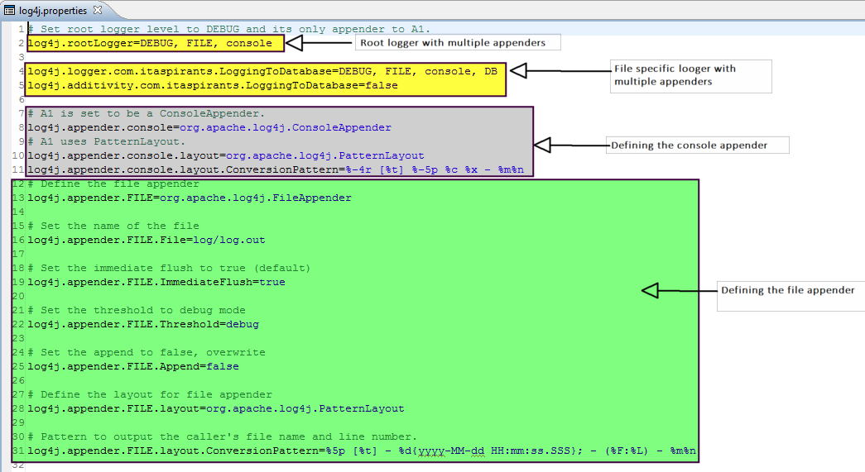

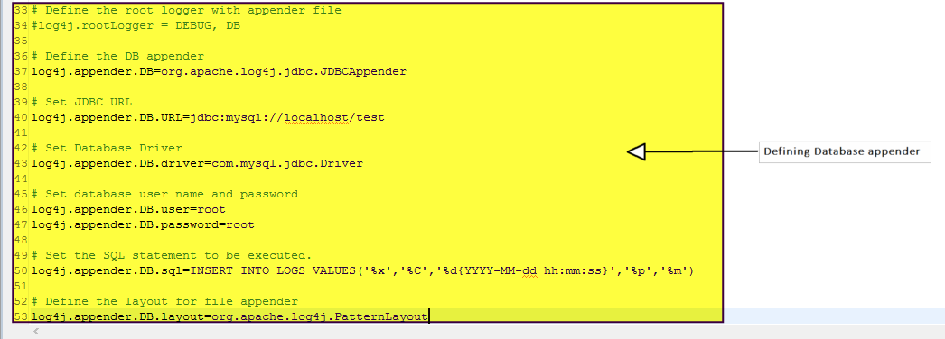

Now we will see business logic file

1. Output for 'LoggingToDatabase.java' file

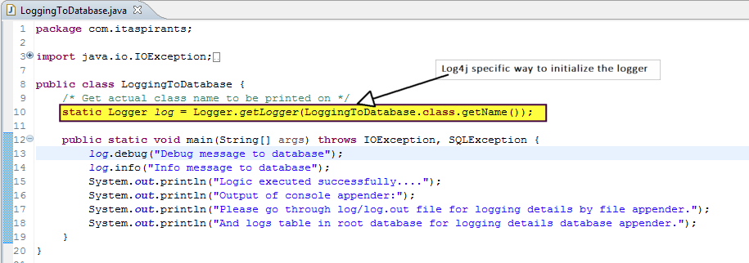

Logger object was initialized in previous project(in SLF4J way) as follows:



Hence go through the difference between the way of initialization of logger object in both frameworks.

As there a specific logger is mentioned for this 'LoggingToDatabase.java' file in the log4j2.properties file, with Debug as logging level and three appenders as follows, when we execute this file, will get following three outputs for each appender:



Console appender output:

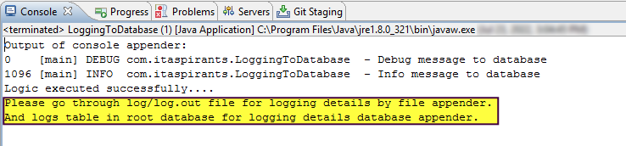

File appender output:

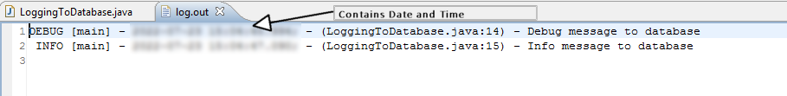

Database appender output:

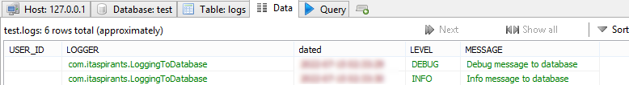

2. Output for 'LoggingWithLog4JMultipleAppenders.java' file

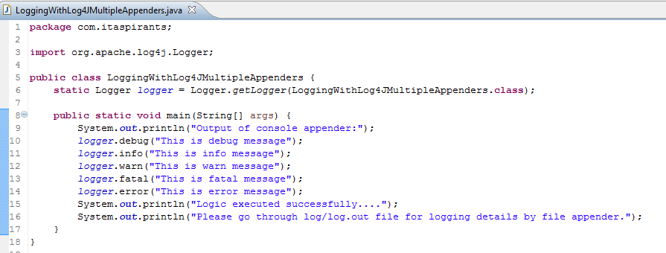

Root logger definition screen shot in log4j.properties file:



As there is no any specific logger is mentioned for this file, the default root logger get applied. This root logger have DEBUG as log level and console and file appendes in log4j2.properties file (refer the above screen shot, when we execute this file, will get following two outputs for each appender:

Console appender output:

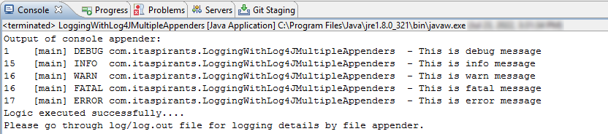

File appender output file:

