This is third (and the last) project for introducing functionality of Java Logging Framework. There are total three projects about Java Logging in Core Java section. First one is 'CoreJavaLoggingWithSLF4JAndLog4j' and second one is 'CoreJavaLoggingToDBWithLog4JMultipleAppenders'.

Before going further please go through and understand these first two projects of Java Logging in Core Java section and the notes provided on Java logging.

**About this project:**

1.This project uses Log4j alone instead of combination of SLF4J and log4j. Hence it is not possible for this project to change the logging framework from log4j to any other e.g. Logback which was possible in project 'CoreJavaLoggingWithSLF4JAndLog4j' but on the other hand it can uses some log4j specific features which is not possible in combination with SLF4J.

2.It is different from previous two projects in the sense that it uses xml based configuration instead of .properties(like previous two projects)

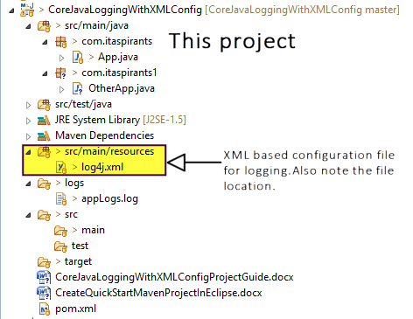

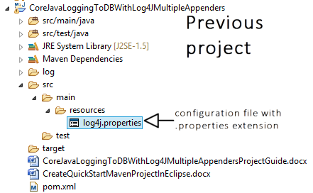

***So before moving forward, please go through the difference in mapping between .xml based configuration file and .properties based configuration file.

3. This project is somewhat extension to the concept of the previous project

i) it uses package specific logger which is applicable for all the files in that particular package.

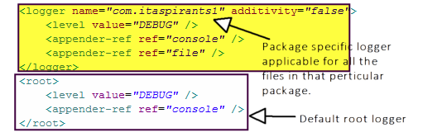

ii) it introduces with how to log an exception to the log file.

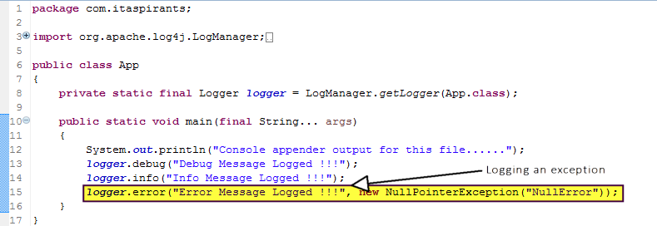

Here in this project guide we will focus only on the difference and the advance features used in this project than the previous one.

So by skipping the project structure related things and the basic flow regarding logging as those are already mentioned in above screen shots and in previous project guide files, we will directly move to the output of the files.

**Output of the files:**

**1. App.java**

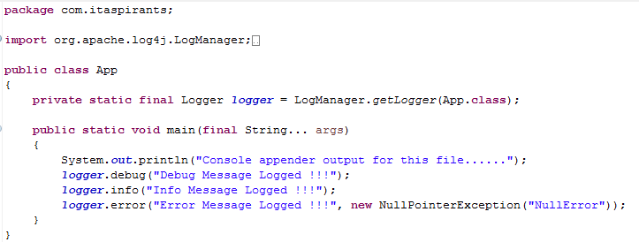

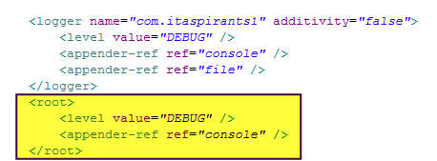

As there is no any specific file or package logger is mentioned for this file the default root logger get applied and produces only the console logger output as below.

Output:

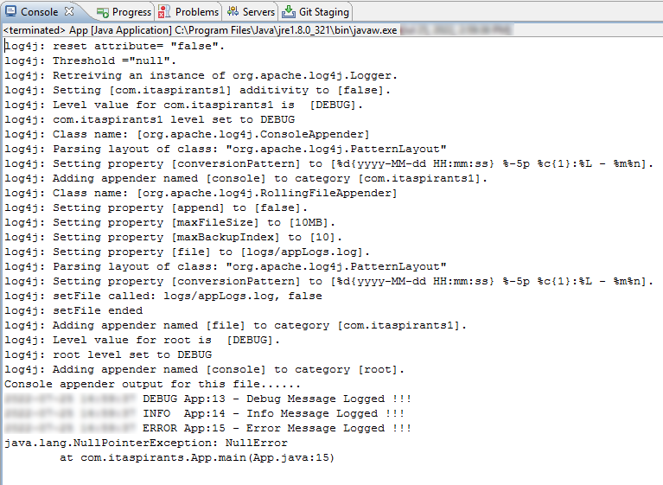

**2. OtherApp.java**

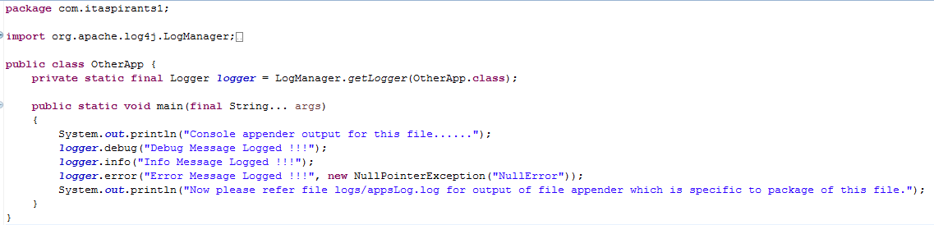

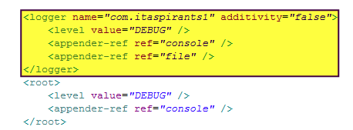

As there is specific package based logger viz. 'com.itaspirants1' is mentioned for this file the default, it get applied and produces console logger and file logger output as below.

Console logger output:

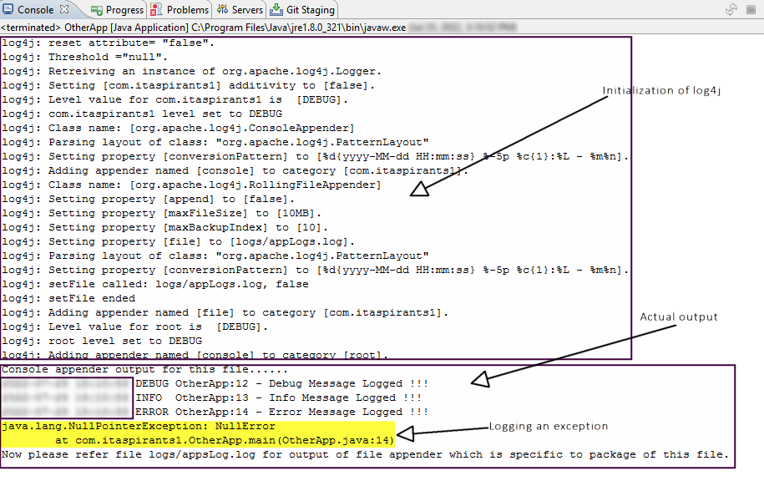

File logger output:

File location: logs/appsLog.log

