**What this project does??**

This project provides in depth idea about what are Reflection API and Annotations in Java, how they work and real time use of them.

You are requested to go through the provided notes about this topic before actual execution for better understanding of the concepts.

You need to understand the Reflection API and annotations as almost all major frameworks like Spring, Hibernate and many more make use of the annotations very extensively.

**Steps to create project:-**

Go to File Menu->New-> Java Project->Give Project Name->Next->under details click 'Create New Source Folder'->Provide package Name->Click Finish

**Project Structure is as follows :-**

**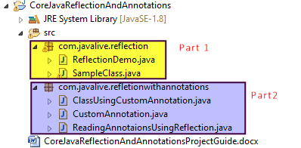**

Please note that we have divided the project into two packages and their sequence is mentioned in above screen shot.

Brief introduction to each package is as follows:

Package 1:-

C:\Users\Administrator\Documents\DonationCoder\ScreenshotCaptor\Screenshots\Screenshot - 7_26_2022 , 2_47_28 PM.png

Please follow the order mentioned in above screen shot.

This package provide idea about what is Reflection and how it can be used in real time scenario.

This package contains two classes. First class viz. 'SampleClass' contains various fields and methods. Nothing else. Now the second class viz. 'ReflectionDemo' uses reflection mechanism to create, read various class level fields and methods of 'SampleClass'.

Package 2:

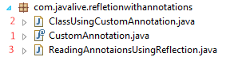

Please follow the order mentioned in above screen shot.

This package contains classes and interface which focuses on explaining how to use Reflection API to read various annotations of the given class.

Interface 'CustomAnnotation.java' defines the custom annotation.

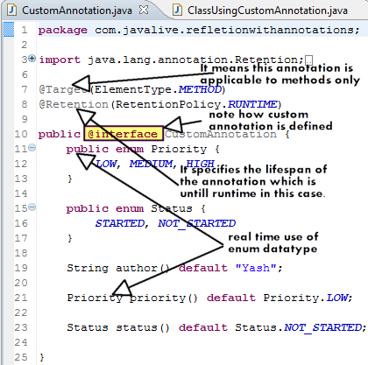

Now second file viz. 'ClassUsingAnnotation.java' uses the above defined annotation for its method.

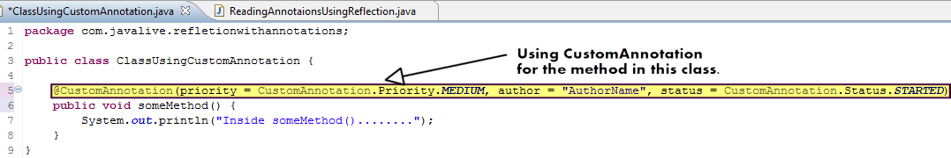

Third file viz. 'ReadingAnnotationsUsingReflections.java' as name suggest reads the values of the annotation of class 'ClassUsingAnnotation.java' by using Reflection API

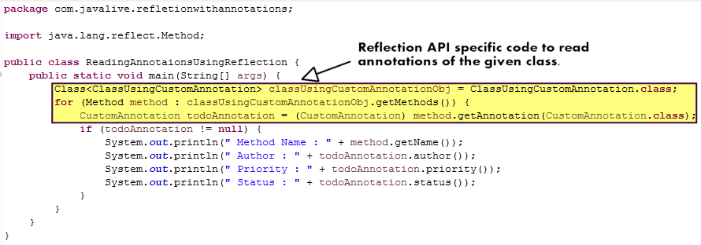

Now when we execute this class, we get following output:

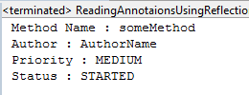

Now compare this output with following screenshot(already mentioned above)



Thus it explains how Reflection API is used to read annotations for the given class.

**In real life scenario, almost all the frameworks like Spring, Hibernate and so on are making extensive use of annotations. In that case the definition of annotation (like 'CustomAnnotation' in this case) and files which actually reads the annotations and use internal framework based logic accordingly (like 'ClassUsingCustomAnnotation' in this case) are provided by these frameworks. We should know the use/role of these annotations in the given framework and we have to just use them in our business logic file(like 'ClassUsingCustomAnnotations' in this case).**