Hibernate 5 + P6Spy configuration example

**Technologies used:** Java SE 1.8 | Hibernate 5.2.10.Final | P6Spy 3.0.0 | Maven 3.3.9 | MySQL 5.7.12 | Eclipse Neon.3

[P6Spy](https://www.google.co.in/url?sa=t&rct=j&q=&esrc=s&source=web&cd=1&cad=rja&uact=8&ved=0ahUKEwjHvMG2luPTAhVGOI8KHd1NADsQFggmMAA&url=https%3A%2F%2Fgithub.com%2Fp6spy%2Fp6spy&usg=AFQjCNG3GsXFUijSg81FRPQyoyY7hkh5HQ&sig2=bzhrwkJ5utxfKKtcE0hmsA) is a framework that enables us to log all sql statements and parameters for java application.

By using P6Spy with Hibernate, you can log current execution time, total elapsed time, sql statement with bind variable, sql statement executed etc.

In this section, I will show you how to setup P6Spy with Hibernate framework.

Project structure

Review the following maven project structure.

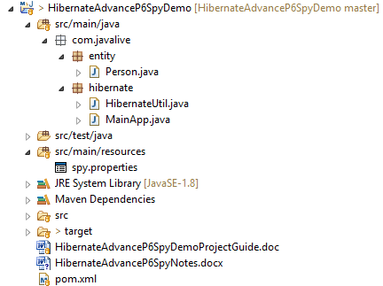

Jar Dependencies

In pom.xml file of your maven project, add the dependencies below.

<dependencies>

*<!-- Mysql Connector -->*

<dependency>

<groupId>mysql</groupId>

<artifactId>mysql-connector-java</artifactId>

<version>6.0.5</version>

</dependency>

*<!-- Hibernate 5.2.9 Final -->*

<dependency>

<groupId>org.hibernate</groupId>

<artifactId>hibernate-core</artifactId>

<version>5.2.10.Final</version>

</dependency>

*<!-- P6Spy 3.0.0 -->*

<dependency>

<groupId>p6spy</groupId>

<artifactId>p6spy</artifactId>

<version>3.0.0</version>

</dependency>

</dependencies>

P6Spy configuration file

Create spy.properties file under src/main/resources source folder and add the following properties in it.

**spy.properties**

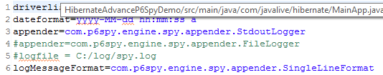

For all available options in spy.properties file, refer this link - [Common Property File Settings](https://p6spy.github.io/p6spy/2.0/configandusage.html#settings).

Hibernate Utility class + P6Spy

To integrate P6Spy with Hibernate, modify the connection URL and driver class. For example –

Change driver class from com.mysql.cj.jdbc.Driver to com.p6spy.engine.spy.P6SpyDriver.

Change connection URL from jdbc:mysql://host/db to jdbc:p6spy:mysql://host/db.

The following HibernateUtil helper class demonstrates how to bootstrap hibernate with P6Spy.

**HibernateUtil.java**

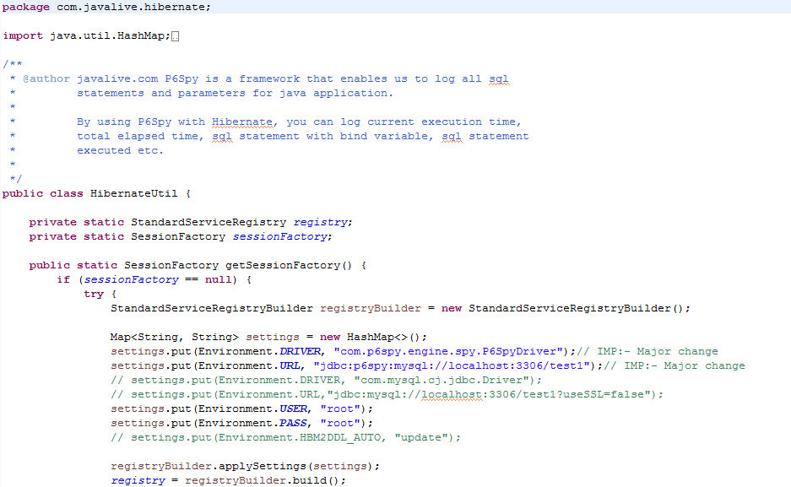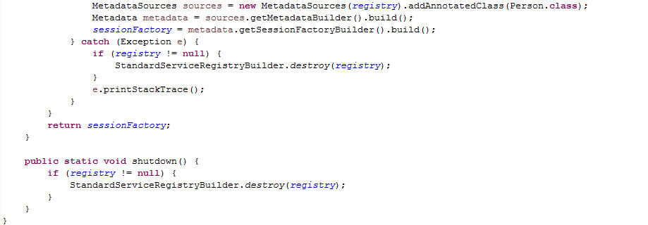

Entity class

A simple model class with JPA annotations.

**Person.java**

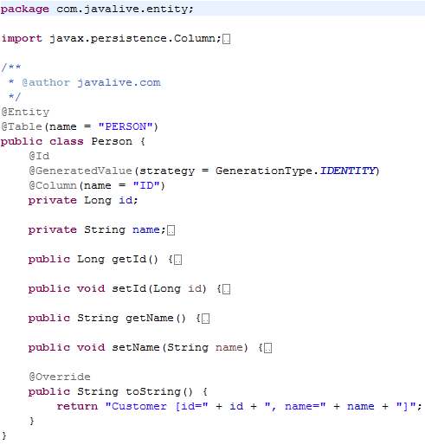

Run Application

Create the MainApp class to test the above P6Spy and Hibernate configuration.

**MainApp.java**

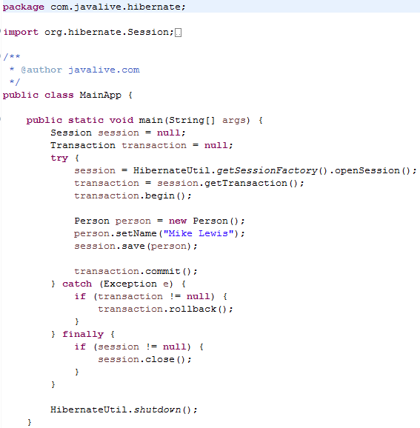

**Output**

