What this project does?

This project is responsible for explaining how 'Batch Execution' in hibernate works.

Steps to create project:-

Note that this is pure java(annotation) based hibernate project.

(Refer Hibernate5StandaloneWithFullJavaConfig project for more details to get idea about pure annotation based project and its functioning.)

1. Create quick start maven project.

2. Add require dependencies for hibernate, mysql in pom.xml file.

3. Create required packages and add the files.

Project structure is as follows:

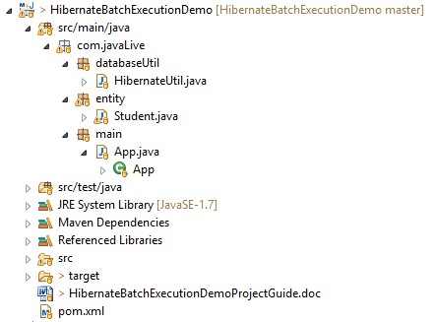

4. Note that here there is no src/main/resources/hibernate.cfg.xml file instead we made all the required configuration in HibernateUtiil.java directly.

5. com.javalive.entity.Student.java:-

Also here there is no .hbm.xml file instead we have merged both .java and.hbm.xml files as in xml based configuration to a single file (these files are in com.javalive.entity package) and that's the power of annotations. Please refer below screen shot. Highlighted sections are JPA annotations which are responsible for mapping of file to the database table

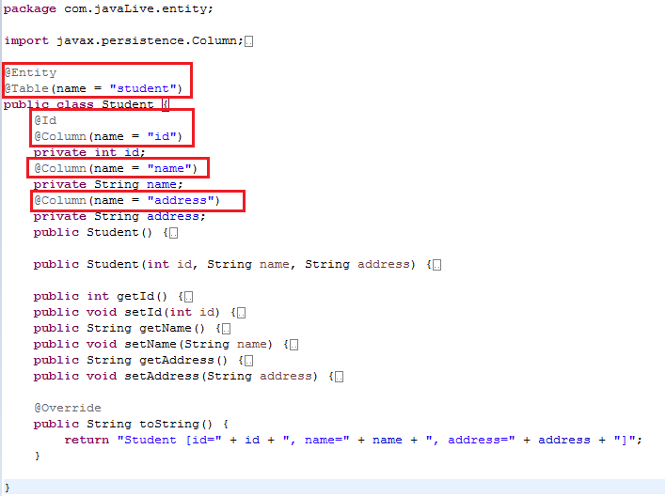

6. In this project please carefully go through initial comment section of HibernateUtil.java to get introductory knowledge about 'Hibernate Batch Processing' and code section to study how we map database properties.

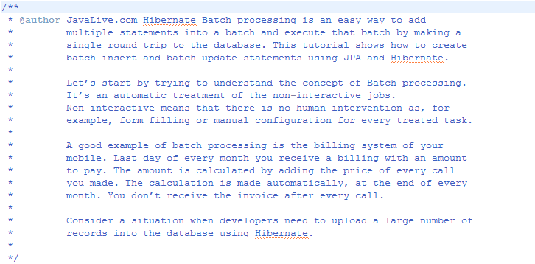

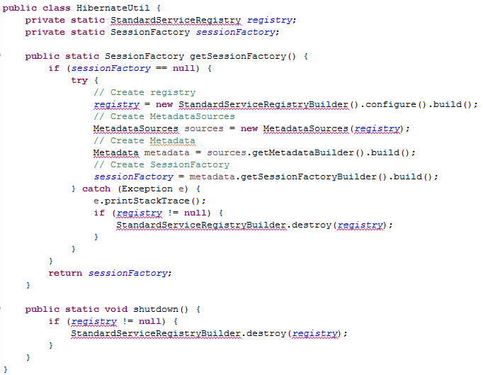

7.****Go through App.java file to study how we carry out database operations and how 'hibernate batch' really works.

Here we are going to insert 100 records in the tale with the help of Hibernate but as from performance point of view, we have decide to break them into two batches of 50 records each. And then perform the insertion operation.

(***Note that for study point of view we have consider 50 records batch, but in real world application this batch size is much bigger as total records are generally in millions.)

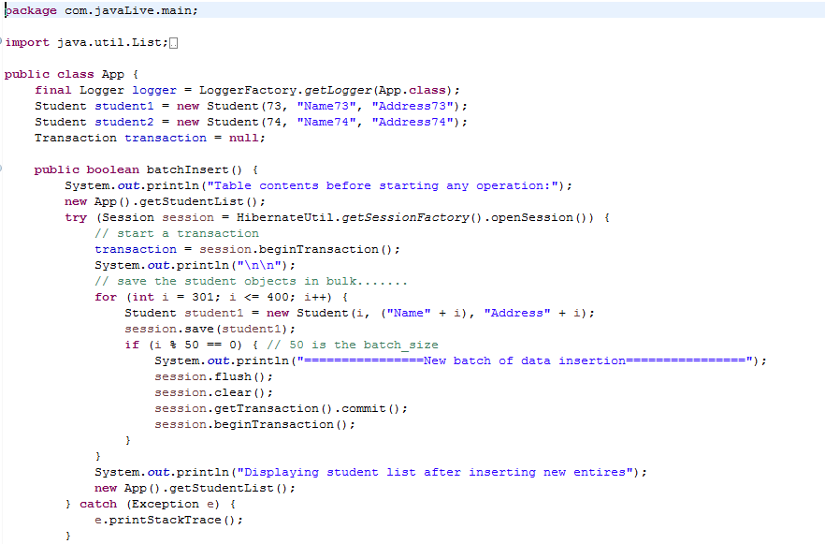
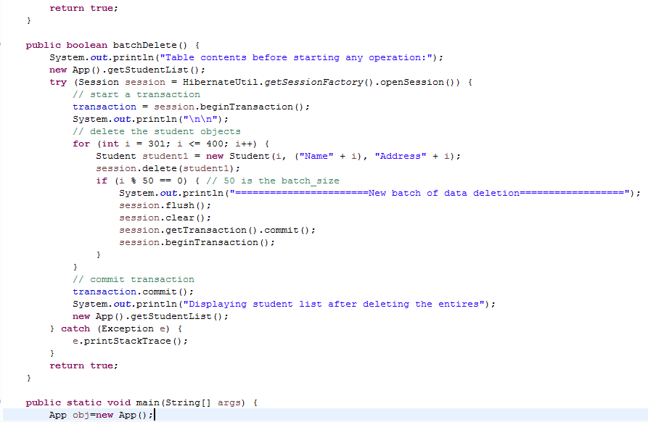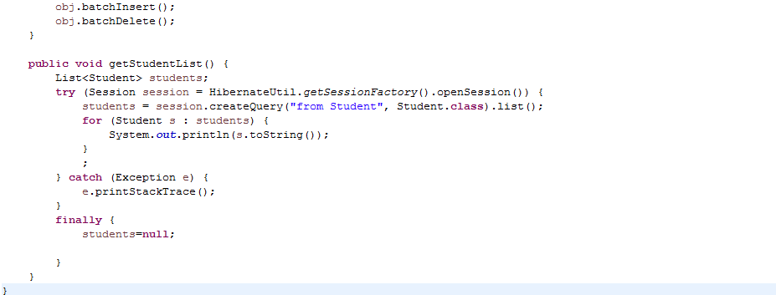

Output of the above file is quite leanly. We haven't provide its screen shots. Execute above program and try to understand it with the help of comments in above file.

