Activate Hibernate Query Statistics and display to console output with SLF4J and Log4j

Note that along with Hibernate Query Statistics this notes also explains **how we can configure Lof4J without configuration file to do logging practice** but please note that it is not useful and not used in 'Production' environment. Its only to study how to display logging messages. Step 1 and Step 3 refer to this functionality. Please carefully go through it.

**Step 1 Add Maven dependencies:**

<dependency>

<groupId>log4j</groupId>

<artifactId>log4j</artifactId>

<version>1.2.17</version>

</dependency>

<!-- https://mvnrepository.com/artifact/org.slf4j/slf4j-api -->

<dependency>

<groupId>org.slf4j</groupId>

<artifactId>slf4j-log4j12</artifactId>

<version>1.7.5</version>

</dependency>

**Step 2 Activate Statistic generation in Hibernate configuration:**

**a) Annotation based:**

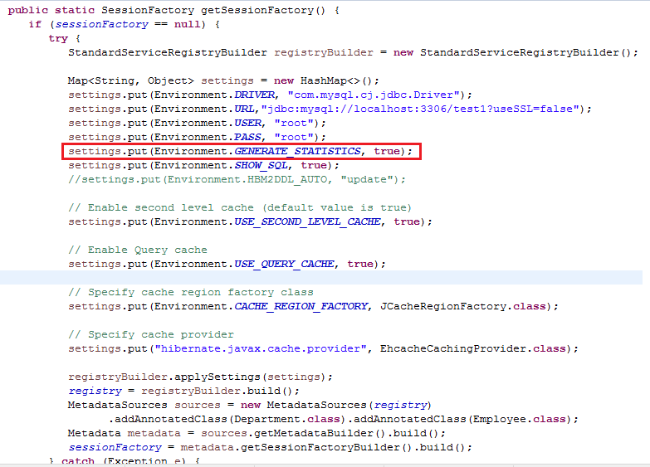

**b) Xml based:**

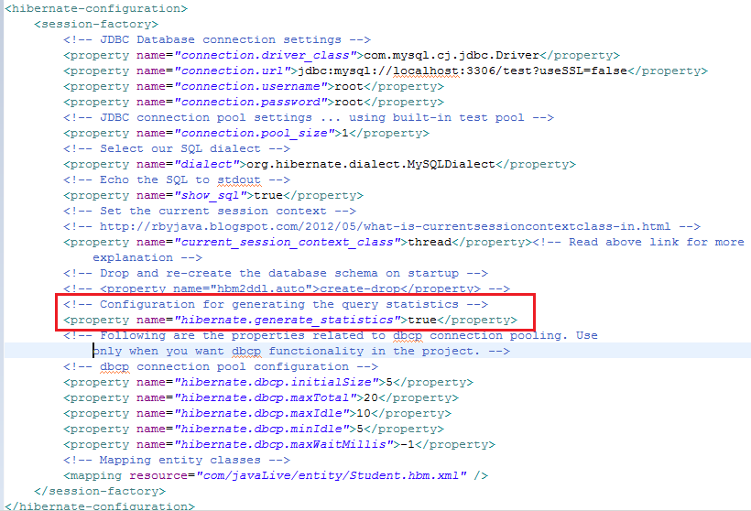

**Step 3: Display query statistics report to console with the help SLF4J and Log4J**

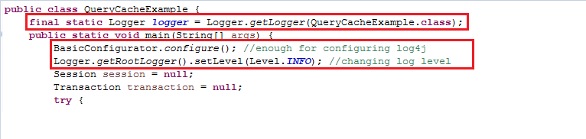

**Step 4 : Now Hibernate statistic reports will get displayed to the console as follows:**

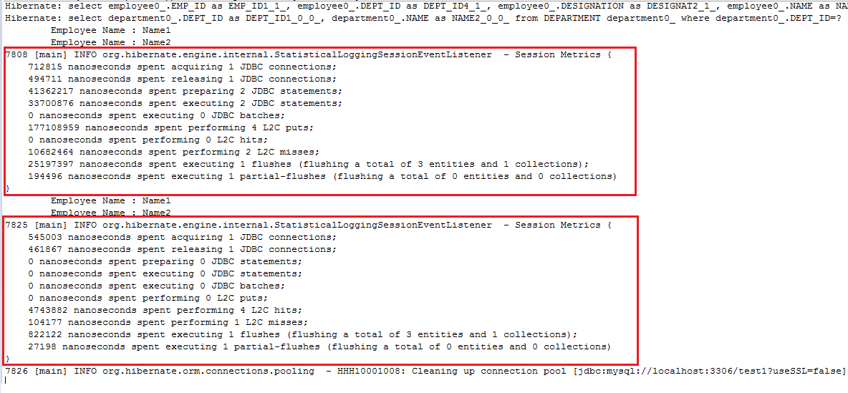Note that Hibernate Query Statistics is useful in Development environment only.

You should not use it in Production.