*Please note that we haven't explained full-fledged annotation based Hibernate project here. Rather we have focused on explaining how unidirectional one to one association is mapped in Hibernate.*

*To know more about annotation based basic Hibernate project please thoroughly go through project* ***' Hibernate5StandaloneWithFullJavaConfig'*** *if you are not familiar with it.*

**What this project dose ?**

This project explains how unidirectional one to one association is mapped in Hibernate by using annotations.

**A short introduction**

In one-to-one association, source entity has a field that references another target entity. The @OneToOne JPA annotation is used to map the source entity with the target entity.

The one-to-one association can be either unidirectional or bidirectional.

In unidirectional association, source entity has a relationship field that refers to the target entity and the source entity’s table contains the foreign key.

**Unidirectional one-to-one association example**

Consider the following domain model and relational model diagrams of one-to-one unidirectional association.

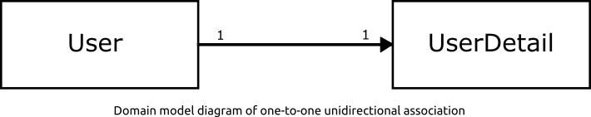

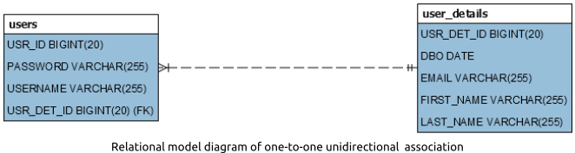

**Project Structure**

**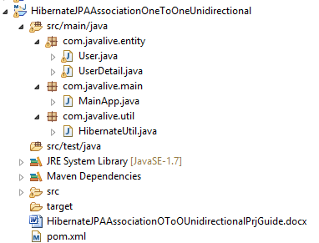**

**Jar dependencies**

Add the following jar dependencies for Hibernate and MySQL driver in pom.xml file.

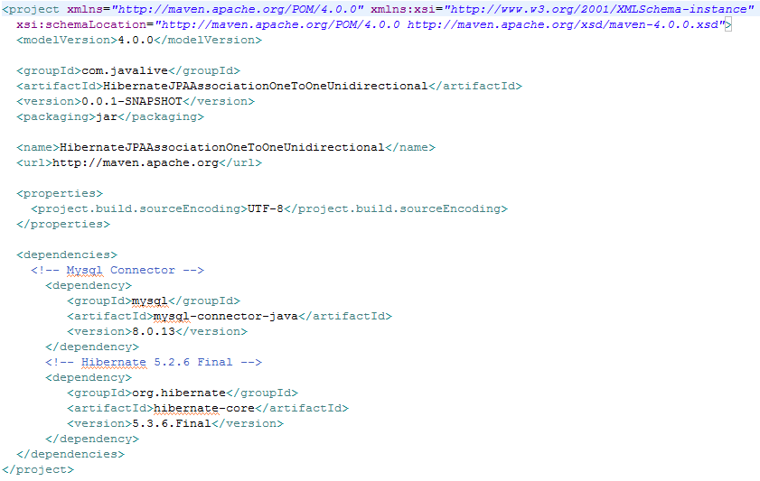

**Entity class**

Create two @Entity classes - User and UserDetail, to map with USER1 and USER\_DETAILS1 tables respectively.

**User.java**

# C:\Users\Administrator\Documents\DonationCoder\ScreenshotCaptor\Screenshots\Screenshot - 9_30_2020 , 2_45_51 PM.png

**UserDetail.java**

**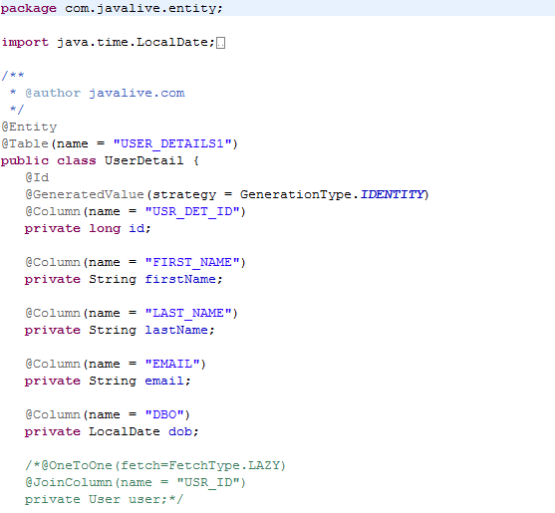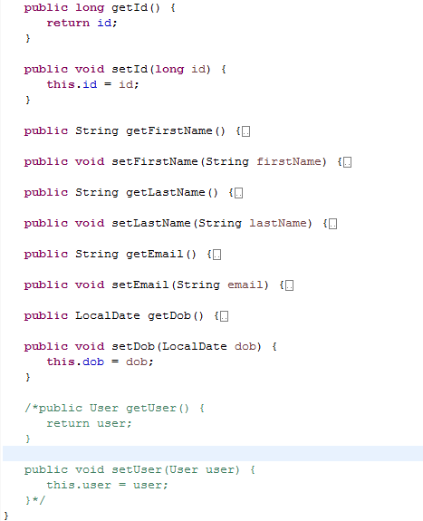**

**Hibernate utility class**

Create a helper class HibernateUtil to bootstrap hibernate.

Map the User and UserDetails entities using the #MetadataSources.addAnnotatedClass() method.

**HibernateUtil.java**

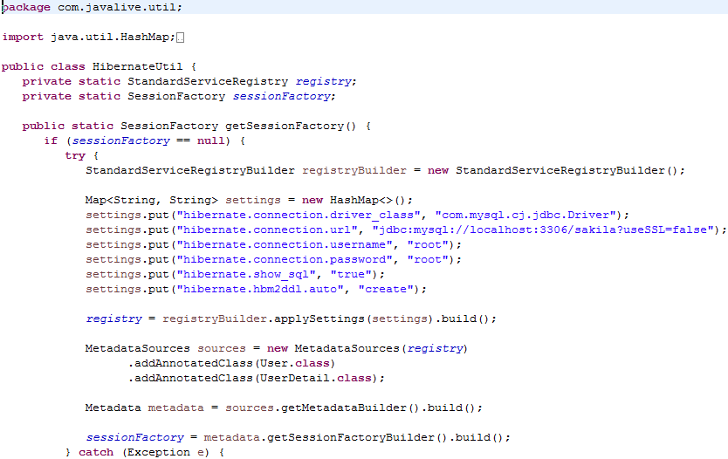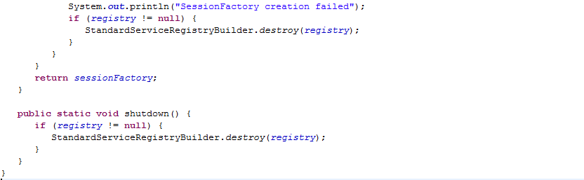

**Main class**

Create the MainApp class to run the application.

**MainApp.java**

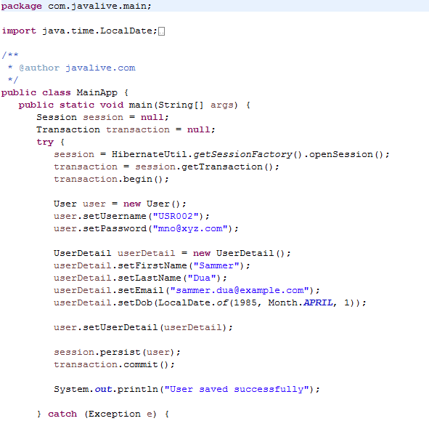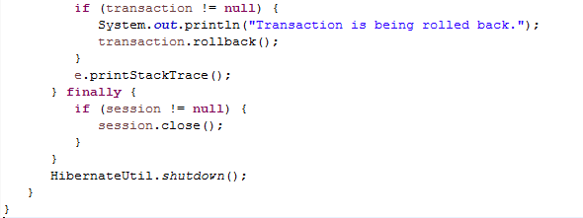

**Output**

On executing the MainApp class, you will see the following records in USER1 and USER\_DETAILS1 tables.



Now see the database for tables created.......

