What this project dose??

This project demonstrates how inheritance mapping carried out in JPA Hibernate using Joined Table strategy.

Steps to create project:-

Note that this is pure for java(annotation) based hibernate project.

(Refer Hibernate5StandaloneWithFullJavaConfig project for more details to get idea about pure annotation based project.)

1. Create quick start maven project.

2. Add require dependencies for hibernate, mysql in pom.xml file.

3. Create required packages and add the files.

Project structure is as follows:

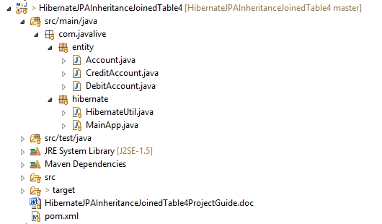

4. Note that here there is no src/main/resources/hibernate.cfg.xml file instead we made all the required configuration in HibernateUtiil.java directly.

Note that here there is no .hbm.xml file instead we have merged both .java and.hbm.xml files as in xml based configuration to a single file (these files are in com.javalive.entity package) and that's the power of annotations.

5. In this project please carefully go through HibernateUtil.java(to study how we map database properties) 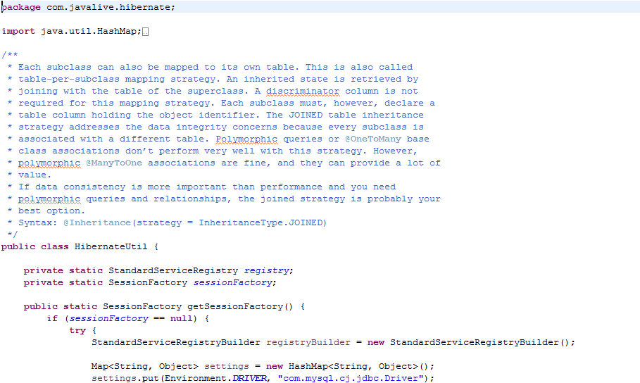 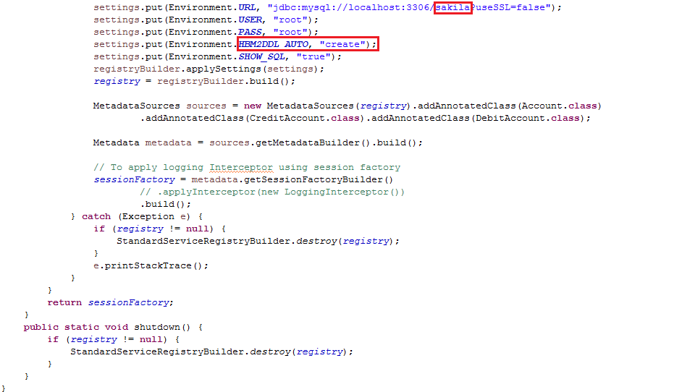

6. ****Now in this project carefully go through annotations in the files of com.javalive.entity package to come to know how inheritance get mapped in this method. Also read comment section at the start of HibernateUtil.java to understant JoinedTable Inheritance strategy.

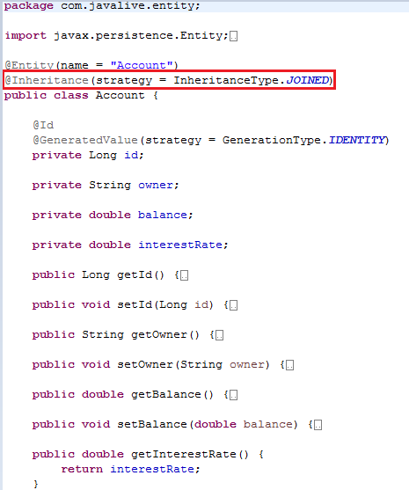

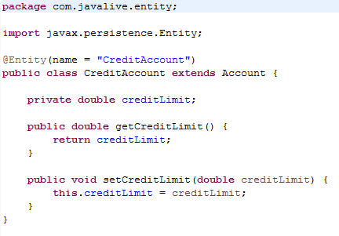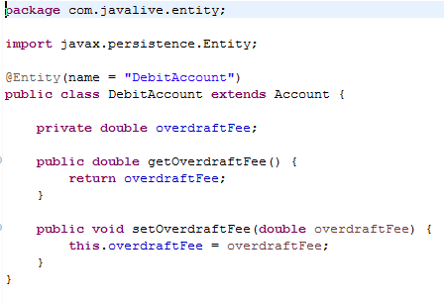

7. Also go through MainApp.java file to study how we carry out database operations.

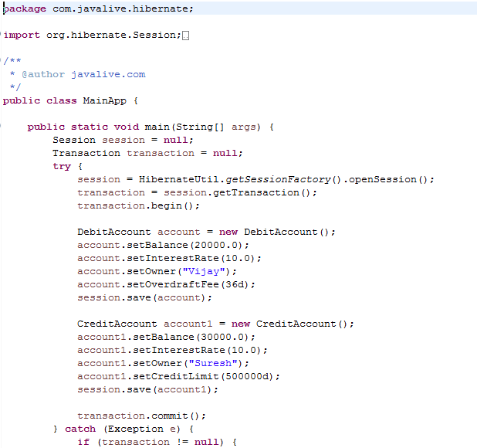


Console output is as follows:

Database table output is as follows:
