**Old way to create connection object.**

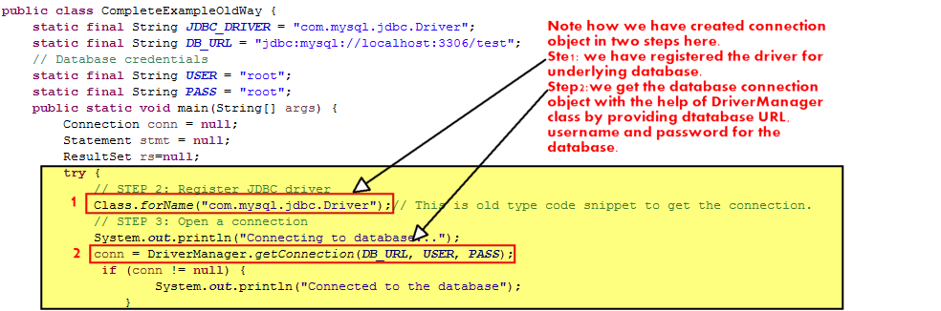

**New way to create connection object.**

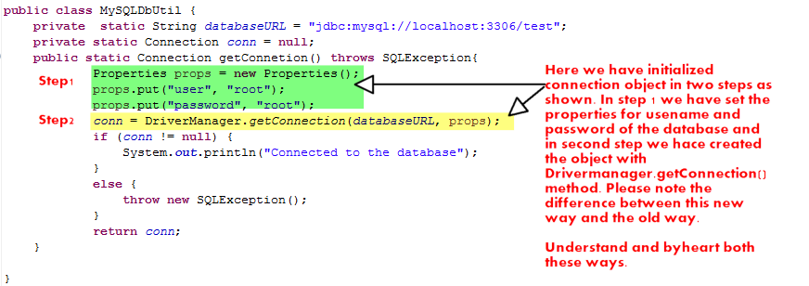

Note that we have make a separate file which contains a method to return the connection object. This is an example of 'Factory' design pattern where a dedicated class is used to create objects.

We have use it in various other files in this application as follows:

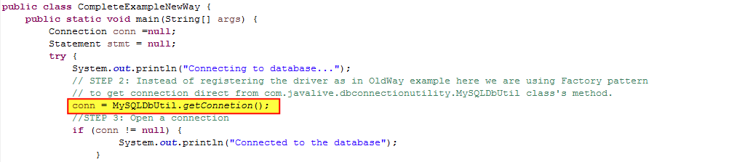

In real time scenario, if our application is using more than one database, we can add separate class file for creating connection object to that particular database. Means this class is returning connection object for MySQL database, similarly we can make other class to make connection to Oracle or MongoDB and so on.