What this project does??

This project provides in depth idea about various concepts of Java Database Connectivity.

Go through file ' OldWayVsNewWayToCreateDatabaseConnection.docx' first to understand the basic about getting connected to the database.

You are requested to go through the provided notes about each topic before actual execution for better understanding of the concept.

Steps to create project:-

1. Create quick start maven project. Please refer file 'CreateQuickStartMavenProjectInEclipse.docx' for more details.

2. Add required dependencies.

Project Structure is as follows :-

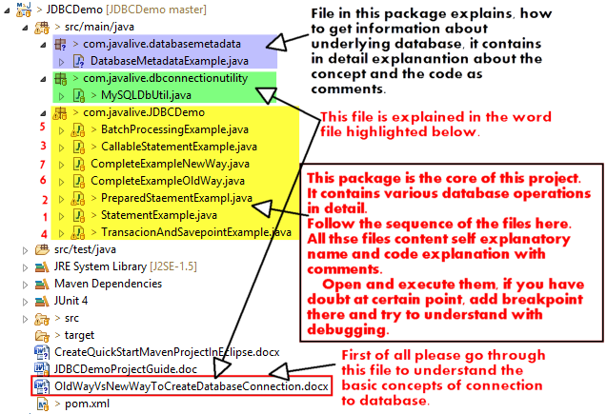

****In this project most important files to study are as follows:

a) com.javalive.dbconnectionutility. MySQLDbUtil.java:-

This file is an utility file to make a connection with db. Note that this file contains coding in new way to get database connection.

b) All the files in package com.javalive.JDBCDemo. Their names are self explanatory and each of these files contains a single concept of JDBC.

