Steps to create project:-

Note that this is the basic project structure for any xml based hibernate project.

Attributes of hibernate.cfg.xml and hbm.xml files may get changed.

1. Create quick start maven project.

2. Add require dependencies for JPA, EclipseLink(a rival of Hibernate and is one of the JPA Provider) and mysql in pom.xml file.

3. Create required packages and add the files.

4. Now this is important: create persistance.xml file at location as below:

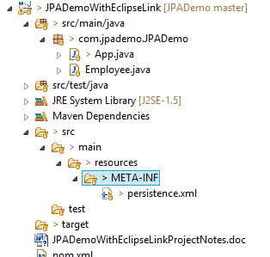

Note the location of above file unlike hibernate.cfg.xml file which's location is src/main/resources folder.

5. In this project please carefully go through persistance.xml(to study how we mapp database properties) and Student.hbm.xml file (which is a mapping file mapping Student class to database table 'Student'.

6. Here we haven't created any utility class as that of hibernate project(viz. HibernateUtil.java) but its good practice to create utility class to get connected to the database. Code regarding database connection and JPA database operations both are included in App.java class in this project. Now create and run the project.

