**\*\*Please go through theory part of JSP action tags and their uses from our notes for better understanding of the concept.**

**Also refer' IntroductionToJSPActionTags.docx' file in this project for theory part of JSP Action Tags.**

**What this project do?**

**This project demonstrates introduction and use of various jsp action tags.**

**How to create this project??**

**This is non maven 'Dynamic web project'.**

Refer file 'CreatingDynamicWebProjectForServletJSPInEclipse.docx' in this project folder for getting more details about how to create 'Dynamic web project' in eclipse.

If you don't know about configuring Apache Tmocat server, please refer file 'How to configure Apache Tomcat Server in Eclipse IDE.docx' in this project for more details.

**This project is pure xml based i.e. elements are mapped in web.xml file.**

**First of all carefully study the project structure of this project (i.e. 'Dynamic Web Project')**

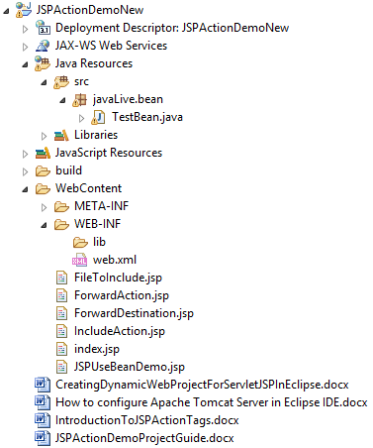

**Study following files very carefully:**

**web.xml:** This is deployment descriptor file for the given project. Study it to understand how we mapped welcome files.

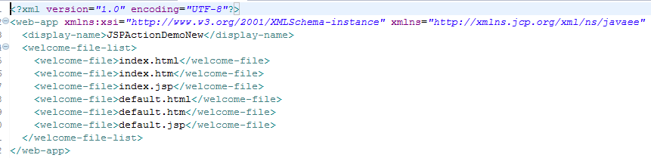

Second file is javaLive.bean.TestBean.java

This is a plain Java Bean class which we are going to used in JPS useBean action tag in upcoming JSP files of this project.

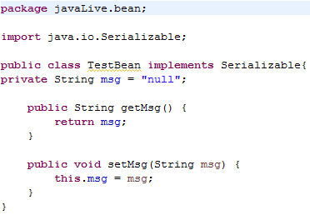

Third file is index.jsp which is welcome file of this project.

It simply contains links to various JSP pages which ultimately shows various JSP Action tags.

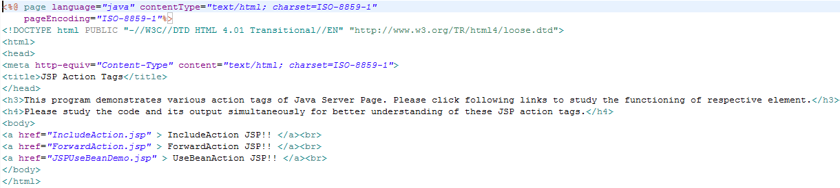

FileToInclude.jsp

This file is used as include file for IncludeAction.jsp file

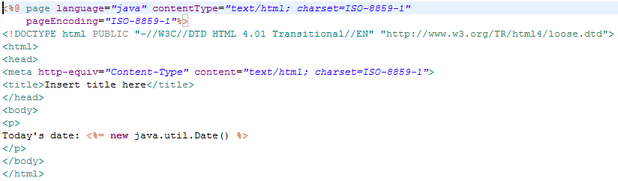

IncludeAction.jsp

This file simply includes above file and shows the output.

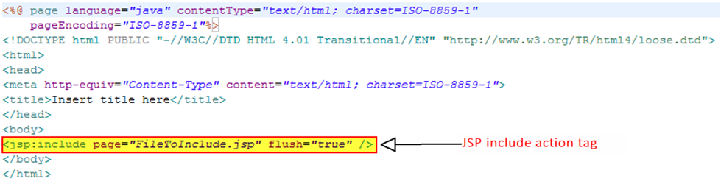

ForwardAction.jsp

After calling this file it simply forwards the request to ForwardDestination.jsp file.

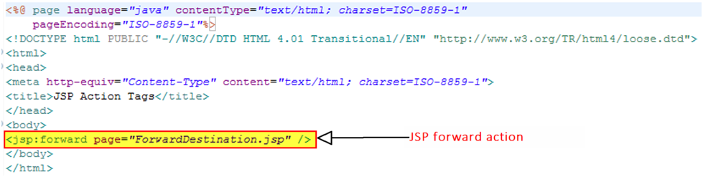

ForwardDestination.jsp

This JSP is called by ForwardAction.jsp file to show the output.

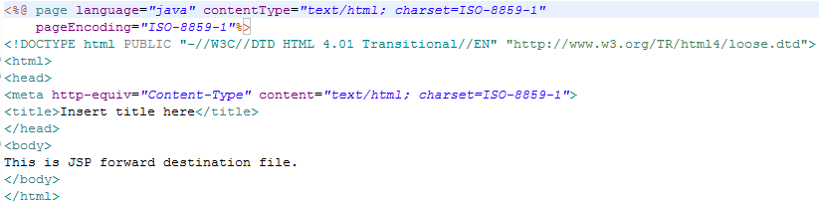

JSPUseBeanDemo.jsp

As mentioned earlier this file is used as bean for jsp:useBean action tag.

Please refer following highlighted section which illustrates it.

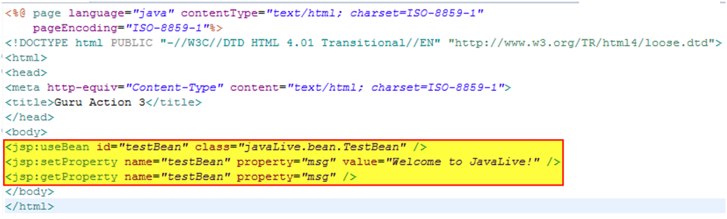

**Running the application:**

Right click on the project ->Run As->Run on Server

Welcome file viz. index.jsp get displayed. Now click on any link to study the functionality of respective JSP Action Tag.

***\*\*While studying these output please study the code for respective JSP file (also mentioned in this file as screen shot) for better understanding of that particular JSP Action tag.***

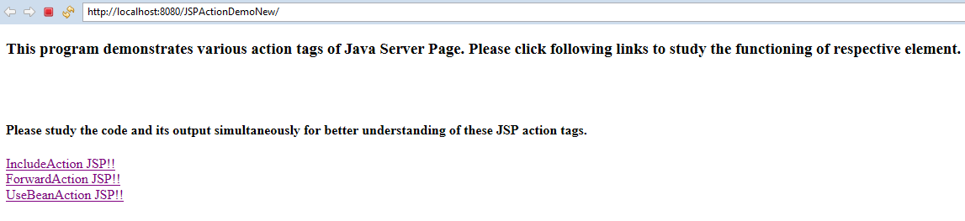

When you click on 'IncludeAction JSP!!' link, it shows following output.

Please refer screen shot of FilesToInlcude.jsp and IncludeAction.jsp for better understanding of following output. It is very simple and straight forward.

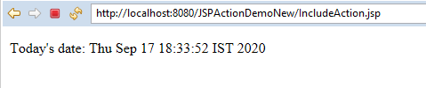

When you click on 'ForwardAction JSP!!' link, it shows following output.

Please refer screen shot of ForwardAction.jsp and ForwardDestination.jsp for better understanding of following output.

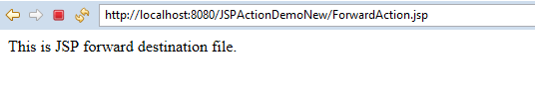

When you click on 'UseBeanAction JSP!!' link, it shows following output.

Please refer screen shot of File JSPUseBeanDemo.jsp for better understanding of following output.

