**\*\*Please go through theory part of JSP directives and their uses from our notes for better understanding of the concept.**

**Also refer' JSPDirectivesGeneralNotes.docx' file in this project for theory part of JSP Action Tags.**

**What this project do?**

**This project demonstrates introduction and use of jsp directives.**

**How to create this project??**

**This is non maven 'Dynamic web project'.**

Refer file 'CreatingDynamicWebProjectForServletJSPInEclipse.docx' in this project folder for getting more details about how to create 'Dynamic web project' in eclipse.

If you don't know about configuring Apache Tmocat server, please refer file 'How to configure Apache Tomcat Server in Eclipse IDE.docx' in this project for more details.

**This project is pure xml based i.e. elements are mapped in web.xml file.**

**First of all carefully study the project structure of this project (i.e. 'Dynamic Web Project')**

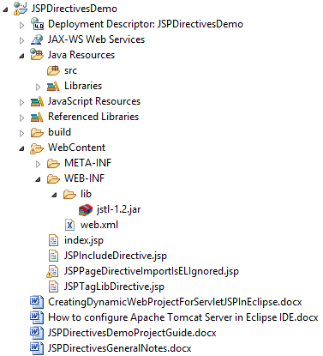

**Study following files very carefully:**

**web.xml:** This is deployment descriptor file for the given project. Study it to understand how we mapped welcome files.

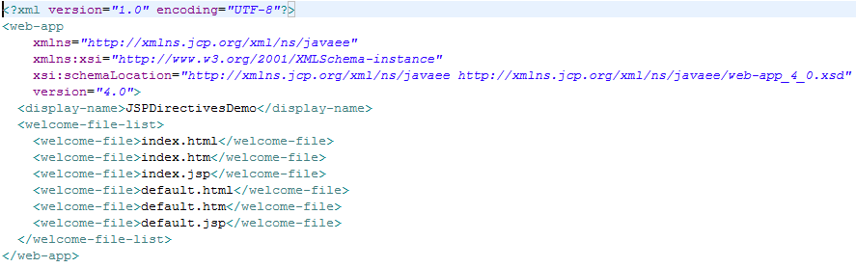

**Second file is index.jsp**

It simply contains links to various JSP pages which ultimately shows various JSP directives.

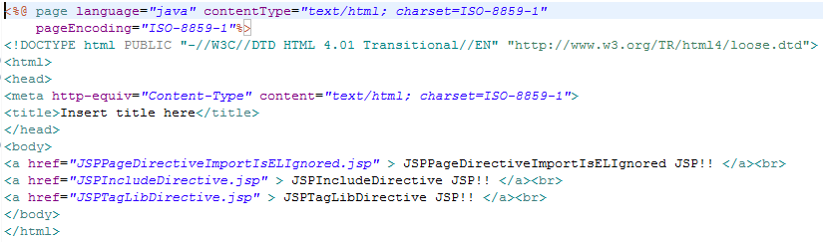

**JSPPageDirectiveImportIsELIgnored.jsp**

This page demonstrates 'import' and 'isELIgnored' page directives.

Note that default value of 'isELIgnored' is false.

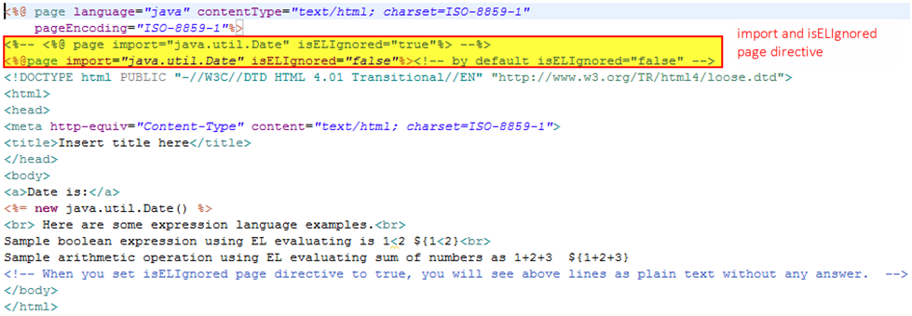

**JSPIncludeDirective.jsp**

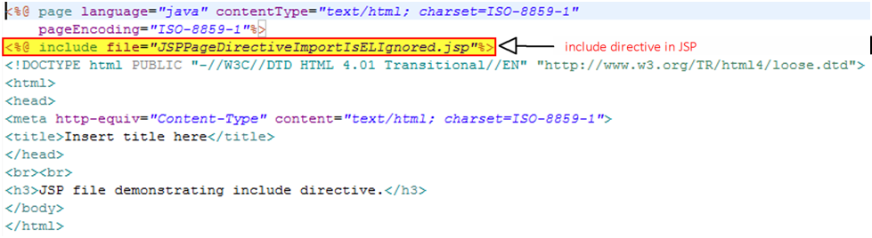

**JSPTagLibDirective.jsp**

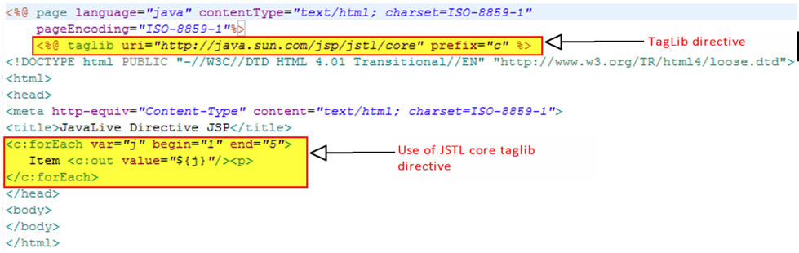

**Running the application:**

Right click on the project ->Run As->Run on Server

Welcome file viz. index.jsp get displayed. Now click on any link to study the functionality of respective JSP directives.

***\*\*While studying these output please study the code for respective JSP file (also mentioned in this project guide file as screen shot) for better understanding of that particular JSP Action tag.***

**index.jsp**

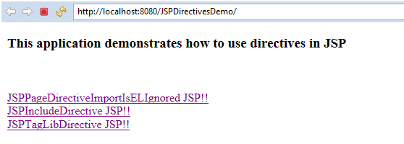

*Please refer screen shot of FilesToInlcude.jsp and IncludeAction.jsp for better understanding of following output. It is very simple and straight forward.*

**JSPPageDirectiveImportIsELIgnored.jsp**

with isELIgnored=false

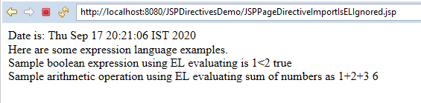

with isELIgnored=true

Please note that when isELIgnored is set to true, EL expression is treated as plain text hence the following output.

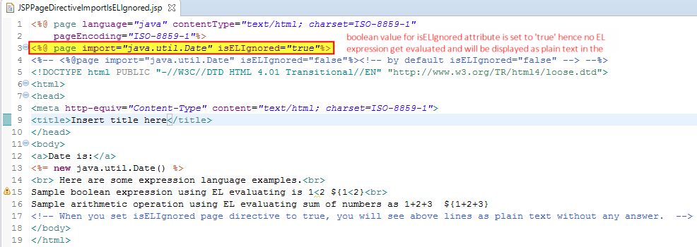

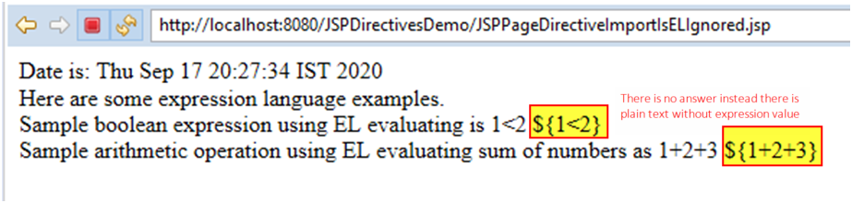

**JSPIncludeDirective.jsp**

This directive include file during translation of given jsp file.

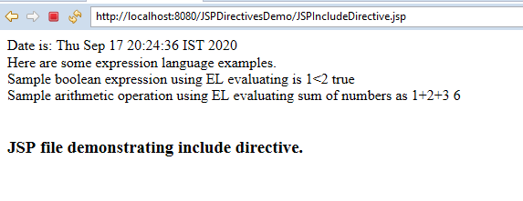

**JSPTagLibDirective**

*Please refer screen shot of file ' JSPTagLibDirective.jsp' for better understanding of below output.*

