**\*\*Please refer' JSTL General Notes.docx' file in this project for theory part of this project for better understanding of the concept.**

**What this project do?**

**This project demonstrates introduction and use of Expression language and JSP Standard Tag Library i.e. JSTL.**

**How to create this project??**

**This is non maven 'Dynamic web project'.**

Refer file 'CreatingDynamicWebProjectForServletJSPInEclipse.docx' in this project folder for getting more details about how to create 'Dynamic web project' in eclipse.

If you don't know about configuring Apache Tmocat server, please refer file 'How to configure Apache Tomcat Server in Eclipse IDE.docx' in this project for more details.

**This project is pure xml based i.e. elements are mapped in web.xml file.**

**First of all carefully study the project structure of this project (i.e. 'Dynamic Web Project')**

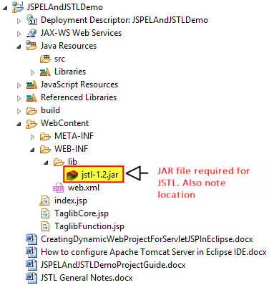

**Study following files very carefully:**

**web.xml:** This is deployment descriptor file for the given project. Study it to understand how we mapped welcome files.

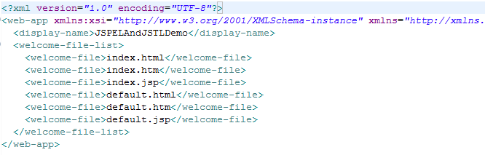

**Second file is index.jsp**

It simply contains links to various JSP pages which ultimately shows various JSTL tags.

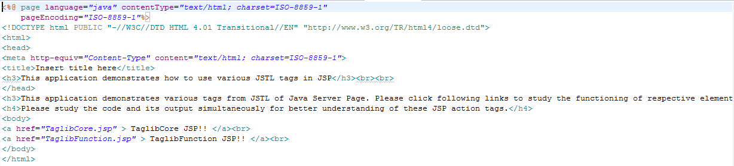

**TaglibCore.jsp**

This file contains various JSTL core tags.

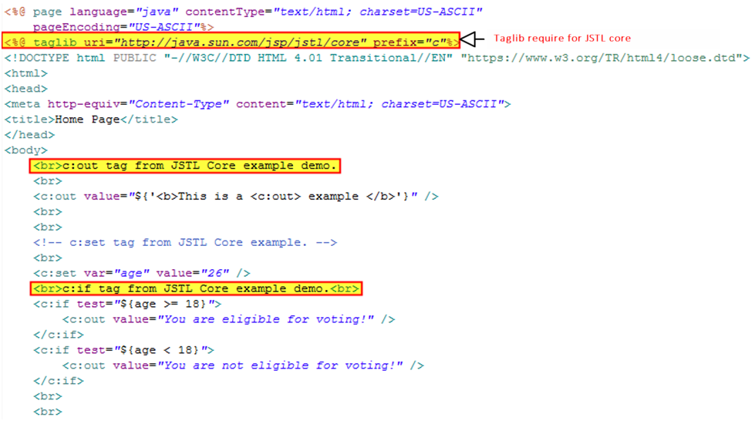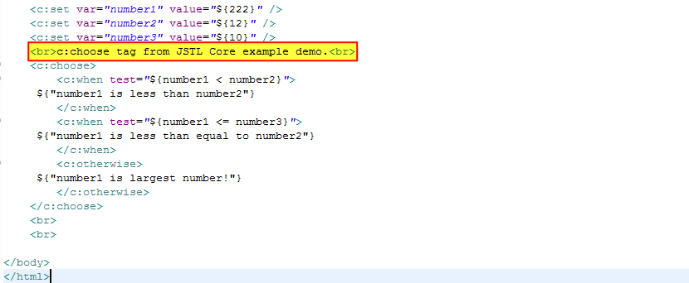

**TaglibFunction.jsp**

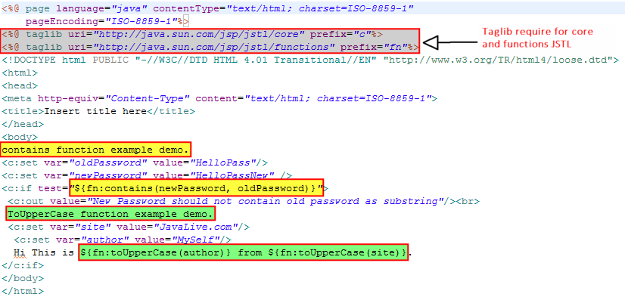

**Running the application:**

Right click on the project ->Run As->Run on Server

Welcome file viz. index.jsp get displayed. Now click on any link to study the functionality of respective JSTL.

***\*\*While studying these output please study the code for respective JSP files viz. TaglibCore.jsp and TaglibFunction.jsp (also mentioned in this project guide file as screen shot above) for better understanding of that particular JSP Action tag.***

**index.jsp**

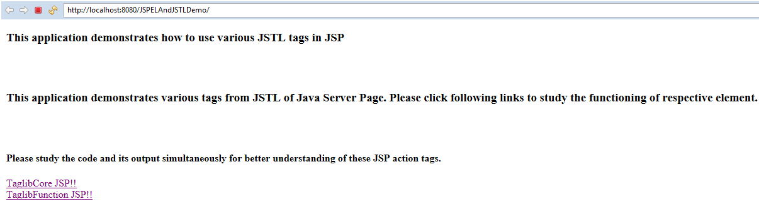

**TaglibCore**

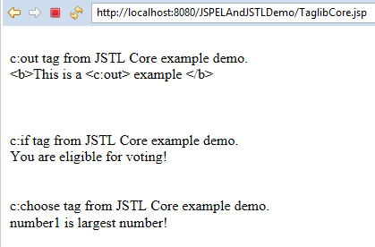

**TaglibFunction**

