**What this project does?**

**This project demonstrates how we can handle exceptions in servlet and jsp application.**

**How to create this project??**

**This is non maven 'Dynamic web project'.**

Refer file 'CreatingDynamicWebProjectForServletJSPInEclipse.docx' in 'ServletDemo' project folder for getting more details about how to create 'Dynamic web project' in eclipse.

**This project is pure xml based i.e. elements are mapped in web.xml file.**

**First of all carefully study the project structure of this project (i.e. 'Dynamic Web Project')**

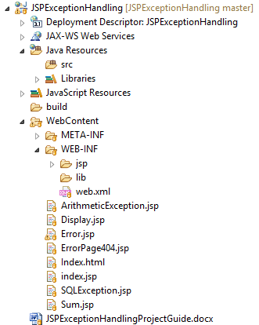

**This project does not contains any servlet.**

**Study following files very carefully:**

**1. web.xml:** This is deployment descriptor file for the given project. Study it to understand how we mapped error pages in two different ways.

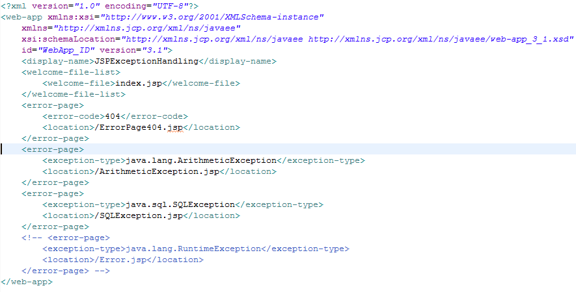

Functioning of the project

Error in JSP servlet application handle in two different ways

**A) Error handling at application level**

a) with error-code:- This type is used to handle the error with the help of error code.

In our application if 404 i.e. source not found exception occurs then page specified in web.xml file i.e. WEB-INF/jsp/errorpages/ErrorPage404.jsp is rendered to user. Carefully study page directive isErrorPage of file WEB-INF/jsp/errorpages/ErrorPage404.jsp

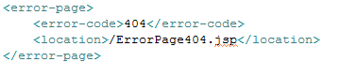

To activate this functioning in our project, just uncomment code



in file Sum.jsp

b) with error-type:- Here we have explained two Exception subclasses here generally used in servlet-jsp applications.

1. java.lang.ArithmeticException

<error-page>

<exception-type>java.lang.ArithmeticException</exception-type>

<location>/ArithmeticException.jsp</location>

</error-page>

Now when ArithmeticException occurs in the application, /ArithmeticException.jsp page rendered to the user.

Carefully study page directive isErrorPage of file /ArithmeticException.jsp

To activate this functioning in our project, just **set y=0** in Sum.jsp file.

2. java.sql.SQLException

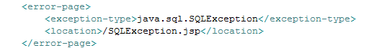

Now when any SQL related Exception occurs in the application, /SQLException.jsp page rendered to the user.

Carefully study page directive isErrorPage of file /ArithmeticException.jsp

To activate this functioning in our project, just **set x=5** in Sum.jsp file.

Both of a and b above are at application level and they are mapped in web.xml file

**B) Error handling at page level:-**

Now to handle the error at page level, create custom error page with isErrorPage="true" directive (Error.jsp in our case) and set value of errorPage directive to the above files path.

**It sets Error.jsp page as default error handling page for file Sum.jsp so if any exception occurs in Sum.jsp page other than that are mapped in web.xml file,Error.jsp page is rendered to the user.**

Syntax: <%@ page errorPage=*"Error.jsp"*%>

Study file Sum.jsp carefully for this.

Now when any errors other than ArithmeticException and SQLException occurs in page Sum.jsp then page Error.jsp renders to the user.

To activate the functioning, uncomment line

**throw** **new** RuntimeException("Error condition!!!");

in Sum.jsp file

Sum.jsp file is as below. Please read the comments very carefully.

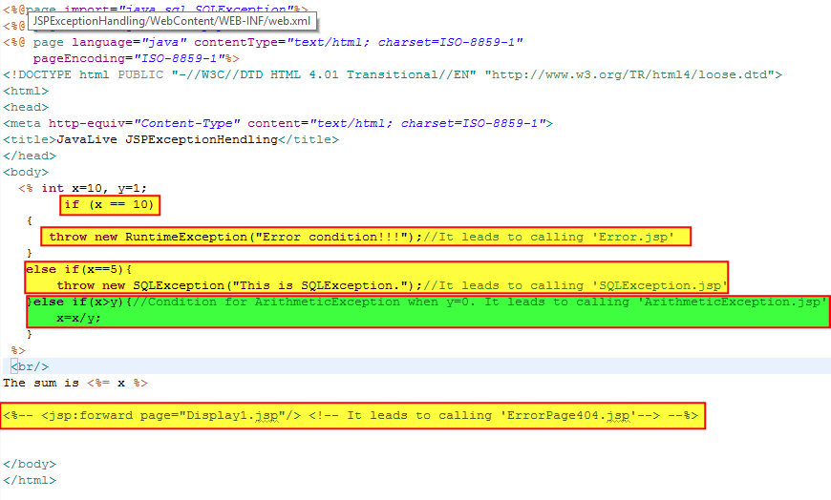

Error.jsp file is as below:

