**\*\*Please go through theory part of JSP Expression Language and its uses from our notes for better understanding of the concept.**

**\*\*Also refer file 'IntroductionToJSPExpressionLanguage.docx' in this project for more notes.**

**What this project do?**

**This project demonstrates jsp Expression Language i.e. EL.**

**How to create this project??**

**This is non maven 'Dynamic web project'.**

Refer file 'CreatingDynamicWebProjectForServletJSPInEclipse.docx' in this project folder for getting more details about how to create 'Dynamic web project' in eclipse.

If you don't know about configuring Apache Tmocat server, please refer file 'How to configure Apache Tomcat Server in Eclipse IDE.docx' in this project for more details.

**This project is pure xml based i.e. elements are mapped in web.xml file.**

**First of all carefully study the project structure of this project (i.e. 'Dynamic Web Project')**

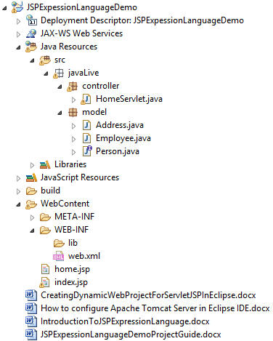

**Study following files very carefully:**

**web.xml:** This is deployment descriptor file for the given project. Study it to understand how we mapped context parameters and welcome files.

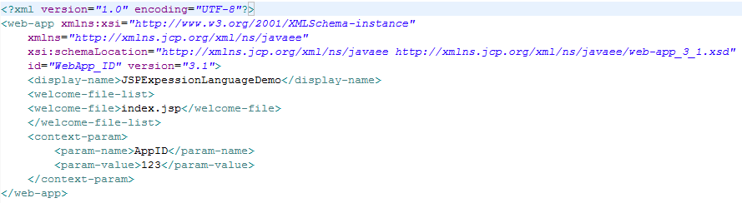

Second file is javaLive.controller.HomeServlet.java

This is main controller of this application. It declares and initialize objects of classes from model package and set them as attributes of various scopes and forwards the request to home.jsp where these attributes are displayed with the help of JSPs implicit objects.

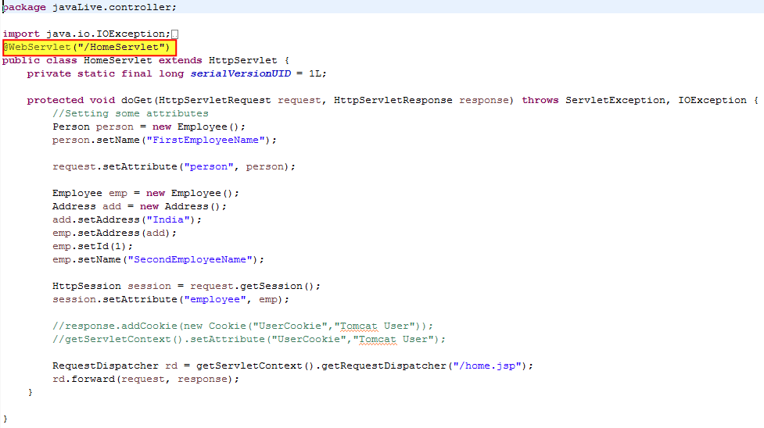

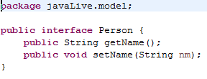

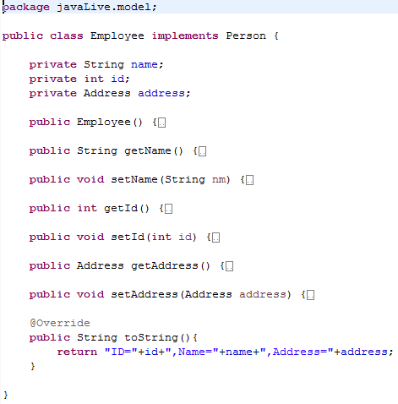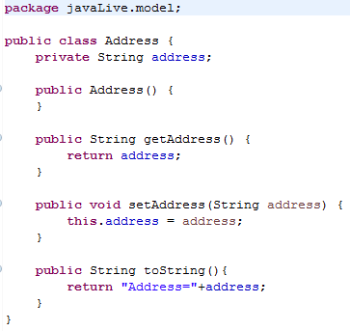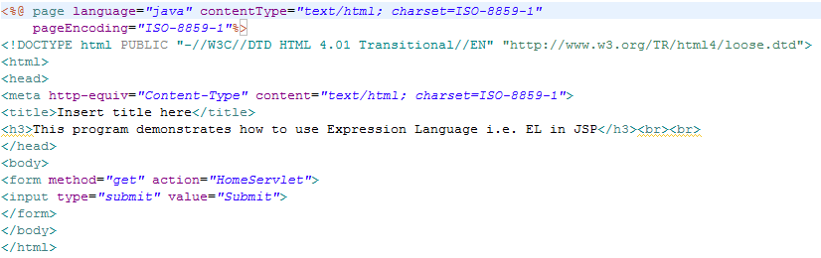

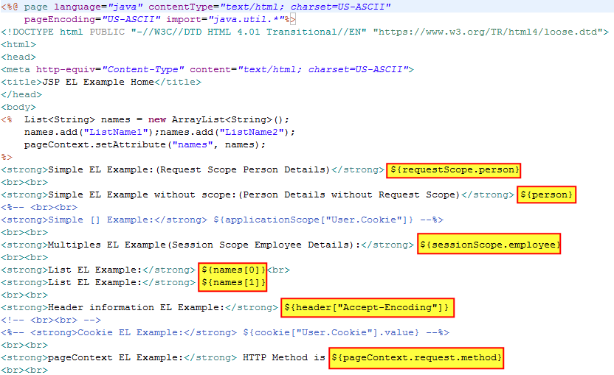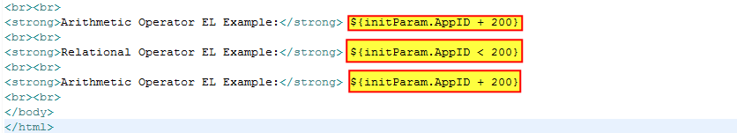

**Running the application:**

Right click on the project ->Run As->Run on Server

Welcome file viz. index.jsp get displayed. Now click on 'submit' button.

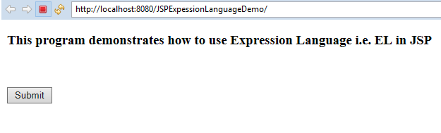Request get forwarded to HomeServlet controller where various attributes are added and then to home.jsp which displays values of various scopes attributes and init parameters, header values and list elements as below:

