**\*\*Please go through theory part of JSP implicit objects and their uses from our notes for better understanding of the concept.**

**What this project do?**

**This project demonstrates jsp implicit objects.**

**We simply set various attributes and context and servlet init parameters in 'MainServlet.java' servlet and web.xml respectively and access them with the help of jsp implicit objects in 'ImplicitObjetcs.jsp' file thereby we come to know how jsp implicit objects works.**

**How to create this project??**

**This is non maven 'Dynamic web project'.**

Refer file 'CreatingDynamicWebProjectForServletJSPInEclipse.docx' in this project folder for getting more details about how to create 'Dynamic web project' in eclipse.

If you don't know about configuring Apache Tmocat server, please refer file 'How to configure Apache Tomcat Server in Eclipse IDE.docx' in this project for more details.

**This project is pure xml based i.e. elements are mapped in web.xml file.**

**First of all carefully study the project structure of this project (i.e. 'Dynamic Web Project')**

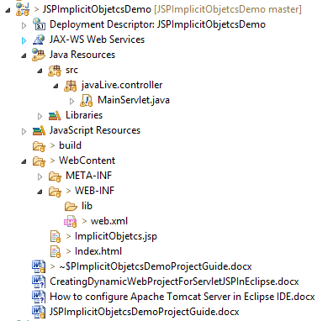

**Study following files very carefully:**

**web.xml:** This is deployment descriptor file for the given project. Study it to understand how we mapped context parameters, servlets , servlet init parameters and welcome files.

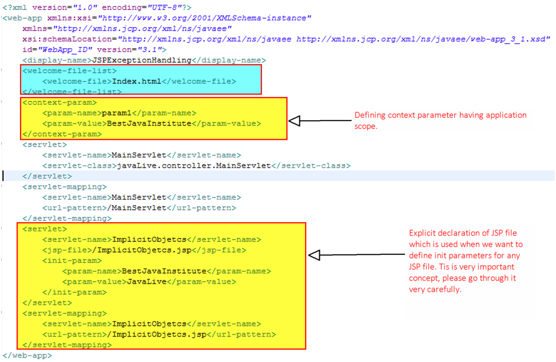

Second file is javaLive.controller.MainServlet.java

This is main controller of this application. It set attributes of various scopes and forwards the request to ImplictObjects.jsp where these attributes are displayed with the help of JSPs implicit objects.

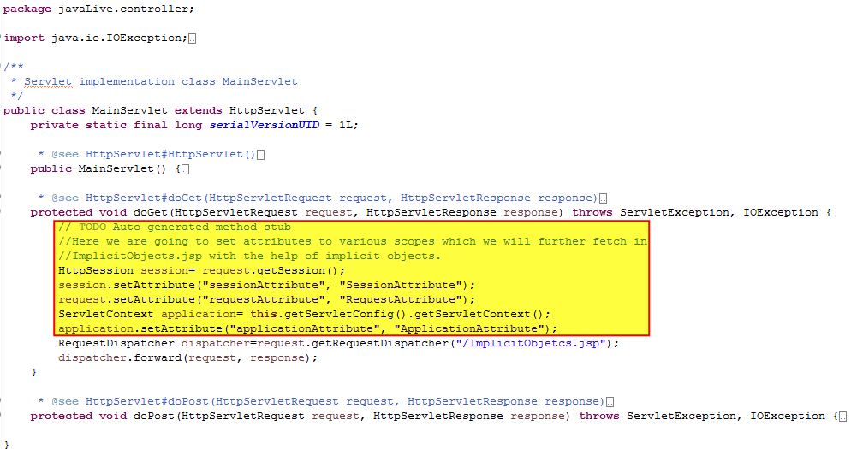

Next file is index.jsp which is welcome file of the application which just forwards the request to MainServlet.java.

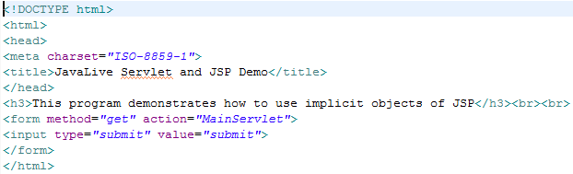

Next and most important file of this application is ImplicitObjects.jsp, which displays various scopes attributes and parameters with the help of JPS implicit objects. Please refer highlighted section of below screen shot for more details.

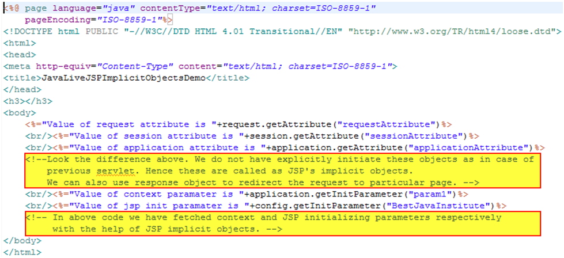

**Running the application:**

Right click on the project ->Run As->Run on Server

Welcome file viz. index.jsp get displayed. Now click on 'submit' button.

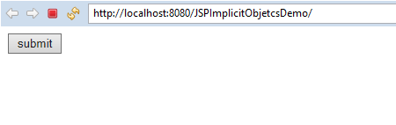

Request get forwarded to MainServlet controller and then to ImplicitObject.jsp which displays values of various scopes attributes and parameters as below

