**\*\*Please go through theory part of JSP elements and their uses from our notes for better understanding of the concept.**

**Please also refer file 'IntroductionToJSPElements.docx' in this project for theory part of JSP elements.**

**What this project do?**

**This project demonstrates various jsp elements and their uses in the application.**

**We have various jsp files in Web Content folder each explaining different jsp element.**

**How to create this project??**

**This is non maven 'Dynamic web project'.**

Refer file 'CreatingDynamicWebProjectForServletJSPInEclipse.docx' in this project folder for getting more details about how to create 'Dynamic web project' in eclipse.

If you don't know about configuring Apache Tmocat server, please refer file 'How to configure Apache Tomcat Server in Eclipse IDE.docx' in this project for more details.

**This project is pure xml based i.e. elements are mapped in web.xml file.**

**First of all carefully study the project structure of this project (i.e. 'Dynamic Web Project')**

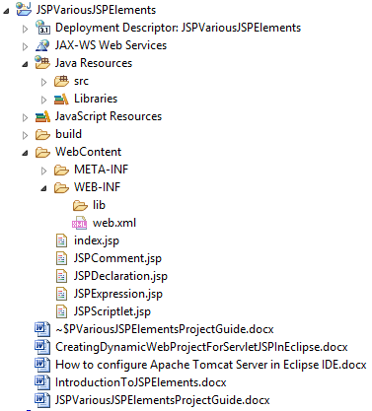

**Study following files very carefully:**

**web.xml:** This is deployment descriptor file for the given project. Study it to understand how we mapped welcome files.

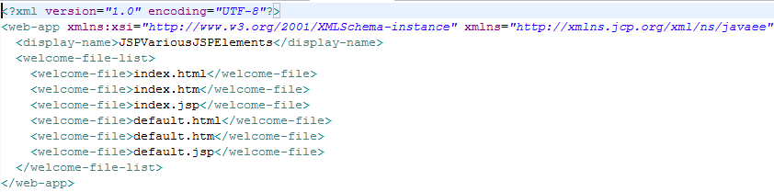**index.jsp**

This is the welcome file of the application which simply contains links to other JSPElement files. Please click them one by one to understand their functioning.

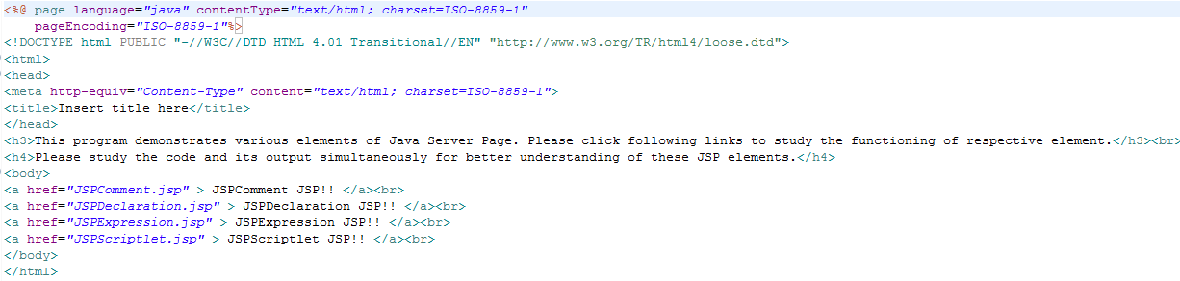

**JSPComment.jsp**

This file is responsible for explaining how to comment any text in .jsp file.

**Please note that for this file observe following code as we can't see comment in its output.

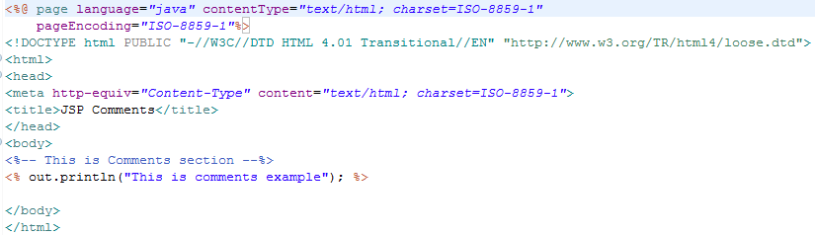

**JSPDeclaration.jsp**

This file explains how to use JSP Declaration.

Please refer below screen shot.

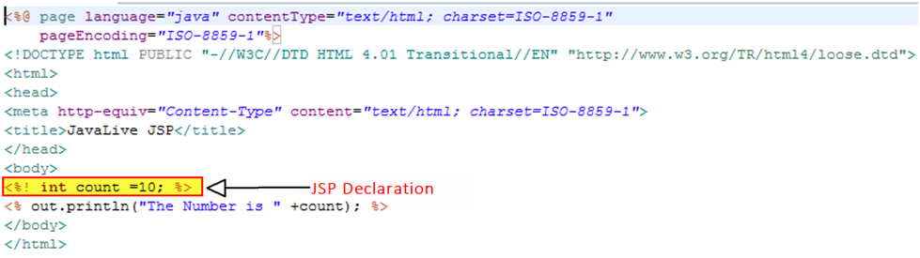

**JSPExpression.jsp**

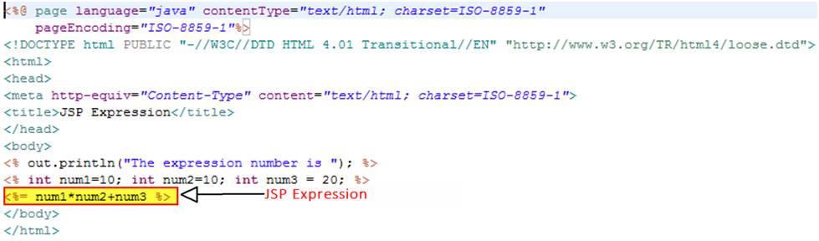

**JSPScriptlet.jsp**

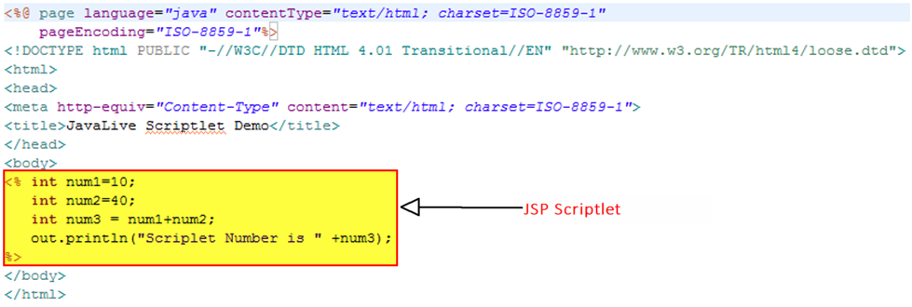

**Running the application:**

Right click on the project ->Run As->Run on Server.

Welcome file viz. index.jsp get displayed. Now click on 'submit' button.

Please click given links one by one to study respective JSP element.

As mentioned in screen shot below, study respective .jsp file code for better understanding of the output.

