**What this project does?**

This project demonstrates:

**A) How to create init parameters for**

1. application scope

2. servlet scope

**Both of above are declared in web.xml file.**

**B) How to create attributes for**

1. request scope

2. application scope

3. session scope

We have declared parameters in web.xml file and attributes in controllers.First.java servlet. We read their values in controllers.Second.java file.

**How to create this project??**

**This is non maven 'Dynamic web project'.**

Refer file 'CreatingDynamicWebProjectForServletJSPInEclipse.docx' in 'ServletDemo' project folder for getting more details about how to create 'Dynamic web project' in eclipse.

**This project is pure xml based i.e. elements of this projects are mapped in web.xml file.**

**First of all carefully study the project structure of this project (i.e. 'Dynamic Web Project')**

**Study following files very carefully:**

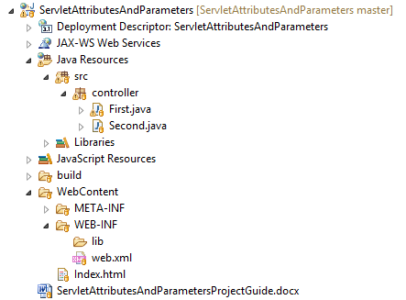

**1. web.xml:** This is deployment descriptor file for the given project. Study it to understand how welcome file defined, init parameters for context and servlets are mapped.

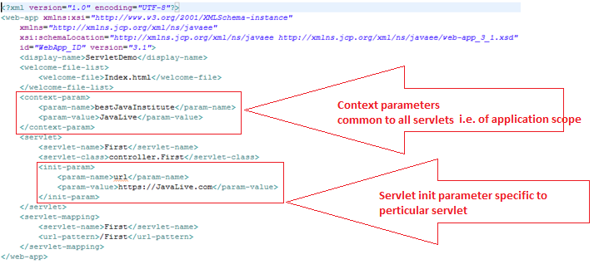

**2. Servlets** : controllers.First.java to study the declaration of attributes in various scopes: 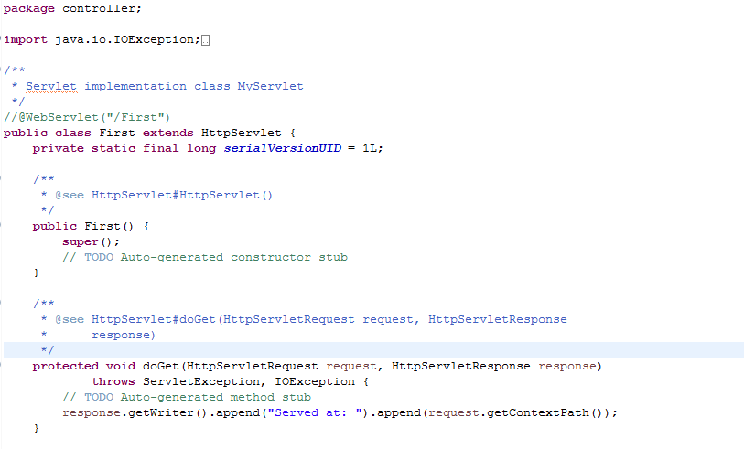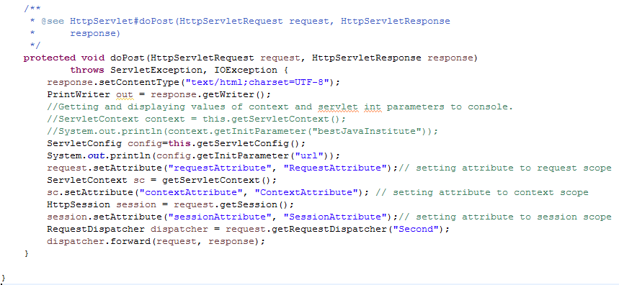

controllers.Second.java to study how we read these values:

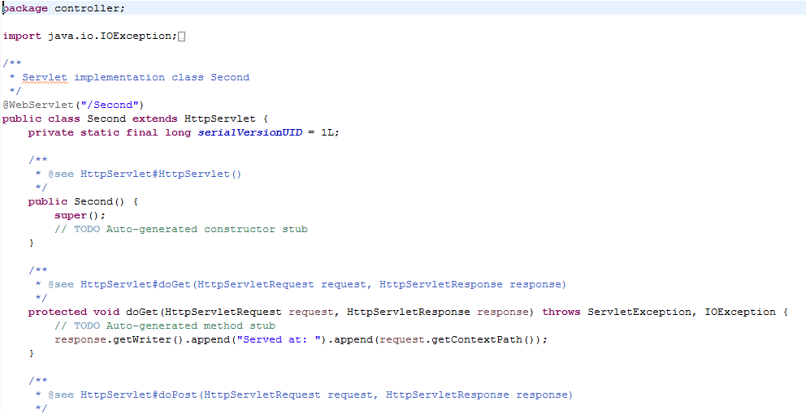 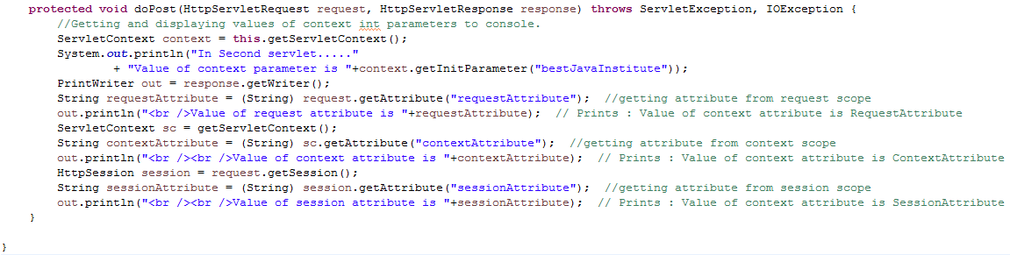

Now run the project as follows:

Right click on the project-> Run As -> Run on Server -> Select the project under 'configured' -> Finish

It will shows output as follows:



Click submit

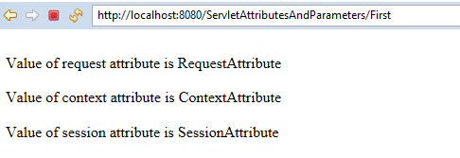

Please study above output which shows how we read and display attributes of various scopes.(this code of displaying these values is included in servlet Second.java)

Also go through the console output as follows:



**This output is mainly regarding servlet init parameter(which is in first line) and context parameter which we have set in web.xml. Please refer screen shot of web.xml in initial section of this file.**