Creating First Servlet Application using Eclipse IDE

**Eclipse** IDE is the most popular Java IDE used in the Industry. It is developed by an open source community and can be downloaded for free from [Eclipse.org](https://www.eclipse.org/)

Steps to create Servlet using Eclipse IDE

To create a Servlet application in Eclipse IDE you will need to follow the following steps:

1. Goto **File** -> **New** -> **Dynamic Web Project**

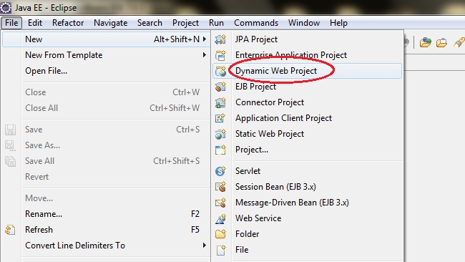

1. Give a Name to your Project and click **Next**

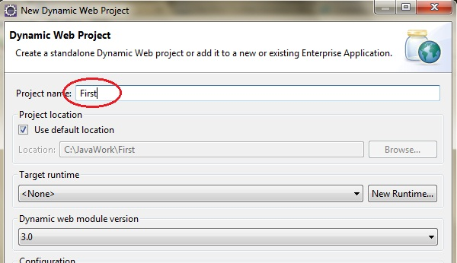

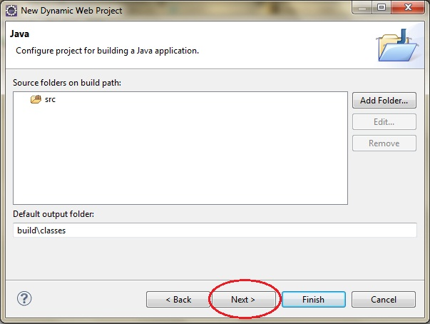

1. Check **Generate web.xml Deployment Descriptor** and click **Finish**

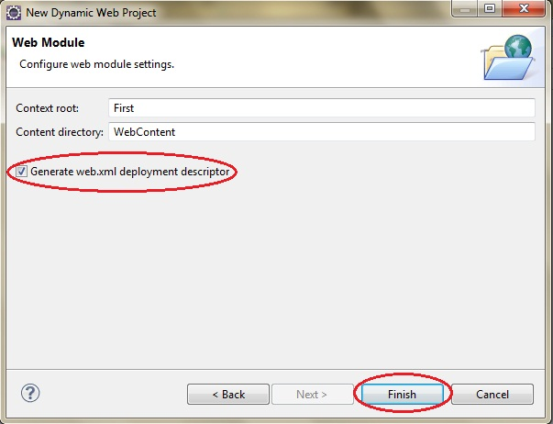

1. Now, the complete directory structure of your Project will be automatically created by Eclipse IDE.

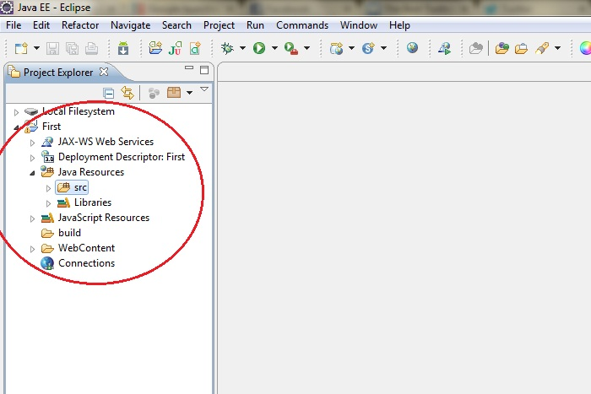

1. Click on **First** project, go to **Java Resources** -> **src**. Right click on **src** select **New** -> **Servlet**

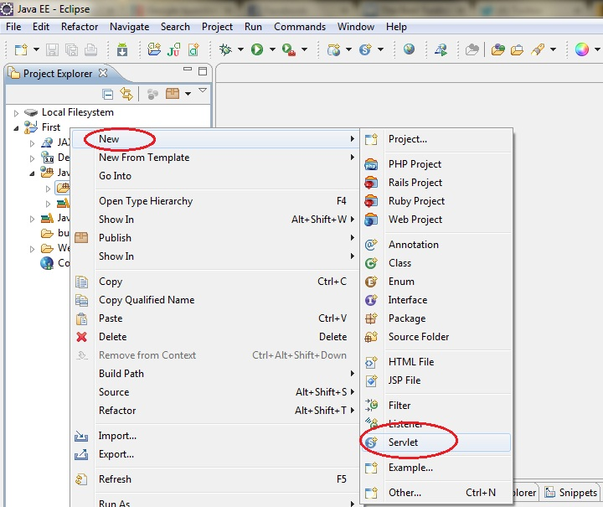

1. Give Servlet class name and click **Next**

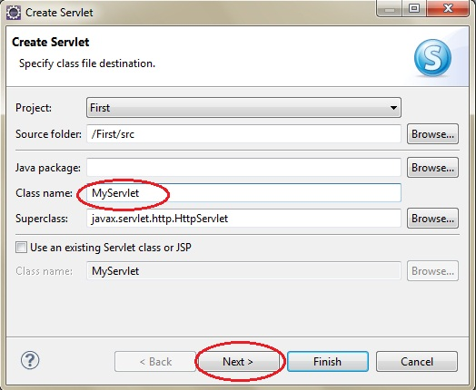

1. Give your Servlet class a Nmae of your choice.

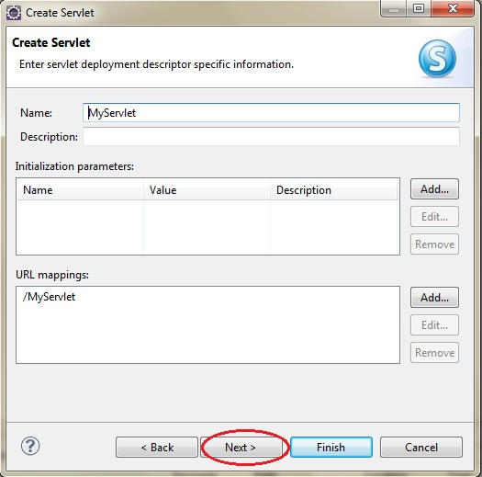

1. Leave everything else to default and click **Finish**

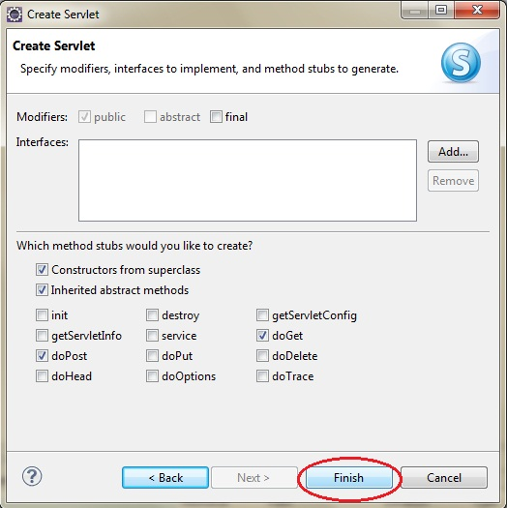

1. Now your Servlet is created, write some code inside it. You can take reference from the code in the picture below.

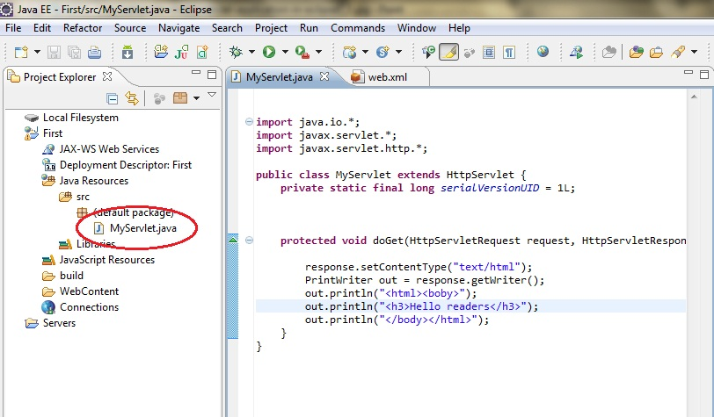

1. Add **servlet-api.jar** JAR file to your project. Click on **Libraries**, right click on **Web App Libraries** select **Build Path** -> **Configure Build Path**

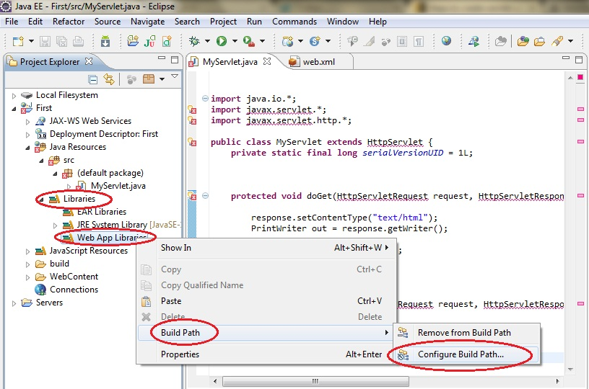

1. Click on **Add External JARs**

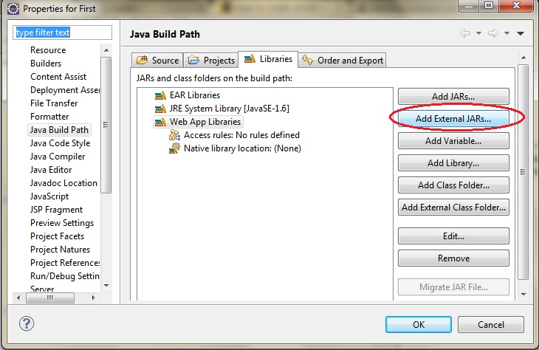

1. This JAR is now added to your project's build path.
2. Select **servlet-api.jar** from **Apache Tomcat Directory**

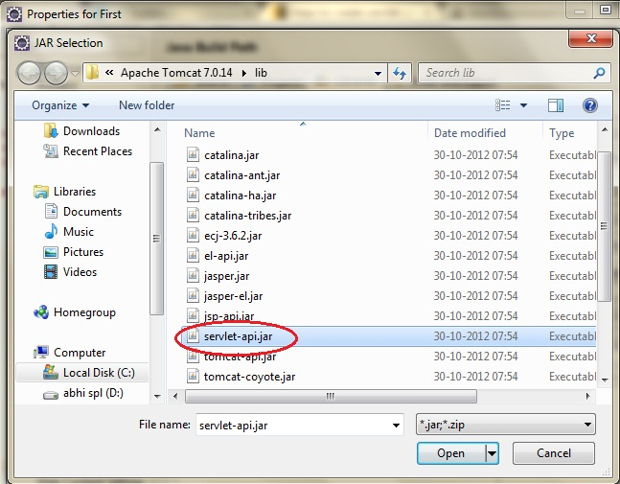

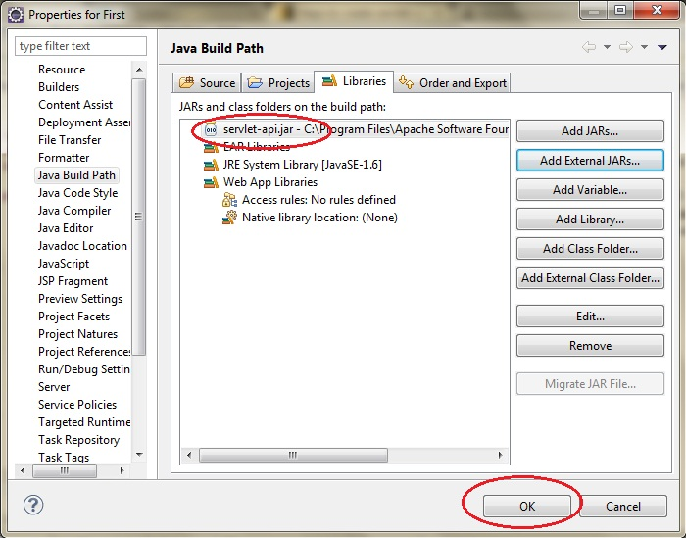

1. Now all you have to do is Start the server and run the application.

