**What this project does?**

**This project demonstrates use of filters in servlet and jsp application.**

Before going forward, please go through theory part of servlet filter mentioned in the notes of Servlet and JSP

Also go through project 'ServletJSPHibernateXMLFullAp' for more example of servlet filter.

**How to create this project??**

**This is non maven 'Dynamic web project'.**

Refer file 'CreatingDynamicWebProjectForServletJSPInEclipse.docx' in 'ServletDemo' project folder for getting more details about how to create 'Dynamic web project' in eclipse.

This project illustrates how J2EE filters work with servlet and jsp

**This project is pure xml based i.e. elements are mapped in web.xml file.**

**First of all carefully study the project structure of this project (i.e. 'Dynamic Web Project')**

Especially src folder, Web Content folder(where welcome files are stored and web.xml file. Their location and structure.)

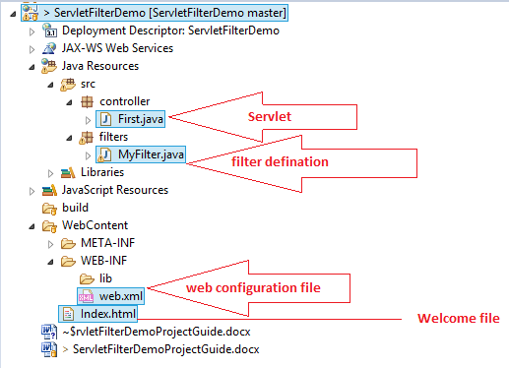

**Study following files very carefully:**

**1. web.xml:** This is deployment descriptor file for the given project. Study it to understand how welcome file defined, how servlet and filters mapped etc.

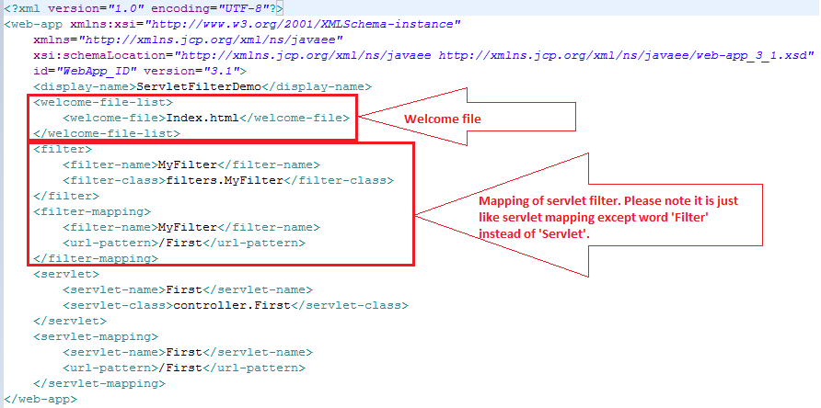

**2. Servlets** of this projects are in 'controller' package.

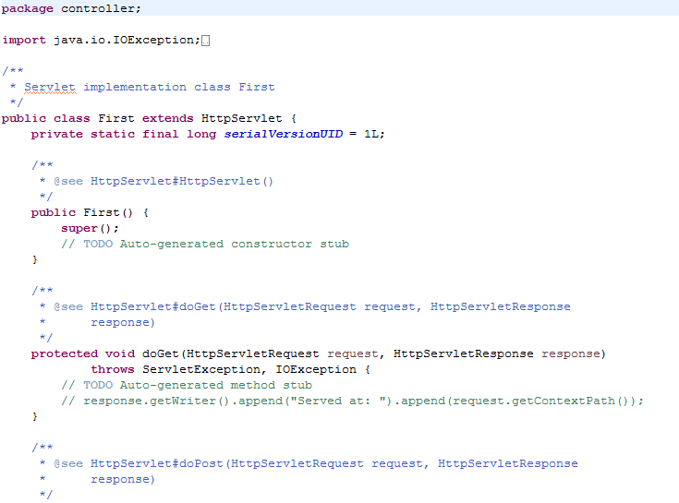 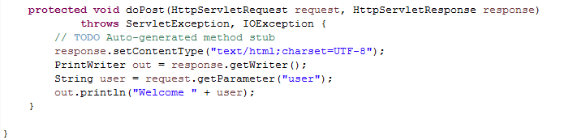

**3. Filter** of this project is in 'filters' package.

**Go through doFilter method of the filter where we (only for study purpose, otherwise this task can easily done by any other mean) validate username and password enter buy user for any blank space and displays a message accordingly.

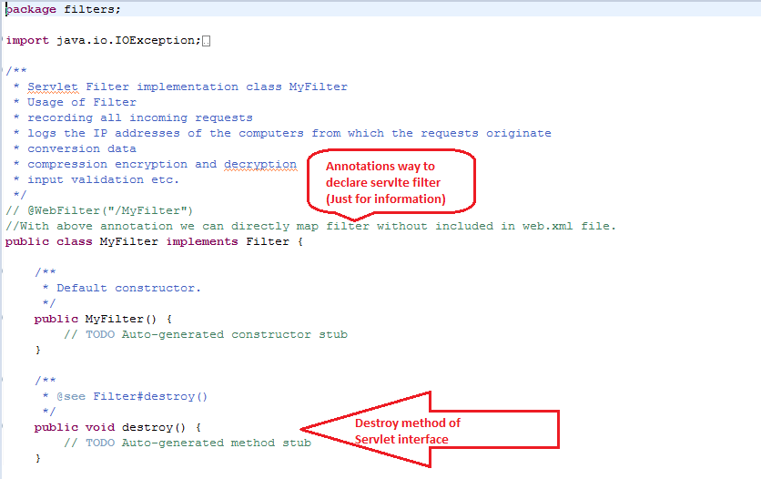 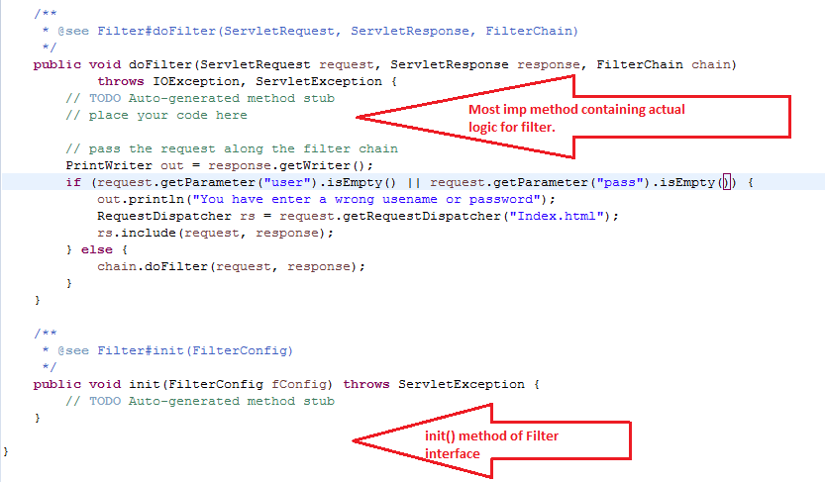

**Please go through the mapping of the filter in web.xml file.**

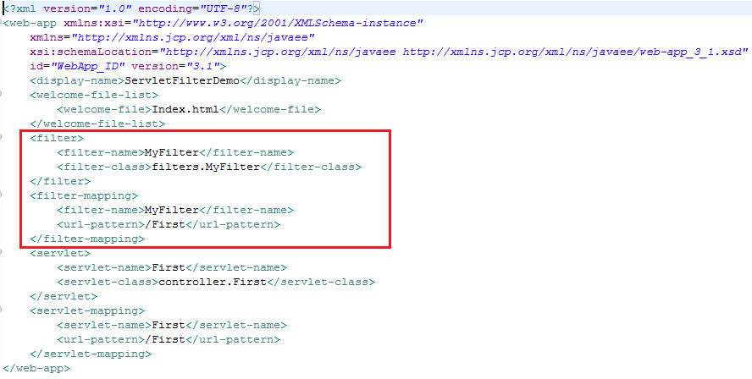

Now run the application:

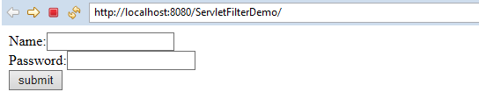

Now simply click submit button directly without entering any values you will get

**following screen as filter checks whether these text fields are blank.**

**(**Please note that this is 'NOT AT ALL' the way of validation of form fields. This is only to understand how actually servlet filters works.)**

**Some common tasks that we can do with servlet filters are:**

* **Logging request parameters to log files.**
* **Authentication and authorization of request for resources.**
* **Formatting of request body or header before sending it to servlet.**
* **Compressing the response data sent to the client.**
* **Alter response by adding some cookies, header information etc.**

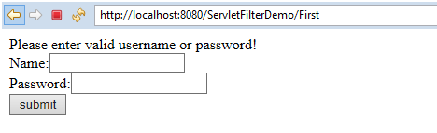

Now enter any values and click 'submit' button. You will get following output.

