How to create sessions with a unique session id for each user in java servlet

For this, servlets provide an interface called‘**HttpSessionInterface’.** The following diagram explains how Http Sessions work in servlets:  
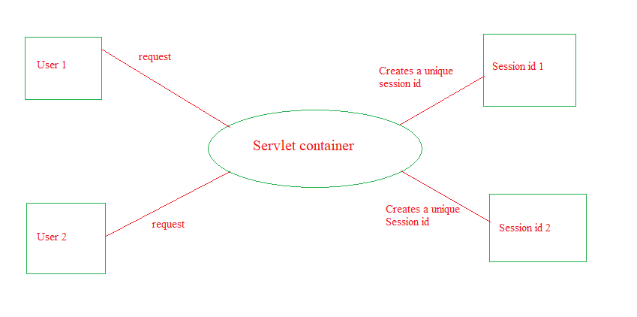

**Note that till now we have covered three different types to manage session in Servlet JSP application viz. using cookies, using URL Rewriting, using Hidden Form Field etc. **This is fourth type or way to manage session in Servlet and JSP app. Among all this is the most important one as it is used very widely in industry.**

**What this project does?**

**This project demonstrates how to use** [**javax**](eclipse-javadoc:%E2%98%82=ServletSessionHTTPSessionDemo/E:%5C/Prashant%5C/Java%5C/Eclipes%5C/sts3.9.2%5C/sts-bundle%5C/pivotal-tc-server-developer-3.2.8.RELEASE%5C/tomcat-8.5.23.A.RELEASE%5C/lib%5C/servlet-api.jar%3Cjavax)**.**[**servlet**](eclipse-javadoc:%E2%98%82=ServletSessionHTTPSessionDemo/E:%5C/Prashant%5C/Java%5C/Eclipes%5C/sts3.9.2%5C/sts-bundle%5C/pivotal-tc-server-developer-3.2.8.RELEASE%5C/tomcat-8.5.23.A.RELEASE%5C/lib%5C/servlet-api.jar%3Cjavax.servlet)**.**[**http**](eclipse-javadoc:%E2%98%82=ServletSessionHTTPSessionDemo/E:%5C/Prashant%5C/Java%5C/Eclipes%5C/sts3.9.2%5C/sts-bundle%5C/pivotal-tc-server-developer-3.2.8.RELEASE%5C/tomcat-8.5.23.A.RELEASE%5C/lib%5C/servlet-api.jar%3Cjavax.servlet.http)**.HttpSession object to create and maintain HTTP session in servlet JSP project.**

**Before going forward please go through theory part of how to create and maintain HTTP Session in JSP Servlet Notes .**

**How to create this project??**

**This is non maven 'Dynamic web project'.**

Refer file 'CreatingDynamicWebProjectForServletJSPInEclipse.docx' in 'ServletDemo' project folder for getting more details about how to create 'Dynamic web project' in eclipse.

**This project is partial xml based i.e. servlet files in controller package are declared with @WebServlet annotation and only welcome files are mapped in web.xml.**

**Note that this project is possible with pure annotation based approach by removing web.xml file. You can try it out with little R & D.**

**First of all carefully study the project structure of this project (i.e. 'Dynamic Web Project')**

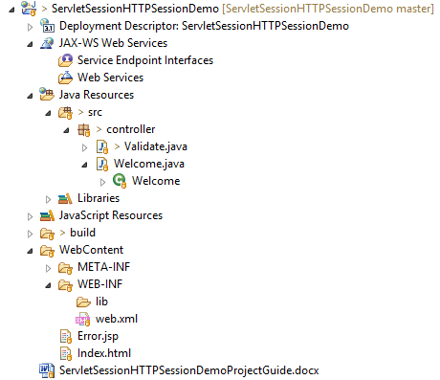

Especially src folder, Web Content folder(where welcome files are stored and web.xml file. Their location and structure.)

**Study following files very carefully:**

**1. web.xml:** This is deployment descriptor file for the given project. But as this is partial xml based project, it only contains welcome file list.

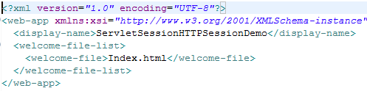

**2. Servlets** of this projects are in 'controller' package. We have mapped them with help of annotation hence their mapping are not present in web.xml

**Now here are two servlets viz. Validate.java and Welcome.java

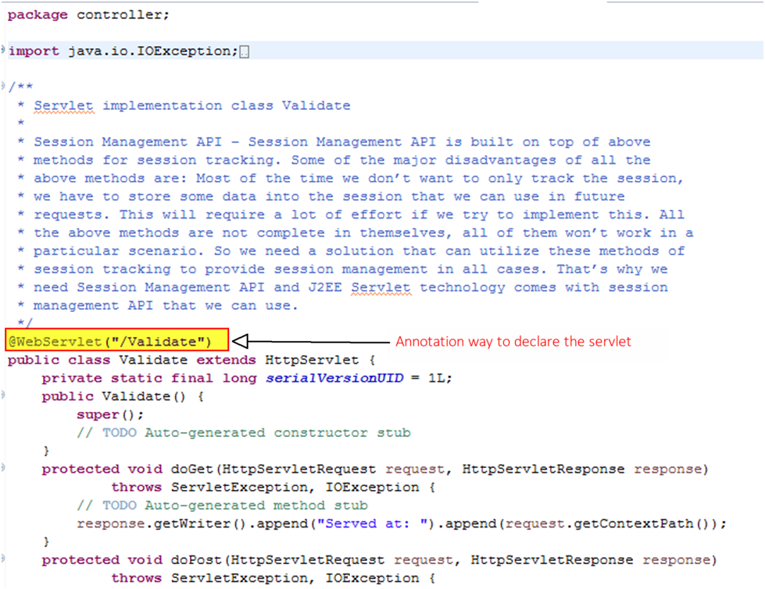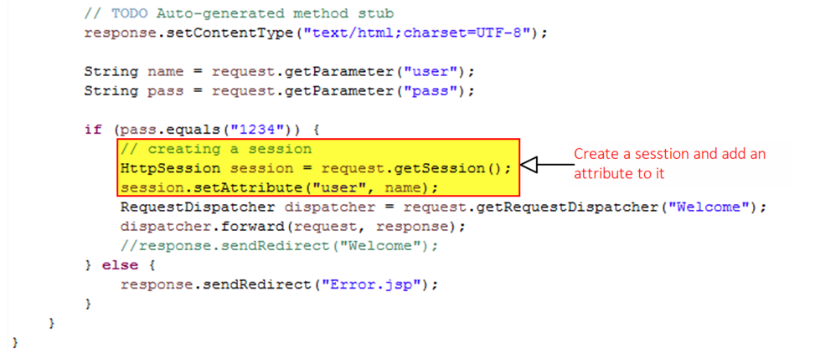

##### Validate contains core operation. It verifies user input and if password of the user matches with particular condition it creates new object of interface [javax](eclipse-javadoc:%E2%98%82=ServletSessionHTTPSessionDemo/E:%5C/Prashant%5C/Java%5C/Eclipes%5C/sts3.9.2%5C/sts-bundle%5C/pivotal-tc-server-developer-3.2.8.RELEASE%5C/tomcat-8.5.23.A.RELEASE%5C/lib%5C/servlet-api.jar%3Cjavax).[servlet](eclipse-javadoc:%E2%98%82=ServletSessionHTTPSessionDemo/E:%5C/Prashant%5C/Java%5C/Eclipes%5C/sts3.9.2%5C/sts-bundle%5C/pivotal-tc-server-developer-3.2.8.RELEASE%5C/tomcat-8.5.23.A.RELEASE%5C/lib%5C/servlet-api.jar%3Cjavax.servlet).[http](eclipse-javadoc:%E2%98%82=ServletSessionHTTPSessionDemo/E:%5C/Prashant%5C/Java%5C/Eclipes%5C/sts3.9.2%5C/sts-bundle%5C/pivotal-tc-server-developer-3.2.8.RELEASE%5C/tomcat-8.5.23.A.RELEASE%5C/lib%5C/servlet-api.jar%3Cjavax.servlet.http).HttpSession and add attribute user to it and forward it to Welcome.java servlet

##### C:\Users\Administrator\Documents\DonationCoder\ScreenshotCaptor\Screenshots\Clip.png

##### Welcome.java servlet read value of user attribute added to session scope and displays welcome message on the console. If there is any other password other than specified, then it redirects to Error.jsp page.

**Now run the application as follows:**

Right click on the application-> Run As -> Run on Server

