Introduction to AOP
Aspect Oriented Programming (AOP) compliments OOPs because it provides modularity. But, the key unit of modularity here is considered as an aspect rather than class. Here, AOP breaks the program logic into distinct parts (called concerns). It is used to increase modularity by cross-cutting concerns.
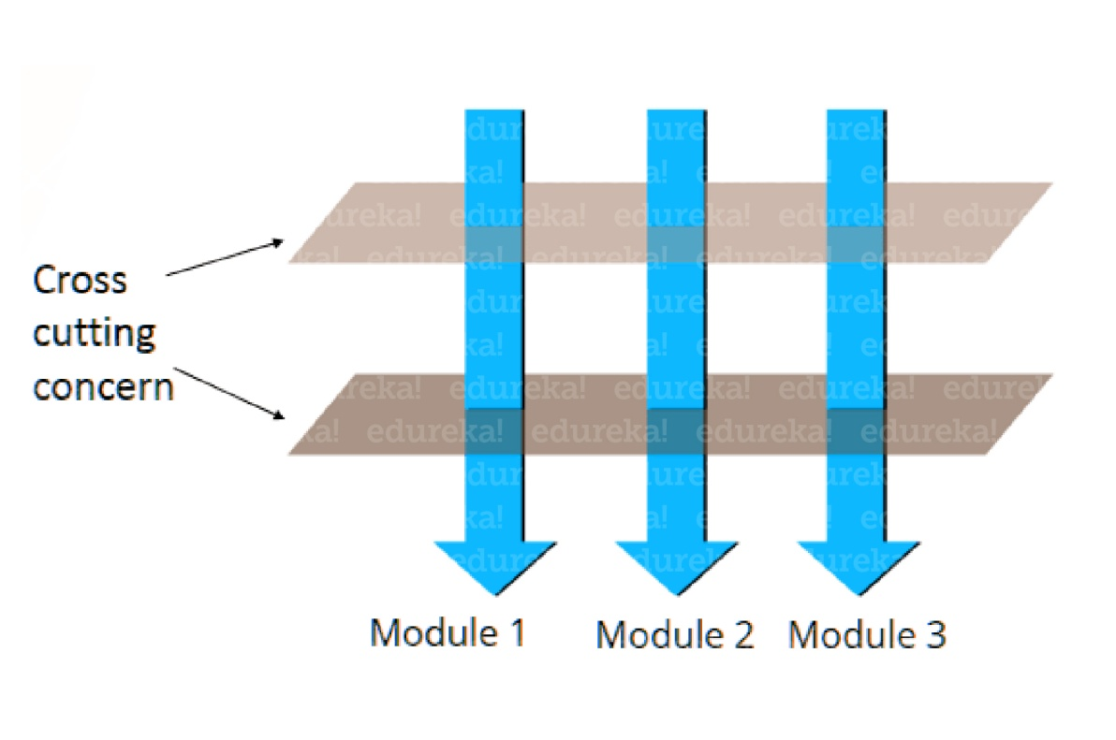A cross-cutting concern is the one that affects the whole application and should be centralized under the same block in the code, such as transaction management, authentication, logging, security etc. As we know Spring AOP enables Aspect-Oriented Programming in spring applications. Here, aspects enable the modularization of concerns such as transaction management, logging or security that cut across multiple types and objects (often termed crosscutting concerns). In this case, AOP provides a way to dynamically add the cross-cutting concern before, after or around the actual logic using simple pluggable configurations. By doing this, it makes easy to maintain code in the present and future as well. So, you can add/remove c/concerns without recompiling complete source code simply by changing configuration files (if you are applying aspects suing XML configuration).
I hope you understood the concepts of AOP and cross-cutting concerns. Now, let’s move further and see why we need AOP.

Why AOP?
The most important functionality is AOP provides the pluggable way to dynamically add the additional concern before, after or around the actual logic. Suppose there are 10 methods as shown in the figure:
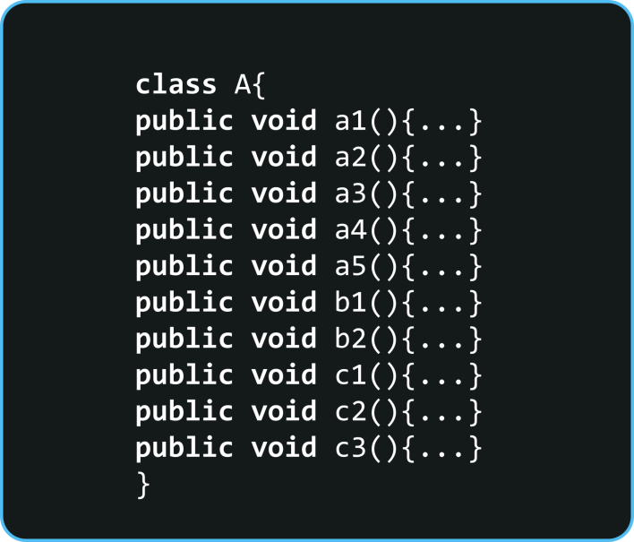You can see that there are 5 methods that start from a, 2 methods that start from b and 3 methods that starts from c.
First, let’s understand Scenario- Here, I have to maintain a log and send notification after calling methods that start from m. So what is the problem without AOP? Here, We can call methods (that maintains a log and sends notification) from the methods starting with a. In such a scenario, we need to write the code in all the 5 methods. But, in case if a client says in future, I don’t have to send a notification, you need to change all the methods. It leads to a maintenance problem. So with AOP, we have below solution.
The solution with AOP– With AOP, we don’t have to call methods from the method. We can simply define the additional concern like maintaining a log, sending notification etc. in the method of a class. Its entry is given in the XML file. Suppose in future, if a client says to remove the notifier functionality, we need to change only in the XML file. So, maintenance is easy in AOP.
That’s the whole concept of why we need Aspect Oriented Programming in Springs. Now let’s move further in this Spring AOP Tutorial blog and understand some core concepts of Aspect Oriented Programming.

Core AOP Concepts
Spring AOP consists of 7 core concepts which are depicted in the following diagram:
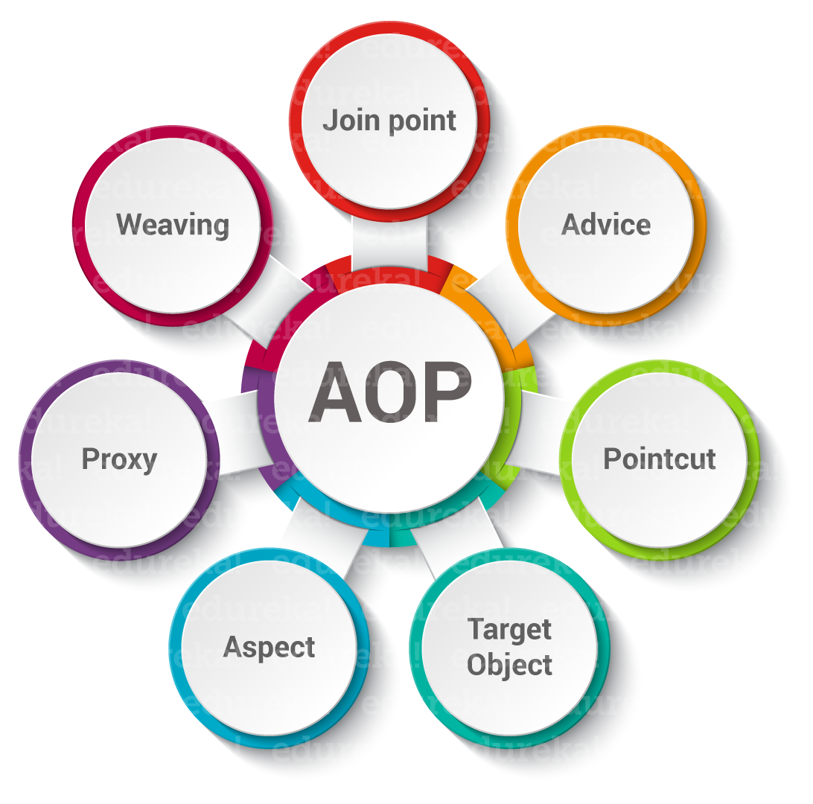
- Aspect: The aspect is nothing but a class that implements the JEE application concerns which cut through multiple classes, such as transaction management, security etc. Aspects can be a normal class configured through Spring XML configuration. It can also be regular classes annotated using @Aspect annotation.
- Pointcut: A Pointcut is an expression that is matched with join points to determine whether advice needs to be executed or not.
- Advice: Advice are the specific actions taken for a particular joinpoint. Basically, they are the methods that get executed when a certain joinpoint meets a matching pointcut in the application.
- Joinpoint: The joinpoint is a candidate point in the program execution where an aspect can be plugged in. It could be a method that is being called, an exception being thrown, or even a field being modified.
- Target Object: These are the objects on which advices are applied. In Spring AOP, a subclass is created at runtime where the target method is overridden and advices are included based on their configuration.
- Weaving: Weaving is the process of linking an aspect with other application types or objects to create an advised object.
- Proxy: It is an object that is created after applying advice to the target object. In clients perspective, object, the target object, and the proxy object are same.
Having understood this, let’s move further and see what are the steps required to create an AOP

Steps to create AOP Example
