Important note: Before going further you are requested to go through theory of AspectJ Aspect Oriented Programming(AOP) mentioned in JavaLive Notes on Spring AOP thoroughly so that you can understand the concept very well. (**This activity i.e. going through theory part of respective subject is applicable for each of our project.)

***You can also refer AOP note provided in this project in file ' SpringAOPNotes.docx'.

In this project we are using AspectJ AOP i.e. a specialized proxy based framework instead of Spring's AOP. to know the difference among them please go through following link:

https://www.baeldung.com/spring-aop-vs-aspectj

Also note that up to some extent we can say that AOP avails Interceptor like functionality to class's method level.

What this project does??

This project explains declaration and functioning of various element of Spring Aspect Oriented Programming i.e. AOP.

Note that this is xml based spring project having configuration file viz. ' spring-config.xml' in resources folder.

Steps to create project:-

1. Create quick start maven project. Refer file 'CreateQuickStartMavenProjectInEclipse.docx' in this project for more details.

2. Add require dependencies for spring as shown in pom.xml file.

3. Create required packages and add the files.

Please refer following screen shot of project structure:

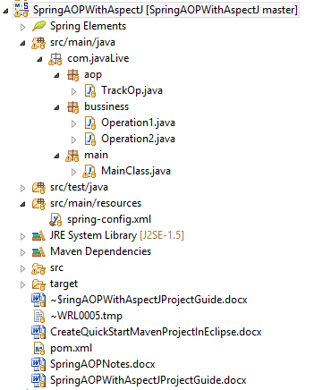

Functioning of the project

This is the best project to understand AOP in most simple manner. It consists on following files:

1. com.javaLive.bussiness.Operation1 and com.javaLive.bussiness.Operation1

Both of these files contains business logic methods as follows:
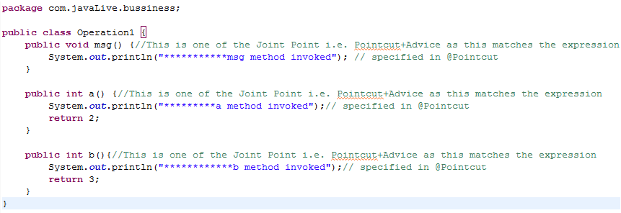
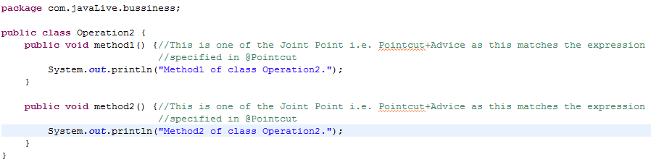

Note that these classes resembles real time business logic which we wants to monitor through AOP.

Now try to understand concept of AOP (viz. Joinpoint as given in the note) in reference with these files.

2. com.javaLive.aop.TrackOp :

Following is most important class of this project. This contains AOP related coding.

Now try to understand various concepts of AOP (viz. Aspect, Pointcut, Advice as given in the note) in reference with following file.(Please pay attention to annotations and comments in this file)
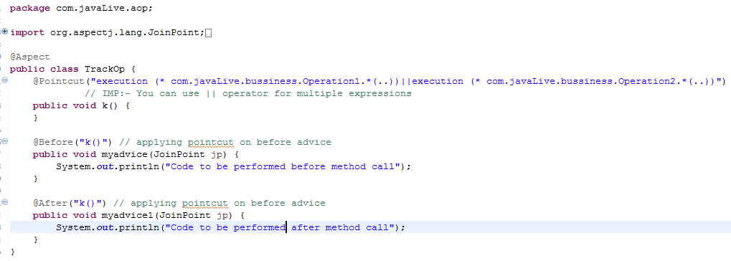

3. com.javaLive.main.MainClass:

This is main class of the application which get the beans form Spring ApplicationContext and calls various business methods of those beans. During this process pay attention to concepts of AOP like Target Object, Proxy and Weaving. We have explained them in the comment section f the file. Also refer notes for this.
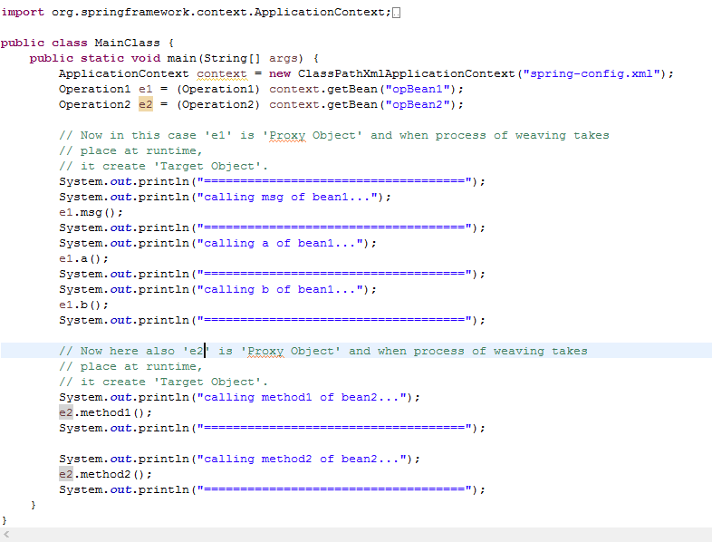4. src/main/resources/spring-config.xml:

This is Spring configuration file contains definition of various beans. Last bean defined is related to Auto Proxy Generation of AOP.
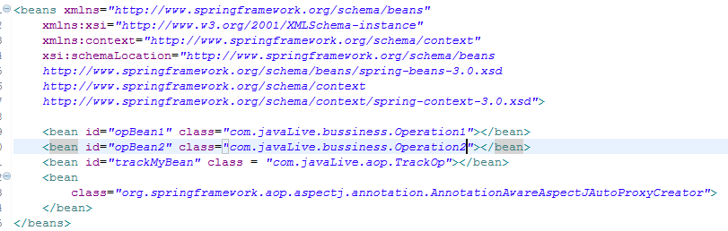

Now following is the output of file MainClass.java
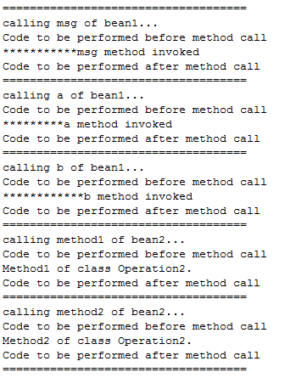

All this output can be understand with only one file i.e. TrackOp.

We have specified in @Pointcut expression that the specified operations should be applied to each method of Operation1 and Operation2 class.
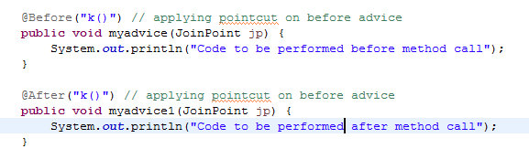

As we have defined @Before and @After advices hence in the output we got the specified messages.

Now last but not the least expression in the @Pointcut have many ways to define.

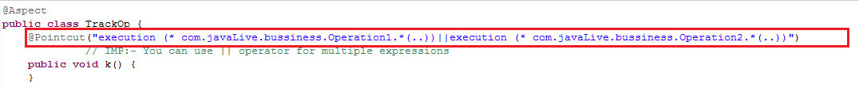

We have used only one of them. So please go through following links to know more about expressions in AspectJ AOP @Pointcut

https://howtodoinjava.com/spring-aop/aspectj-pointcut-expressions/

https://www.baeldung.com/spring-aop-pointcut-tutorial

