Before moving forward its compulsory to understand project ''SampleSpringBootProject'. Hence you are requested to study project 'SampleSpringBootProject' along with the project guide file and 'Introduction To Spring Boot application_properties File.docx' file very carefully.

Now moving forward:

**What this project dose??**

This project explains how to use logging framework Log4j2 in Spring Boot Application. (**Please note that we have used only Log4j2 and not used SLF4j here with it.)

**Project structure:**

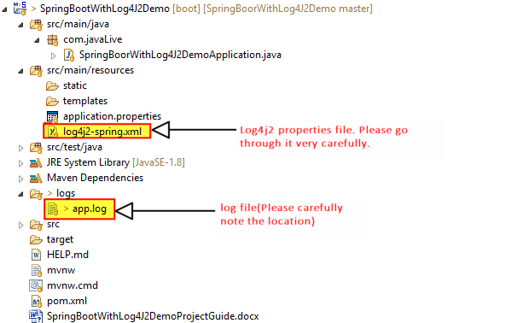

**How this project works??**

Note that Spring Boot uses Logback along with SLF4J as default logging framework. So in order use Log4J2 we have to exclude Logback dependency from pom.xml file and include log4j2 related dependency as follows:

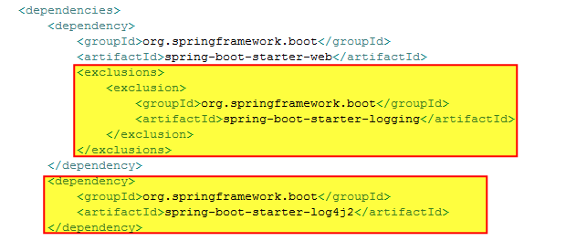

Now next step is to define various logging related properties in resources/log4j2-spring.xml

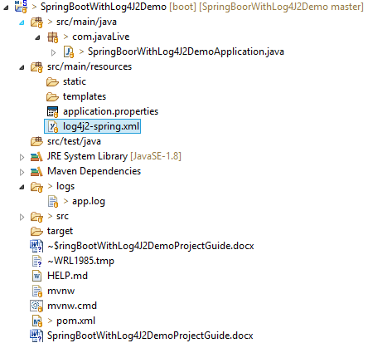

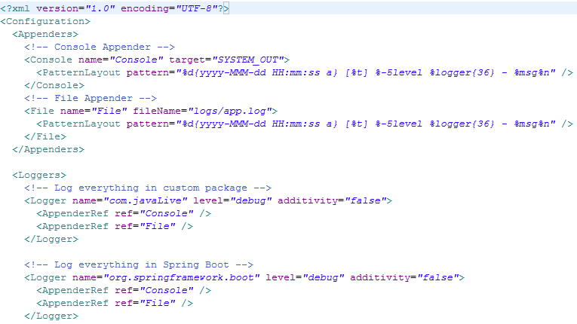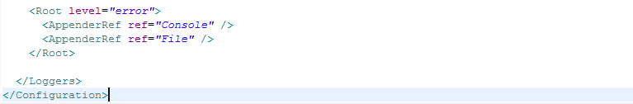

Now we are ready to use log4j2 in our application. We have use it in application's main file 'SpringBoorWithLog4J2DemoApplication' as follows:

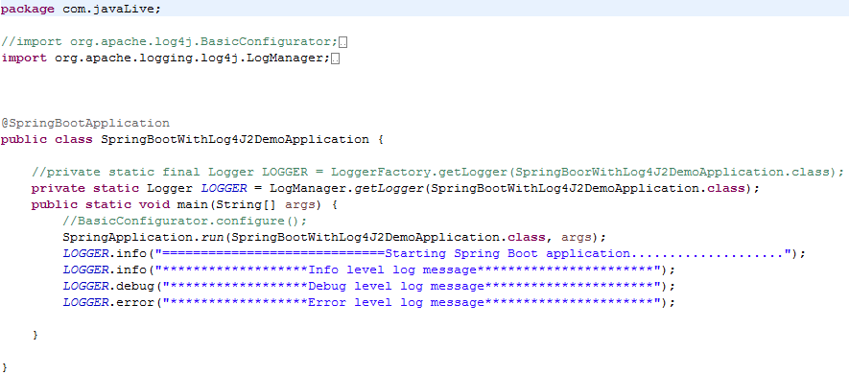

**Running the application:**

Right click on file 'SpringBootWithLog4J2DemoApplication.java' -> Run As -> Spring Boot App

**Output of the project:**

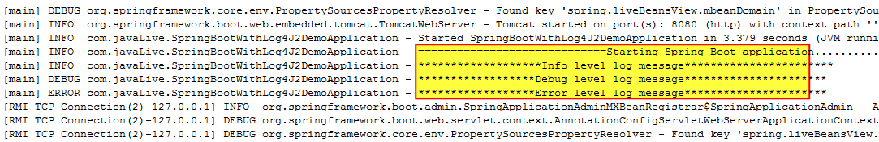

Note above output, along with Spring related message, logging message included by us are also get displayed.

Please note that above is logging messages on console. In order to view logging messages in log file please go through below file in project directory.



Thus we can use log4j2 logging framework in Spring Boot application.