Before moving forward its compulsory to understand project 'SampleSpringBootProject'. Hence you are requested to study project 'SampleSpringBootProject' along with the project guide file and 'Introduction To Spring Boot application_properties File.docx' file very carefully.

**Also you should know basic functioning of any Java logging framework.

Now moving forward:

**What this project dose??**

This project explains how to use ***default logging framework i.e. Slf4J with Logback***  in Spring Boot Application.

**Project structure:**

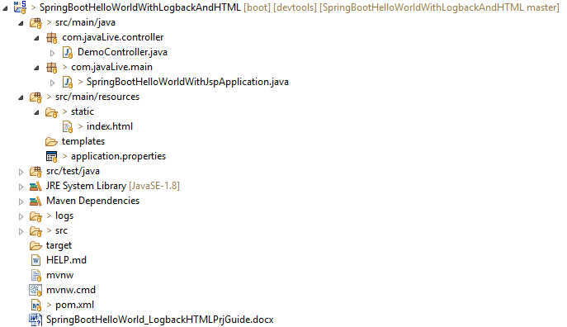

**How this project works??**

Note that Spring Boot uses Logback along with SLF4J as default logging framework. POM dependency for it is as follows:

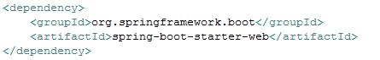

Please note that we do not included any other dependency either for Slf4J and for Logback explicitly as it is inbuilt in above dependency.

Now next step is to define various logging related properties in resources/application.properties.

(Please note that as there are limited number of properties to define here in this application about logging, we have included them in application.properties file but if there are very large number of properties we can define them in separate file with name like 'logback-spring.xml' under resources folder.)

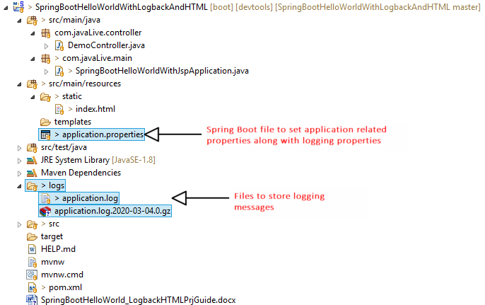

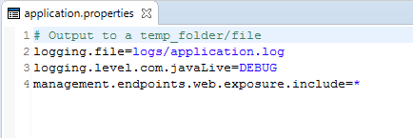

Here in above file we have defined the location for logging file and logging level.

We have use logging statements in application's main file 'SpringBootHelloWorldWithLogbackApplication' as follows:

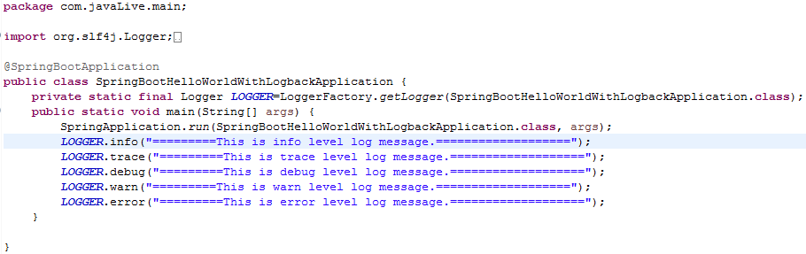

So when we launch the application various messages get logged to console as well as specified file viz. logs/application.log.

**Running the application:**

Right click on file 'SpringBootHelloWorldWithLogbackApplication.java' -> Run As -> Spring Boot App

**Output of the project:**



Please note that above is logging messages on console. In order to view logging messages in log file please go through below file in project directory.



Thus we can use Logback logging framework along with SLF4J in Spring Boot application.