This is project of Spring Boot series after SampleSpringBootProject.

Before moving forward its compulsory to understand ' SampleSpringBootProject' project as this project is simply a minor extension of the same. Hence you are requested to study project 'SampleSpringBootProject' along with the project guide file and 'Introduction To Spring Boot application_properties File.docx' file very carefully.

Now moving forward:

**What this project dose??**

This project explains how to use Spring REST in Spring Boot Application.

**Project structure:**

We have created RestController as shown in below screen shot.

Change 1:

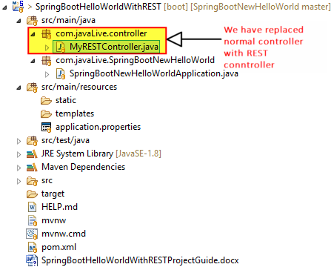

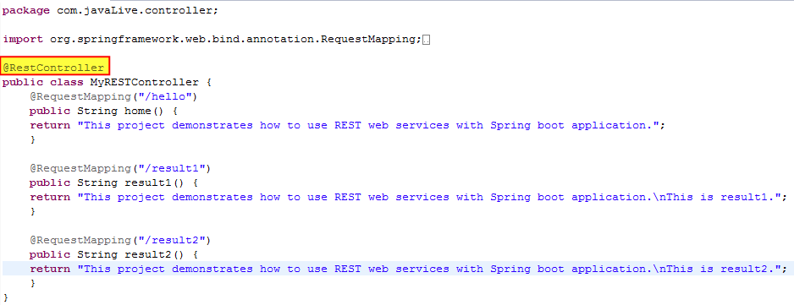

**Running the application:**

Right click on file ' com.javaLive.SpringBootNewHelloWorld .SpringBootNewHelloWorldApplication.java' -> Run As -> Spring Boot App

Now go to Chrome and type as follows, you will get the shown output:

