This is the next project of Spring Boot series.

Before moving forward its compulsory to understand first project mentioned above as this project is extension of the same. Hence you are requested to study project 'SampleSpringBootProject' along with the project guide file and 'Introduction To Spring Boot application_properties File.docx' file very carefully.

**We have given some commonly used TestNG Annotations in file 'TestNGAnnotation.docx' in this project folder. Before moving further please go this file very carefully.**

To know more about TestNG please refer link

<http://websystique.com/java/testng-tutorial/>

Now moving forward:

**What this project dose??**

In this project we will write test cases for a Spring Boot Application using TestNG. TestNG is a testing framework inspired from JUnit and NUnit. It also introduces some new functionalities of its own that make it more powerful and easier to use. TestNG is an open source automated testing framework where NG means NextGeneration.

**Project structure:**

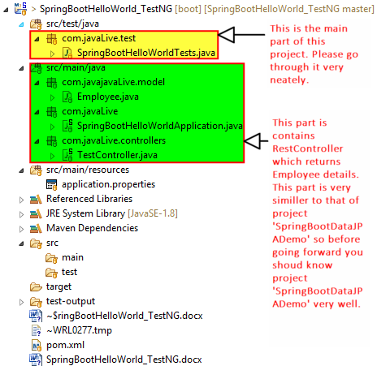

In the Maven we need the Spring Boot Test and the TestNG dependency.Maven will be as follows-

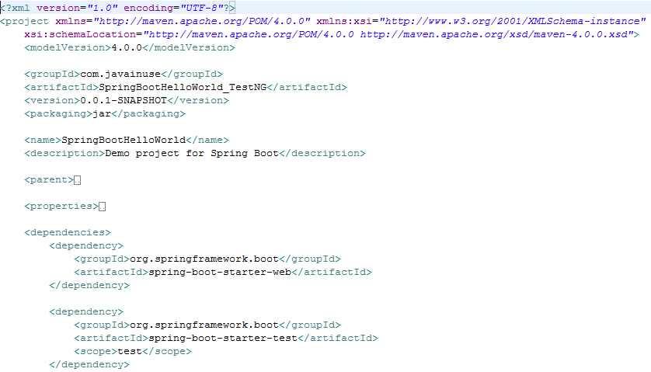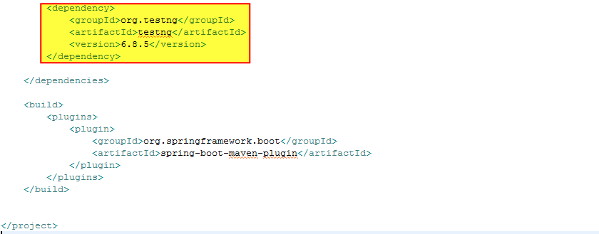

**How this project works??**

**Now as we can see in the project structure, this project contains RestController which returns Employee details.**

***But main part of this project is test cases of TestNG which is in package 'com.javainuse.test' viz. SpringBootHelloWorldTests which is as follows:

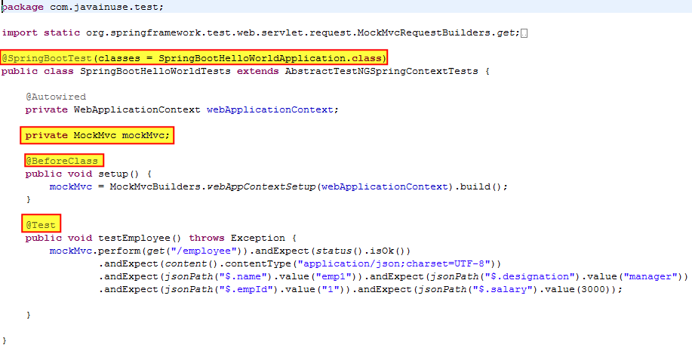

We write test cases using TestNG for the TestController.

Define the SpringBootHelloWorldTests.java as follows:

Spring Boot provides a @SpringBootTest annotation which can be used as an alternative to the standard spring-test @ContextConfiguration annotation when you need Spring Boot features. The annotation works by creating the ApplicationContext used in your tests via SpringApplication.  
To make TestNG test class work with our Spring Boot we should extend AbstractTestNGSpringContextTests

**Running the application:**

This section is divided into two parts as follows:

**Part 1 Regular output:**

Right click on file 'SpringBootHelloWorldApplication.java' -> Run As -> Spring Boot App.

Let's re-run the application now!

Output is as follows:

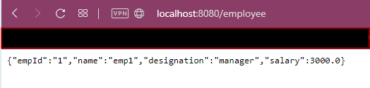

Part 2 To execute TestNG test case:

Go to file 'com.javaLive.test. SpringBootHelloWorldTests' right click on it and run it as shown:

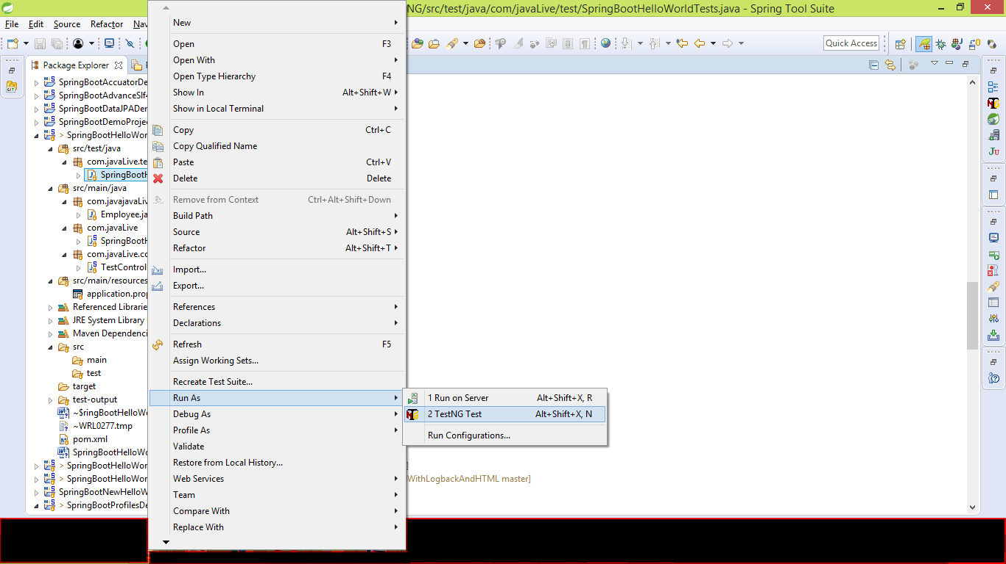

Output of the file is as follows:

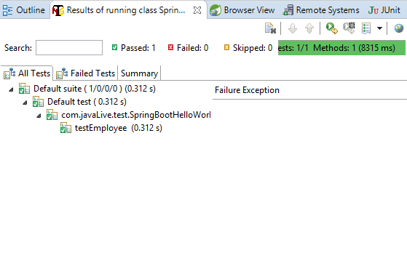

Please note that as we have mentioned same values in test case as that of mentioned in the controller, out test get passed. Please refer code snippet from file 'com.javaLive.controllers.TestController'.

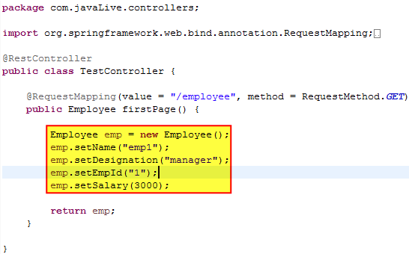

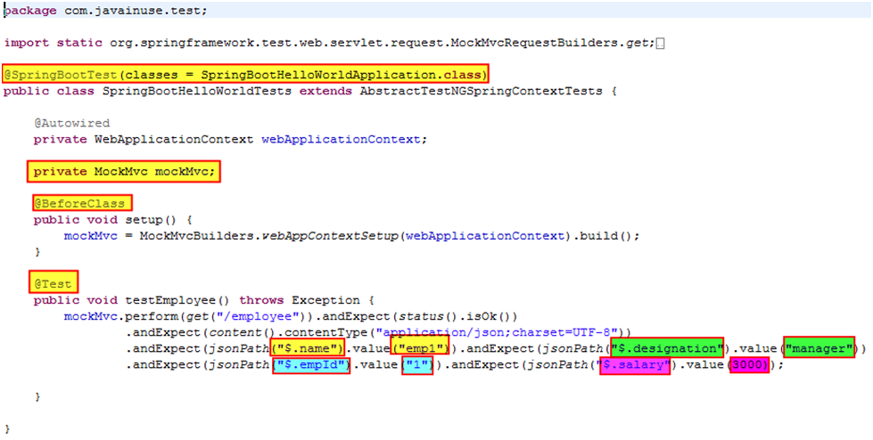

Now change the value of salary in test case as follows and then rerun the test case.

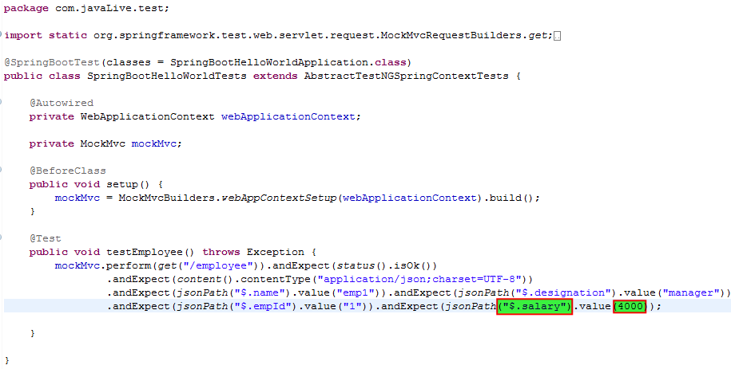

Rerun the test case

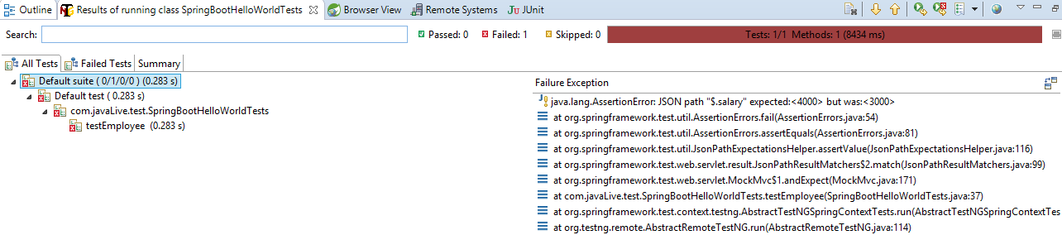

As values from controller and test case mismatches, test get failed.