This is the fourth project of Spring Boot series.

Previous projects with sequence are:

1. SampleSpringBootProject.

2. SpringBootHelloWorldWithJSP

3. SpringBootWithFreeMarkerHelloWorldDemo

Before moving forward its compulsory to understand first project mentioned above as this project is extension of the same. Hence you are requested to study project 'SampleSpringBootProject' along with the project guide file and 'Introduction To Spring Boot application_properties File.docx' file very carefully.

Now moving forward:

**What this project dose??**

This project explains how to use various profiles in Spring Boot Application.

Here we set various properties for the application at run time as per selected profile.

**Project structure:**

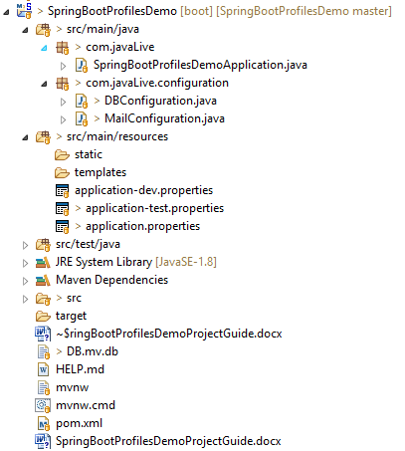

**How this project works??**

In this application, we will see how to configure different databases properties and mailing properties at runtime based on the specific environment by their respective profiles.

As the DB connection is better to be kept in a property file, it remains external to an application and can be changed. Similar is for mailing properties. We will do so here. But, Spring Boot — by default — provides just one property file ( application.properties). So, how will we segregate the properties based on the environment?

The solution would be to create more property files and add the "profile" name as the suffix and configure Spring Boot to pick the appropriate properties based on the profile.

Then, we need to create two  application.properties:

1. application-dev.properties
2. application-test.properties

Of course, the application.properties will remain as a master properties file, but *if we override any key in the profile-specific file, the latter will gain precedence.*

We will now define DB configuration properties for in respective properties file and add code in DBConfiguration.class to pick the appropriate settings.

Similar we do for mailing properties with MailConfiguration.class to pick the appropriate settings.

Here is the base  application.properties:

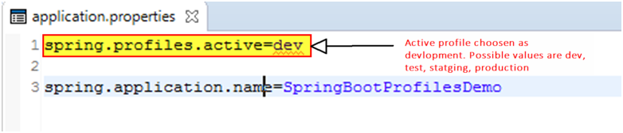

Now contents of application-dev.properties are as follows:

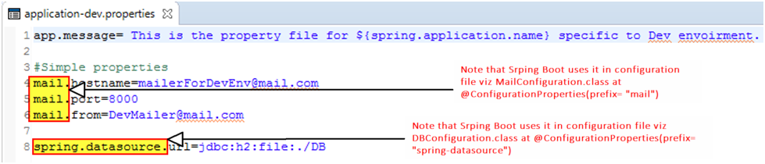

In DEV, we will use an in-memory database and various mailing properties.

Now contents of application-test.properties are as follows:

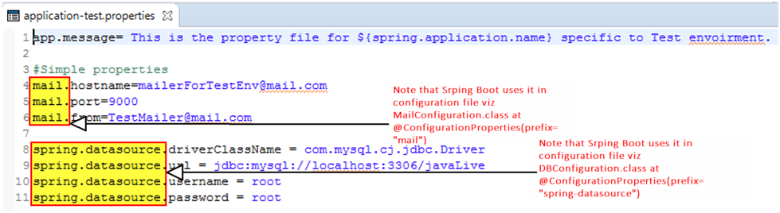

Here we are using MySQL Server and various mailing properties.

Now, we are done with properties files. Let's configure in the DBConfiguration.class to pick the correct one.

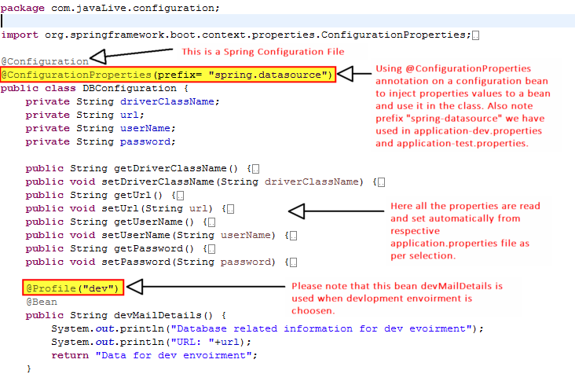 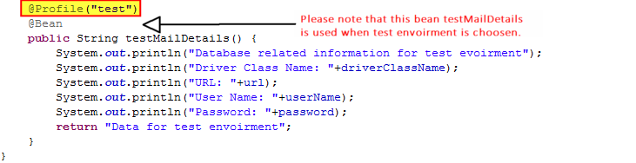We have used the @Profile("Dev")   to let the system know that this is the BEAN that should be picked up when we set the application profile to DEV. The other bean will not be created at all.

One last setting is how to let the system know that this is DEV, TEST, or PROD. But, how do we do this?

We will use the application.properties to use the key below:



From here, Spring Boot will know which profile to pick. Let's run the application now!

With the profile in DEV mode, and it should pick H2 DB.

**Running the application:**

Right click on file 'SpringBootProfilesDemoApplication.java' -> Run As -> Spring Boot App

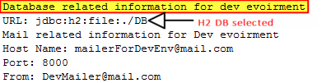

Change the profile to TEST mode in appication.properties as follows:

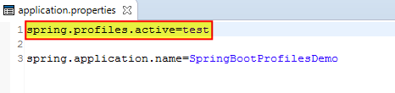

Let's re-run the application now!

Output is as follows:

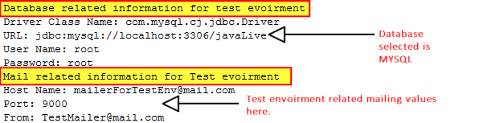

**\*\*\*\*\*\*Please note that here in this application we have included only two profiles/environment viz. dev and test but we can include more profiles/environments viz. staging and prod as per requirement. You can include all four of the at a time.**