Before moving forward its compulsory to understand project 'SampleSpringBootProject'. Hence you are requested to study project 'SampleSpringBootProject' along with the project guide file and 'Introduction To Spring Boot application_properties File.docx' file very carefully.

**Also you should know basic functioning of any Java logging framework.

Now moving forward:

**What this project dose??**

This project explains how to use ***Log4j2*** ***logging framework with Slf4J***  in Spring Boot Application.

**Project structure:**

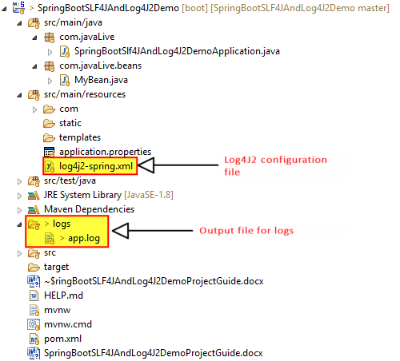

**How this project works??**

Note that Spring Boot uses Logback along with SLF4J as default logging framework. So in order use Log4J2 we have to exclude Logback dependency from pom.xml file and include log4j2 related dependency as follows:

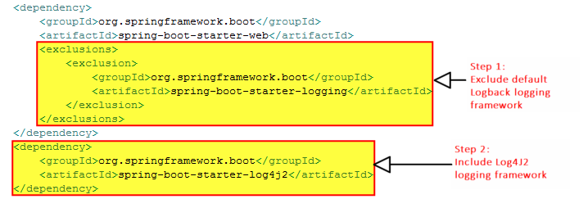

Now next step is to define various logging related properties in resources/log4j2-spring.xml.

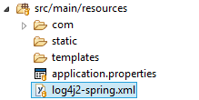

Its contents are as follows:

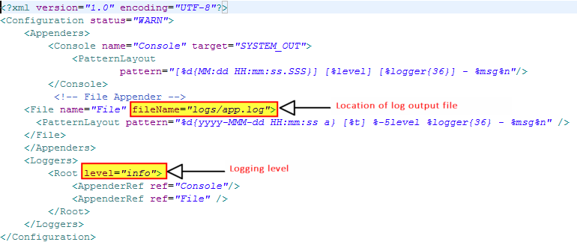

Here in above file we have defined the location for logging file and logging level.

(Please note that if there are limited number of properties to define here in this application about logging, we have included them in application.properties file but as there are large number of properties we can define them in separate file.)

We have use logging statements in application's one of the bean as follows:

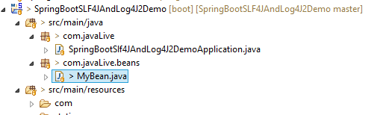

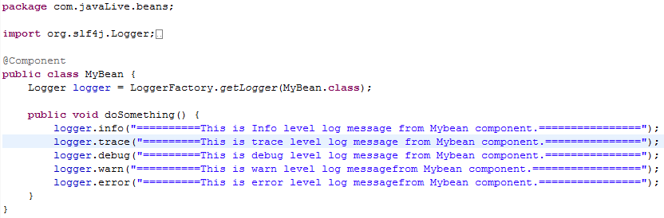

So when we launch the application various messages get logged to console as well as specified file viz. logs/app.log.

**Running the application:**

Right click on file 'SpringBootSlf4JAndLog4J2DemoApplication.java' -> Run As -> Spring Boot App

**Output of the project:**

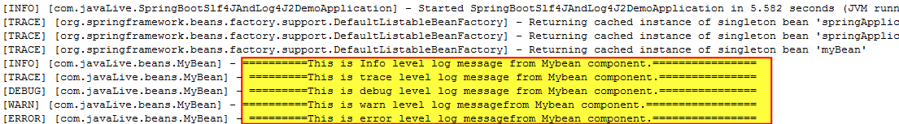

Please note that above is logging messages on console including user defined as well as Spring Framework related. In order to view logging messages in log file please go through below file in project directory.



Thus we can use Log4J2 logging framework along with SLF4J in Spring Boot application.