This is the third project of Spring Boot series after SpringBootHelloWorldWithJSP.

Before moving forward its compulsory to understand first project **'SampleSpringBootProject'** as this project is simply a minor extension of the same. Hence you are requested to study project 'SampleSpringBootProject' along with the project guide file and 'Introduction To Spring Boot application_properties File.docx' file very carefully.

Now moving forward:

**What this project dose??**

This project explains how to use FreeMarker file in Spring Boot Application. This process consists of two steps as:

1. To create proper folder structure and store FreeMarker files in it.

2. Mention specific folder path in application.properties file so that server can locate above created files.

**Project structure:**

We have only two changes here in this project comparing with the previous one.

Change 1:

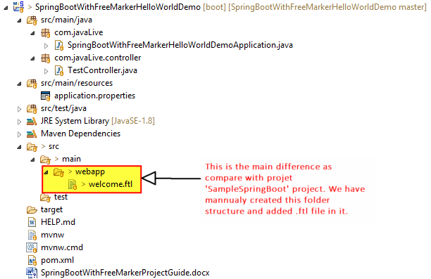

Change 2: Here we have specified the folder where server should search for FreeMarker files.

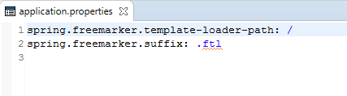

**Contents of .ftl file**

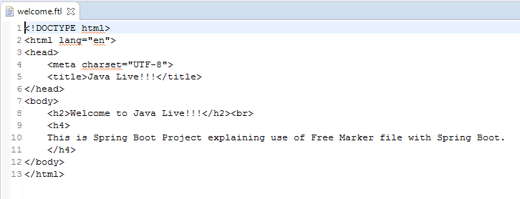

**Running the application:**

Right click on file 'SpringBootWithFreeMarkerHelloWorldDemoApplication.java' -> Run As -> Spring Boot App

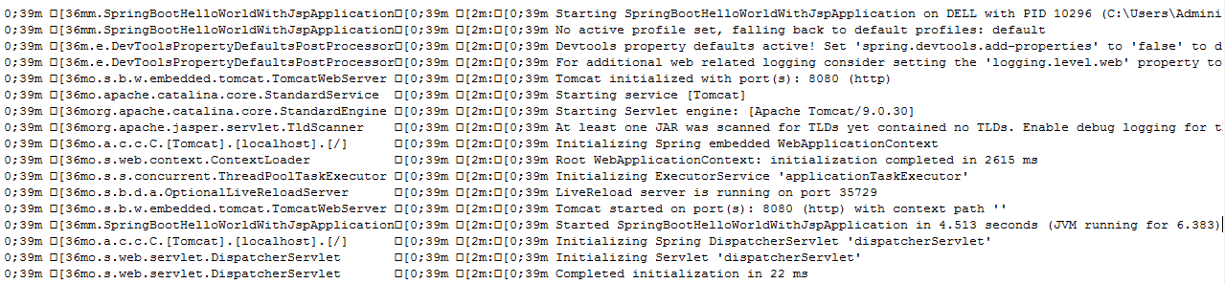

Now go to Chrome and type as follows, you will get the shown output:

