As we know Spring Boot application contains embedded server i.e. inbuilt server. They can be any one of the following:

1. Tomcat (This is default)

2. Undertow

3. Jetty

**What this project dose??**

This project is replica of project 'SampleSpringBootProject' (So you are requested to go through the project guide file of this project for better understanding of this project) with only one modification i.e. we have replaced default embedded Tomcat server with embedded Jetty or Undertow server that's it. Nothing other change here.

In order to do so we have to make only two changes in pom.xml file as follows:

1. Exclude default Tomcat server as:

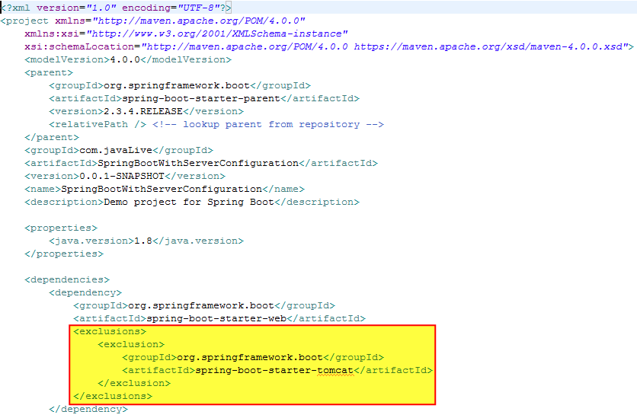

2. Include either Undertow or Jetty servers

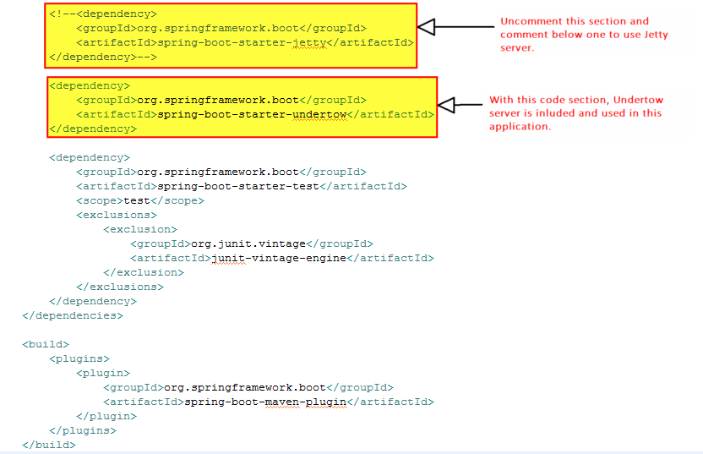

Run the application:

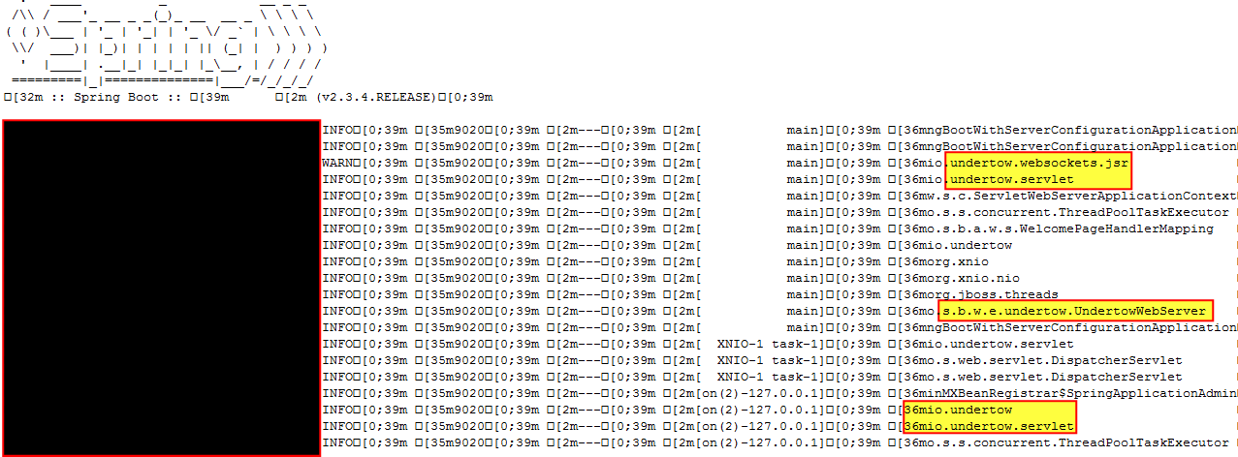

Note the highlighted section. Undertow server is up and running.

We can use Jetty in same way. Just comment undertow related dependency in pom.xml and uncomment Jetty related dependency that's it.

For comparative analysis of all these three servers viz. Tomcat, Undertow and Jetty please refer below link:

[https://examples.javacodegeeks.com/enterprise-java/spring/tomcat-vs-jetty-vs-undertow-comparison-of-spring-boot-embedded-servlet-containers/](%20https:/examples.javacodegeeks.com/enterprise-java/spring/tomcat-vs-jetty-vs-undertow-comparison-of-spring-boot-embedded-servlet-containers/)