**Important note: Before going further you are requested to go through theory of 'Annotation based spring configuration' thoroughly so that you can understand the concept very well. (**This activity i.e. going through theory part of respective subject is applicable for each of our project.)**

**Beside above theory part you should also know various annotations used in Spring Framework.**

**\*\*Note that this is very important project used as foundation for Web MVC based spring project so study it very carefully.**

**What this project does??**

This project explains how to configure beans in spring with annotations and without spring-config.xml file.

**Note that this is annotation based spring project having Java based configuration file viz. ' com.javaLive.config.AppConfiguration.java'. We do not have spring-config.xml here.**

**Steps to create project:-**

1. Create quick start maven project. Refer file 'CreateQuickStartMavenProjectInEclipse.docx' in 'SprinDIWithAutowiring' project for more details.

2. Add require dependencies for spring as shown in pom.xml file.

3. Create required packages and add the files.

**Following is the structure of the file :-**

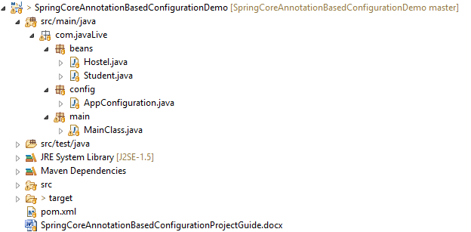

**Functioning of the project**

This is very simple and basic project of spring core.

The main and only difference is unlike other xml based spring projects, this project is Java based i.e. beans are defined in .java file viz. **' com.javaLive.config.AppConfiguration.java' and not in spring-config.xml file.**

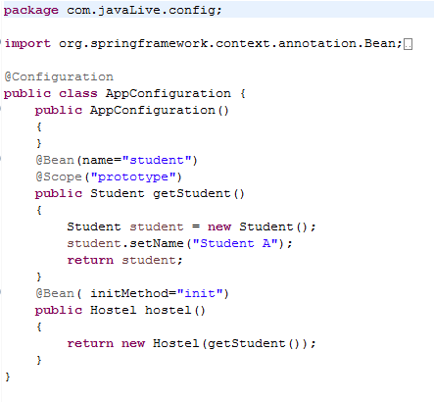

This file contains @Configuration annotation. So as mentioned at the start please go through various annotations used in Spring Framework.

This file contains definition of various beans with @Bean annotation.

At the definition of Hostel bean it contains initMethod. This is part of bean life cycle.

We are going to study them in upcoming projects. For the time, if possible please go through spring bean lifecycle methods.

@Scope annotation responsible for provide scope to the bean.

Other than this,

com.javaLive.beans package contains .java files which are used to define beans.

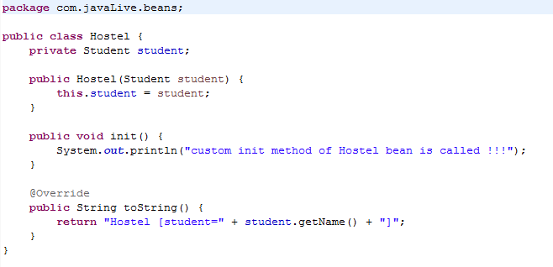

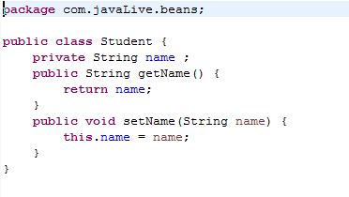

com.javaLive.main package contains MainClass.java file having main method responsible for carrying out various operations on these beans.

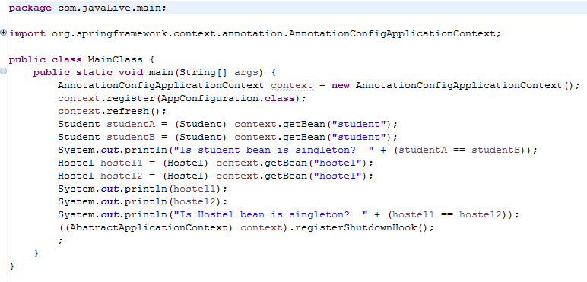

Following is the output of above file.

