**Important note: Before going further you are requested to go through theory of spring bean lifecycle methods mentioned in JavaLive Notes on Spring Core thoroughly so that you can understand the concept very well. (**This activity i.e. going through theory part of respective subject is applicable for each of our project.)**

**What this project does??**

This project explains custom init and destroy methods in spring bean life cycle.

**Note that this is xml based spring project having configuration file viz. ' spring-config.xml' in resources folder.**

**Steps to create project:-**

1. Create quick start maven project. Refer file 'CreateQuickStartMavenProjectInEclipse.docx' in 'SprinDIWithAutowiring' project for more details.

2. Add require dependencies for spring as shown in pom.xml file.

3. Create required packages and add the files.

**Structure of the project is as follows:-**

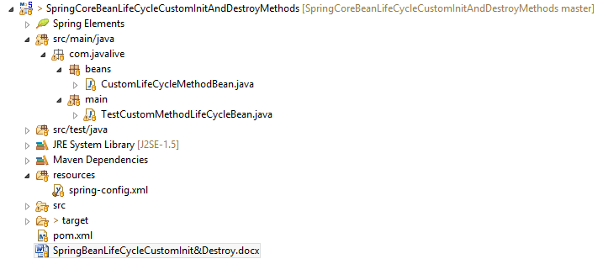

**Functioning of the project**

This project is mainly divided in three parts:

1. com.javaLive.beans package contains a file CustomLifeCycleMethodBean.java which declared as bean in spring-config.xml file. This class defines custom init and destroy methods.

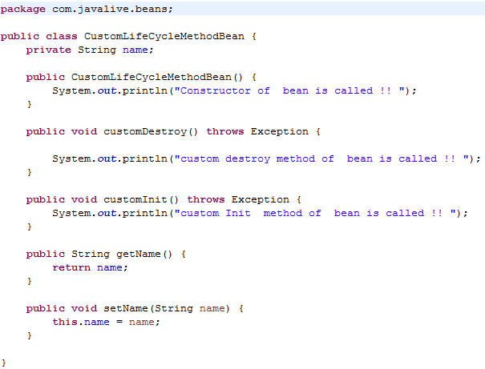

2. spring-config.xml file in resources folder contains bean definition for above class.

**\*\*Note during definition of this bean we have mentioned init-method and destroy-method attributes where we provide name of the methods in the respective class (CustomLifeCycleMethodBean.java in this case) which we are going to use as custom init and custom destroy methods.**

**This is the main part of this project.**

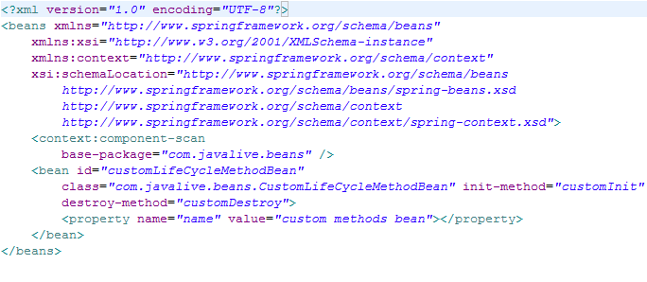

3. com.javaLive.main package contains TestCustomMethodLifeCycleBean.java class which get the bean from spring application context and displays its details.

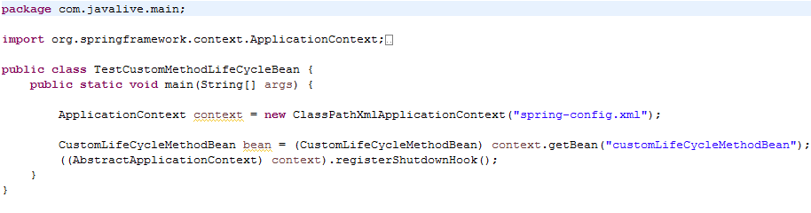

When we run this file, we will come to know in which sequence methods of these custom init, custom destroy and constructor of this bean file get called.

